 | Selected issues of the contemporary world
 | CLASS 4 (Scenario 4)
TOPIC | Military and religious conflicts – part 1
LEARNING CONTENT - DETAILED CHARACTERISTICS | Causes, course and effects of conflicts (Moore’s sphere of conflicts).  Conflict-solving styles and procedures.  Military conflicts- definition, types, examples, statistics.  Religious conflicts – definition, types, examples, statistics.  Negotiation and mediation – characteristics of the processes and examples.  Summary of the main points through working with the world map of the conflicts.
KEY WORDS | causes of conflicts, military conflicts, religious conflicts, negotiation and mediation
SUGGESTED TOOLS | group work, discussion, presentation, Moore’s sphere of conflicts, the world map of the conflicts
TIPS / METHODOLOGICAL REMARKS  (if applicable) | The lecture part includes interactive elements.
IMPLEMENTATION OF THE CLASSES | STEP 1 | Introducing the topic by filling in the work card (Moore’s sphere of conflicts), a short brainstorming, and a general discussion on the sources of social conflicts.
 | STEP 2 | A lecture supported by the presentation prepared in PowerPoint: definition and types of conflicts based on the literature.
 | STEP 3 | A lecture supported by the presentation prepared in PowerPoint: military conflicts – definition, types, selected examples with discussing details.
 | STEP 4 | A lecture supported by the presentation prepared in PowerPoint: religious conflicts – definition, types, selected examples with discussing details.
 | STEP 5 | A lecture supported by the presentation prepared in PowerPoint: effects of the discussed conflicts on varied aspects of social life, e.g. migration, allocation, and need deprivation in different demographic groups.
 | STEP 6 | Summary of the main points of the lecture with students sketching the map of the discussed conflicts.
ADDITIONAL MATERIALS | 1 WORK CARD | Moore’s sphere of conflicts - examples
 | 2 WORK CARD | The world map of the conflicts

WORK CARD | CAUSES OF CONFLICT
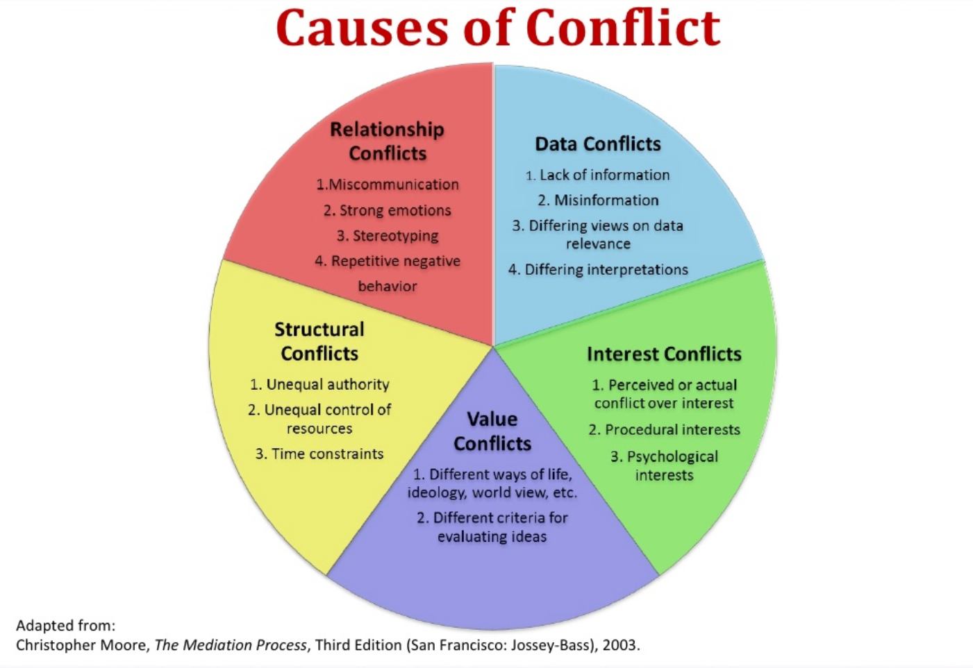
 | Source: https://tiny.pl/wr8wf
TASK  (group or individual work) | Based on the info presented in the graph above, give examples to each of the type of conflict referring to their causes:
- RELATIONSHIP CONFLICTS
……………………………………………………………………………………………………..
- DATA CONFLICTS
……………………………………………………………………………………………………..
- INTEREST CONFLICTS
……………………………………………………………………………………………………..
- VALUE CONFLICTS
……………………………………………………………………………………………………..
- STRUCTURAL CONFLICTS
……………………………………………………………………………………………………..

WORK CARD | MAP OF CONFLICTS
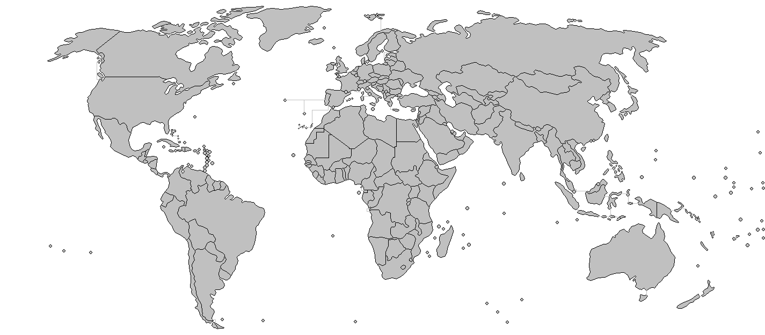
TASK  (group or individual work) | Mark, any known to you, military and/or religious conflicts, on the map.

