 | Selected issues of the contemporary world
 | CLASS 2 (Scenario 2)
TOPIC | Climate change and its consequences - part 1
LEARNING CONTENT - DETAILED CHARACTERISTICS | A short history and main aspects of climate change - natural and caused by man origins.  Main paradigms regulating relations between a human and nature – anthropocentrism, eco-centrism, and bio-centrism.  A new way of thinking about nature.  Climate changes in SDG, global, state, regional and local regulations.  A short history of fighting climate change in theory and practice – philosophy, religion, politics, and economics.  Selected examples of theory and practice reflecting climate changes:  urban design; rational and irrational consumption; CSR, LCA etc.
KEY WORDS | history of climate change, human-nature paradigms, facing climate change
SUGGESTED TOOLS | group work, discussion, presentation
IMPLEMENTATION OF THE CLASSES | STEP 1 | Introducing the topic by indicating the most important sources of the present climate change preceded by a short brainstorming and discussion.
 | STEP 2 | A lecture supported by the presentation prepared in PowerPoint: paradigms describing the relation between a human and nature – anthropocentrism, eco-centrism, and bio-centrism.
 | STEP 3 | A lecture supported by the presentation prepared in PowerPoint: alternative natures – the idea of a new way of thinking about nature introduced by Phil Macnaghten and John Urry.
 | STEP 4 | A lecture supported by the presentation prepared in PowerPoint: origins, history and main ideas of sustainable development as the answer to the challenges of climate change.
 | STEP 5 | A lecture supported by the presentation prepared in PowerPoint: the way towns and cities cope with climate change and find solutions for the future.
 | STEP 6 | A lecture supported by the presentation prepared in PowerPoint: models of consumption and their relation with climate change, alternative lifestyles.
 | STEP 7 | A lecture supported by the presentation prepared in PowerPoint: coping with climate change in business and industry (e.g. Corporate Social Responsibility, Fair Trade, Product Life Cycle Assessment).
 | STEP 8 | Summary of the main point of the lecture with the involvement of students.
ADDITIONAL MATERIALS | 1 WORK CARD | Life Cycle Assessment
 | 2 FILM | Masdar - the most sustainable city?  accessed: https://tiny.pl/wr89l

WORK CARD | LIFE CYCLE ASSESSMENT
INTRODUCTION | Life Cycle Assessment determines the environmental impact of products, processes or services, through production, usage, and disposal. LCA is a systematic set of procedures for compiling and examining the inputs and outputs of materials and energy and the associated environmental impacts directly attributable to the functioning of a product or service system throughout its life cycle.  Source: ISO 14040.2 Draft: Life Cycle Assessment – Principles and Guidelines accessed on: https://www.iso.org/standard/37456.html
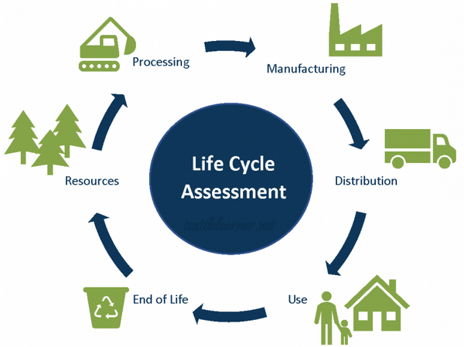
 | Source: https://textilelearner.net/life-cycle-assessment-of-your-clothes/
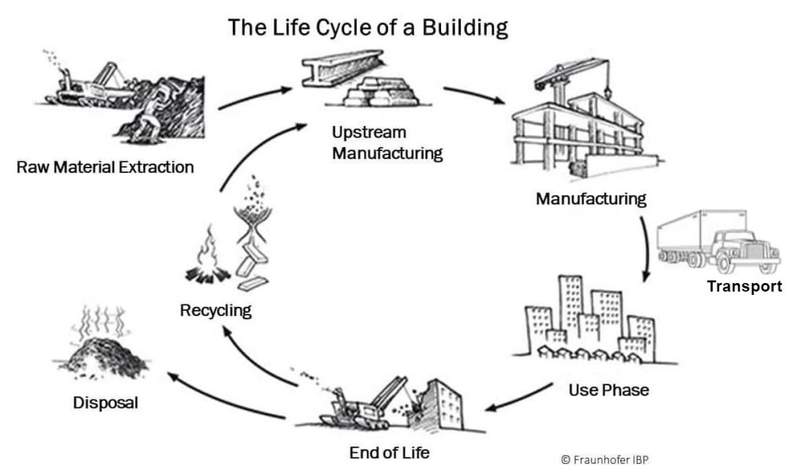
 | Source: https://www.qsi.com.tr/hizmetler/lca-life-cycle-analysis/?lang=en
TASK  (group or individual work) | Based on a given definition and included pictures, prepare LCA, with detailed information, of any chosen product or service.

