 | Selected issues of the contemporary world
 | CLASS 14 (Scenario 14)
TOPIC | Information security in a risk society – part 1
LEARNING CONTENT - DETAILED CHARACTERISTICS | Definition and types of risk and security.  Sources of risk in contemporary society (Ulrich Beck).  Risk versus trust.  Ways of reducing risk and introducing security in different societies.  Manipulating information – history and presence.  Moral panic – a tool of socio-techniques.  Tools to verify the information.
KEY WORDS | information security, information risk, risk society, social trust
SUGGESTED TOOLS | group work, discussion, presentation, work card, whiteboard
TIPS / METHODOLOGICAL REMARKS  (if applicable) | The lecture part includes interactive elements.
IMPLEMENTATION OF THE CLASSES | STEP 1 | Introducing the topic by indicating the sources of the risk in contemporary society (a white board) followed by a short discussion.
 | STEP 2 | A lecture supported by the presentation prepared in PowerPoint: definition and types of risk and security.  Sources of risk in contemporary society (Ulrich Beck).
 | STEP 3 | Brainstorming on the topic of trust.
 | STEP 4 | A lecture supported by the presentation prepared in PowerPoint: risk versus trust; how those two notions relate.
 | STEP 5 | A lecture supported by the presentation prepared in PowerPoint: ways of reducing risk and introducing security in different societies regarding Uncertainty Avoidance Index by Geert Hofstede.
 | STEP 6 | A lecture supported by the presentation prepared in PowerPoint: manipulating information – history and presence. Moral panic – a tool of socio-techniques.  Tools to verify information.
 | STEP 7 | A lecture supported by the presentation prepared in PowerPoint: tools to verify information – introduction to the assignment (additional material 2).
 | STEP 8 | Summary of the main point of the lecture with the involvement of students.

ADDITIONAL MATERIALS | 1 WORK CARD | Information manipulation
 | 2 ASSIGNMENT | Find a tool to verify the information and use it for a selected one.

WORK CARD | INFORMATION SECURITY IN THE RISK SOCIETY
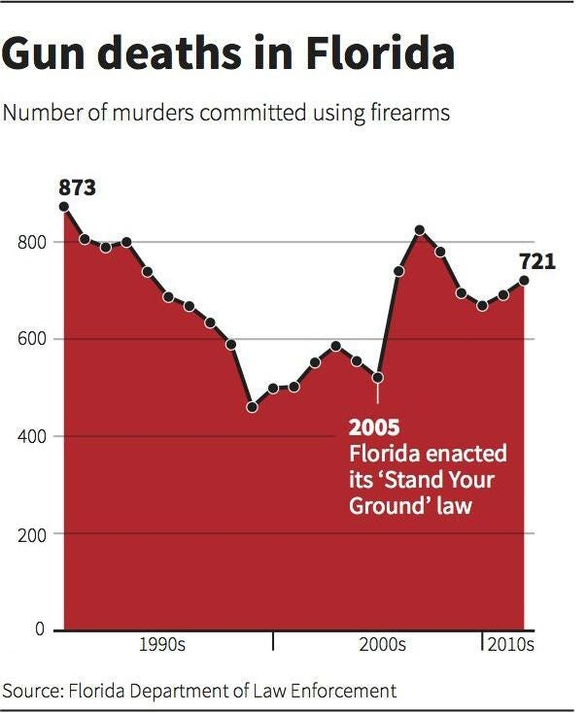 |  | 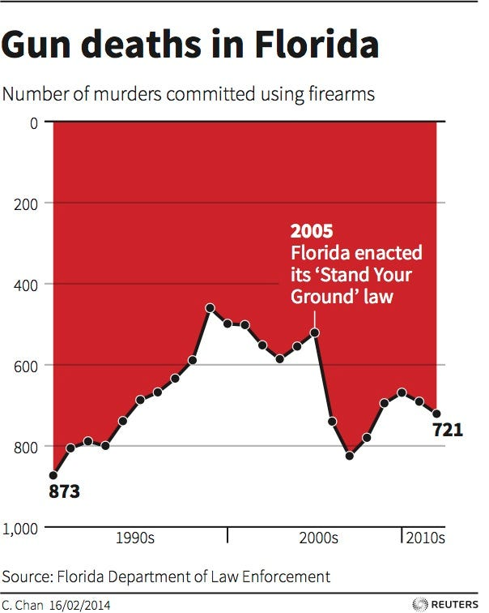
 | Source: https://tiny.pl/wr84w
TASK | What would be the interpretation of the two given above graphs?

