 | Selected issues of the contemporary world
 | CLASS 13 (Scenario 13)
TOPIC | Addictions and civilization diseases – part 2
LEARNING CONTENT - DETAILED CHARACTERISTICS | Summary of the topics presented in the class of Katarzyna Ponikowska.  Case study:  Sugar Coated examines the various public relations tactics that the food industry has employed over the years to beat back accelerating concerns about the toxicity of sugar. Its starting point is a secret PR campaign the industry devised in the 1970s to deflect attention away from developing health concerns about sugar. It then traces how in the years since the industry has honed its PR tactics to counter mounting scientific evidence about the dangers of sugar. In the end, Sugar Coated leaves us with two crucial questions: Will the PR specialists of the multibillion-dollar food industry continue their amazing run of success and allow Big Sugar to keep sweetening the world’s food supply? Or will today's heightened level of public awareness about the relationship between sugar consumption and skyrocketing rates of obesity, diabetes, heart disease, and fatty liver disease in children prove to be too much for industry spin to handle -- ultimately forcing the same kind of reckoning we saw with Big Tobacco?  Screening of the documentary “Sugar Coated” by Michele Hozer.  or alternatively:  Childhood obesity has become an ever-more serious medical issue in the United States. This eye-opening documentary examines the underlying causes behind the epidemic, including the marketing strategies of major U.S. food producers.  Screening of the documentary “Fed up”by Stephanie Soechtig.  Creation of impact campaigns.Discussion on the relation with a documentary character and the director’s ethics.
KEY WORDS | additions, alcoholism
SUGGESTED TOOLS | film screening, group work
IMPLEMENTATION OF THE CLASSES | STEP 1 | Summary of the topics presented in the class of Katarzyna Ponikowska.
 | STEP 2 | Presentation and discussion on the role of a director in a documentary.
 | STEP 3 | Screening of the documentary “Sugar Coated” by Michele Hozer or “Fed up” by Stephanie Soechtig.
 | STEP 4 | Discussion on the relation with a documentary character and the director’s ethics.
 | STEP 5 | Group work on the impact campaign for the film.
 | STEP 6 | Presentation of the group work.
ADDITIONAL MATERIALS | 1 FILM | “Sugar Coated” 2015, Michele Hozer, 91’ or “Fed up” 2014, dir. Stephanie Soechtig, 90’
 | 2 FILM POSTER | Depending on the film chosen
 | 2 WORK CARD | The graphs from the A. Leiserowitz research

FILM POSTER
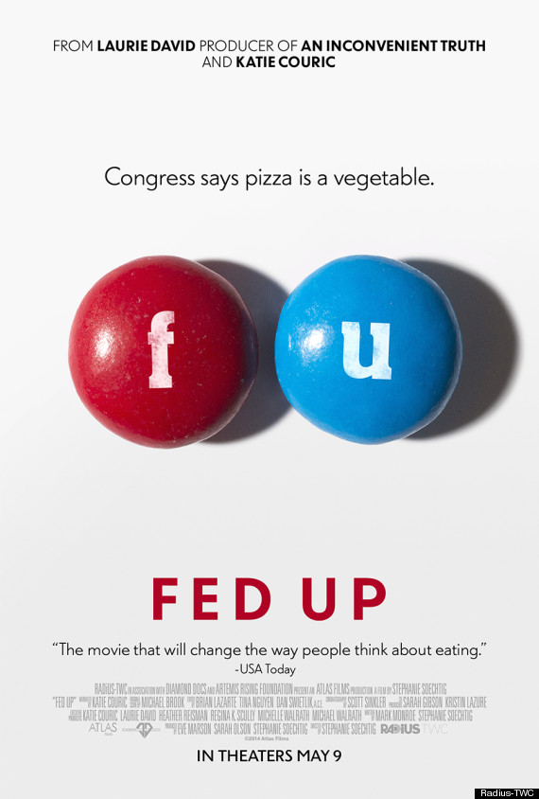
FILM POSTER
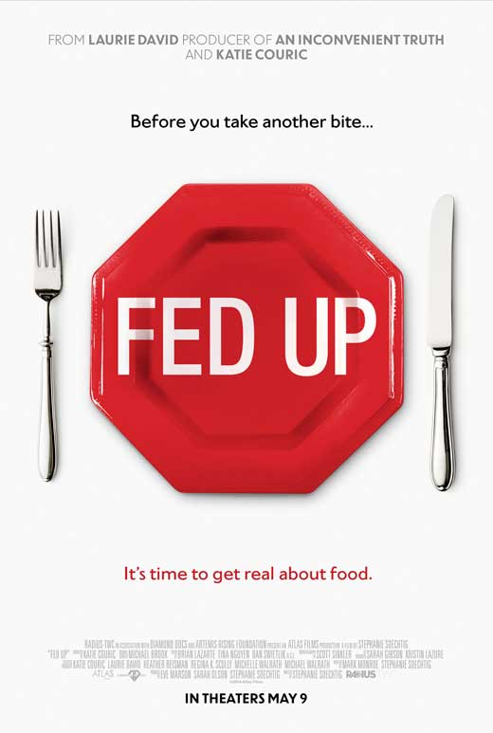
FILM POSTER
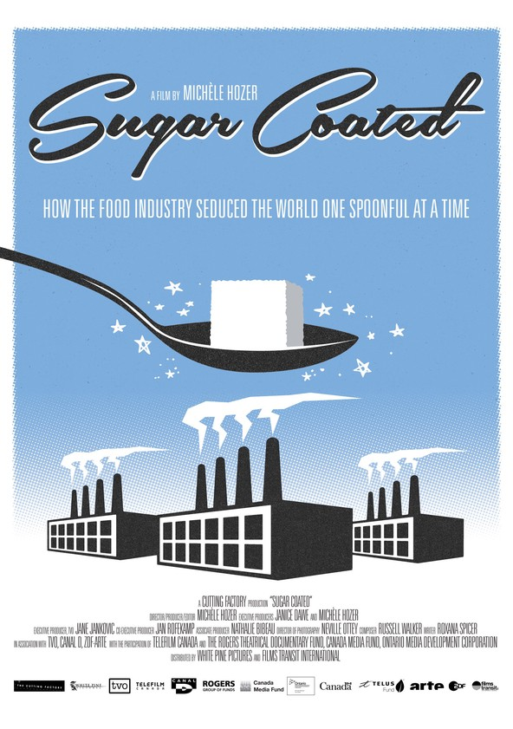

WORK CARD | THE GRAPHS FROM THE A. LEISEROWITZ RESEARCH
