COURSE SCENARIO
UNESCO World Heritage: A Trip Through Mankind’s Shared Inheritance

CLASS 7
TOPIC | The Strategic Objectives, the 5 C, and the fundings for the UNESCO List.
LEARNING CONTENT  - DETAILED  CHARACTERISTICS | This lesson covers two important aspects for the sustainability of UNESCO heritage list. On the one hand, the lesson focus on the strategic objectives that summarize the aims of UNESCO conservation strategy. On the other hand, to maintain the infrastructure and support the conservation of the site, fundings are necessary. The lesson highlights the necessities and how the fundings respond to the diverse tasks, work, and campaigns that UNESCO undertakes. Special attention is put on the top investor countries and their strategies in the support of UNESCO.
KEY WORDS | Credibility, Conservation, Competence, Communication and Community
SUGGESTED TOOLS | Inductive learning  Interactive lecture  Power-point presentation  Interactive online platform  Collaborative brainstorming and decision-making (Phillips 21) Discussion
TIPS /  METHODOLOGICAL  REMARKS | We recommend using an ICT platform, so students can share their comments through their mobile phones, or other ICT devices. For example, they can use Mentimeter@, Quizziz@, Nearpod@, Padlet@, Lino-it@, etc. If these
(If applicable) | platforms are not available, students can write their ideas on a poster, or blackboard in a more traditional way.
IMPLEMENTATION  OF THE CLASSES | STEP 1 | The lecturer will tell the students that the UNESCO Heritage List has five strategic objectives that are summarized in five words that start with the letter C. Students are asked to guess these five words on the screen, using an online platform so all the comments are gathered on the screen. See Work Card 13.
 | STEP 2 | A discussion is opened with the ideas. Once all the suggestions are gathered on the board, the lecturer can use the strategy of small groups discussion (Phillips 21). The group is split in groups of 2-3 people who must decide the final set of 5 words. Then, groups are put together, so the double of people are joined in the discussion, until the whole group decides on the final set of words. At the end of the session, the lecturer discovers the real set of words.
 | STEP 3 | The lecturer explains the funding sources of the UNESCO heritage list. A debate could be opened about the financial needs of UNESCO and where the money is necessary to be invested. The questions of the debate could be:  - Which are the funding sources of UNESCO?  - Why does UNESCO need money? What for?  - What can be the use of the reserved funds?  - Which countries do you think are the top investors?
 | STEP 4 | The students are required to analyse the case study of the USA funding. The materials for the activity are in WORK Card 14.

ADDITIONAL MATERIAL 1 WORK CARD (The UNESCO’s List Criteria)

WORK CARDS
UNESCO WORLD HERITAGE: A TRIP THROUGH MANKIND’S SHARED INHERITANCE

WORK CARD 7: The UNESCO’s List Criteria

UNESCO 1972 World heritage List – Criteria
- Look these sites up and check the criterion / criteria that was used to include them on the list
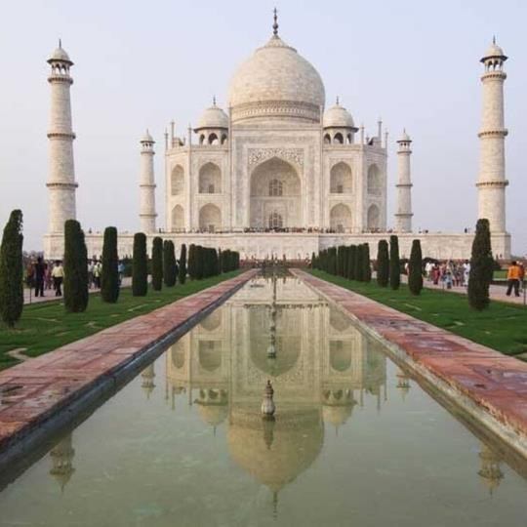
Taj Mahal (India)
Date of Inscription:
Criteria:
Reason:

Link:
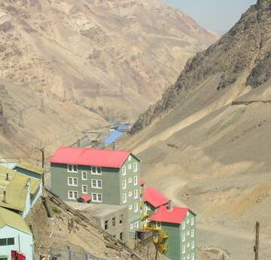
Sewell Mining Town (Chile)
Date of Inscription:
Criteria:
Reason:

Link:

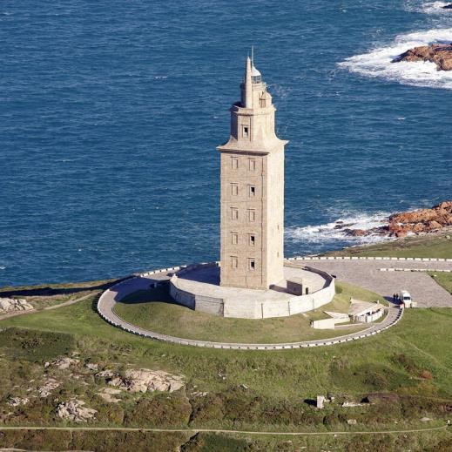
Tower of Hercules (Spain)
Date of Inscription:
Criteria:
Reason:

Link:

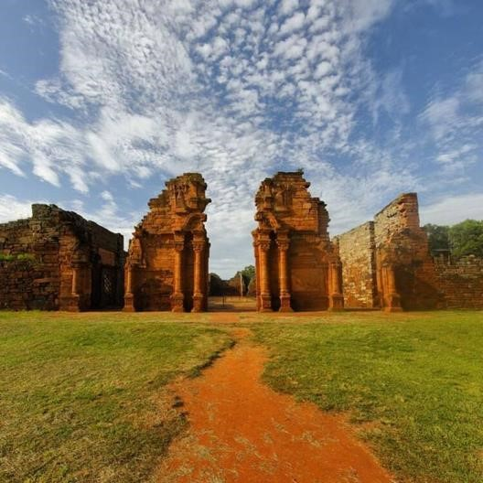
Jesuit Missions (Argentina & Brazil)
Date of Inscription:
Criteria:
Reason:

Link:

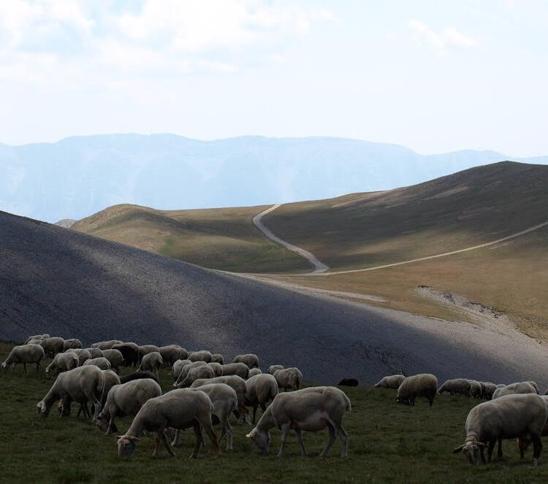
Madriu-Perafita-Claror Valley (Andorra)
Date of Inscription:
Criteria:
Reason:

Link:

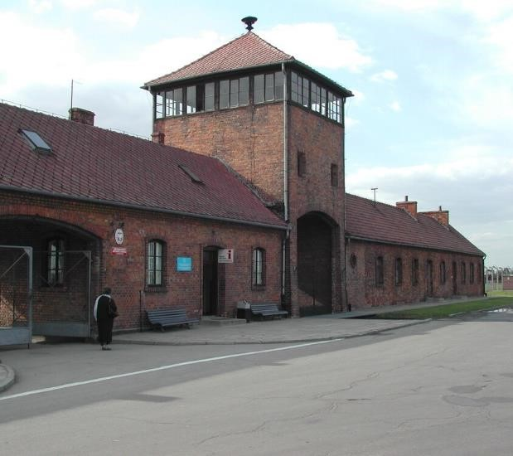
Auschwitz Birkenau (Poland)
Date of Inscription:
Criteria:
Reason:

Link:
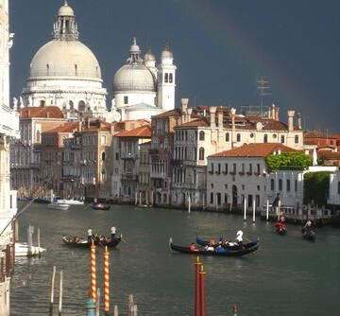
Venice and its lagoon (Italy)
Date of Inscription:
Criteria:
Reason:

Link:

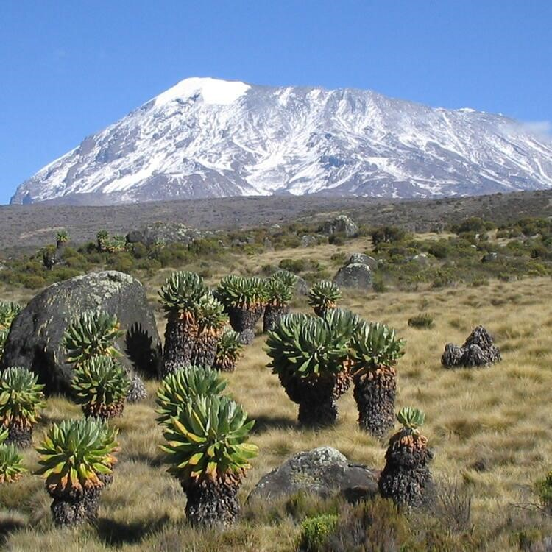
Kilimanjaro National Park (U.R. Tanzania)
Date of Inscription:
Criteria:
Reason:

Link:

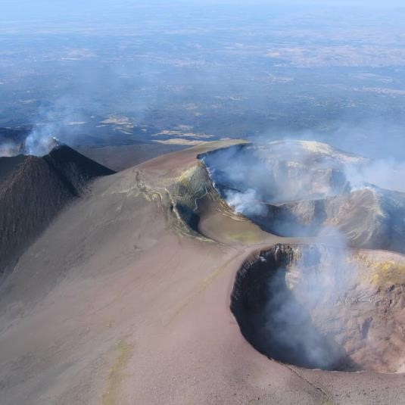
Mount Etna (Italy)
Date of Inscription:
Criteria:
Reason:

Link:

Hyrcanian Forests (Iran)
Date of Inscription:
Criteria:
Reason:

Link:

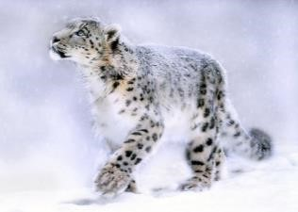
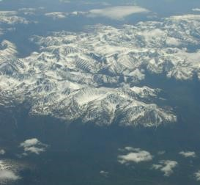
Golden mountains of Altai (Russian Federation)

Date of Inscription:
Criteria:
Reason:

Link:

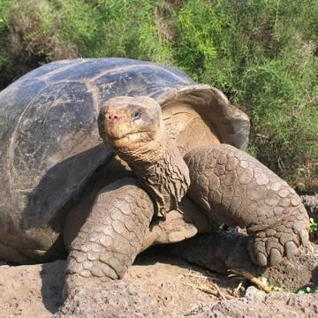
Golden Mountains of Altai (Russian Federation)
Date of Inscription:
Criteria:
Reason:

Link:

