COURSE SCENARIO
UNESCO World Heritage : A Trip Through Mankind’s Shared Inheritance

CLASS 5
TOPIC | UNESCO Inscription Process
LEARNING CONTENT  - DETAILED  CHARACTERISTICS | This topic will describe the process of admission of a new heritage resource in the UNESCO list. Students will understand the political and cultural implications behind each of decisions in the process and how certain countries have been more successful in their politics of heritage conservation than others. Reflection will be carried out regarding those countries whose presence in the list is scarce or almost non-existent. Finally, the lesson will introduce the consultive bodies, namely ICOMOS; UICN and ICCROM, and explain their function.
KEY WORDS | Indicative lists, international cooperation, heritage committees, ICOMOS, UICN, ICCROM
SUGGESTED TOOLS | Interactive lecture  Power-point presentation  Website  Photographs of heritage resources  Discussion  Collaborative work
TIPS /  METHODOLOGICAL  REMARKS  (If applicable) | Students will be encouraged to make their own conclusions about the process of inclusion. Lecturers will foster the exchange of ideas and the points of view of students from different contexts and backgrounds to encourage the discussion upon a wider variety of resources and national contexts.  Students can be encouraged to bring information about heritage resources from their own countries. It is important that in al the discussions examples from the countries of origin of the students are explained.
IMPLEMENTATION  OF THE CLASSES | STEP 1 | The lecturer will define what an indicative list is and will show some examples to the students.
 | STEP 2 | Students will work in groups and will look for the presence of different countries in the list. See Work Card 11 (table 1) In this particular exercise, lecturers are encouraged to alter the work card to add the countries of origin of the students. This will enrich the discussion as students are supposed to have more information about those sites.
 | STEP 3 | Students working in groups will look up for specific data about certain countries. See Work Card 11 (table 2). These countries are interesting as their implication and number of applications have much varied through time.
 | STEP 4 | There will be an open discussion about their findings. This exercise will help students to understand specific strategies carried out by countries to maintain their influence of the list.
 | STEP 5 | Finally, students will be given the name of the consultive bodies, and they will be asked to look for information about them on the web. They will have to fill out a table that is provided in Work Card 10.
 | ETC. | Students will share their findings with the other students.

ADDITIONAL MATERIAL 1 WORK CARD (Citizen Kane)

WORK CARDS
UNESCO WORLD HERITAGE: A TRIP THROUGH MANKIND’S SHARED INHERITANCE

WORK CARD 5: Citizen Kane

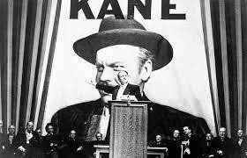
- Watch the movie “Citizen Kane” at home:
https://youtu.be/74ol6mKC3aY

“Legendary was Xanadu, where Kubla Khan decreed his
stately pleasure dome. Today, almost as legendary is
Florida’s Xanadu, the world’s largest private pleasure
ground.”

- Then, answer the following questions.
- Who directed the film, Citizen Kane?

- What is the main theme or central message of Citizen Kane?

- How does Citizen Kane explore the themes of power, wealth, and the American Dream?

- How does Citizen Kane’s representation of European heritage compare to its depiction of American heritage?

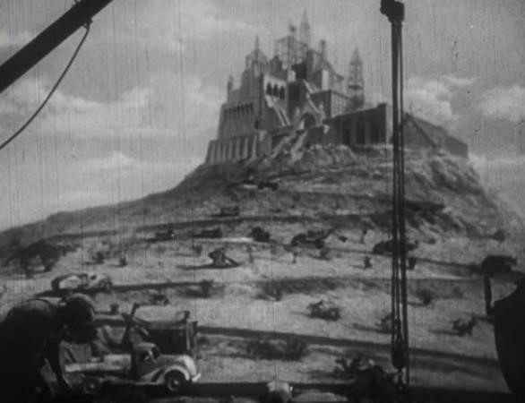
- Read the Newsreel Narrator’s comment and explain heritage’s role in the construction of Citizen Kane’s persona.
Legendary was Xanandu where Kubla
Khan decreed his stately pleasure dome.
Today, almost as legendary is Florida’s
Xanadu, world’s largest private pleasure
ground. Here, on the deserts of the
Gulf Coast, a private mountain was
commissioned and successfully built.
One hundred thousand trees, twenty
thousand tons of marble are the
ingredients of Xanadu Mountain. Contents of Xanadu’s palace: paintings, pictures, statues, the very stones of many another palace – a collection of everything so big it can never be catalogued or appraised, enough for ten museums – the loot of the world.
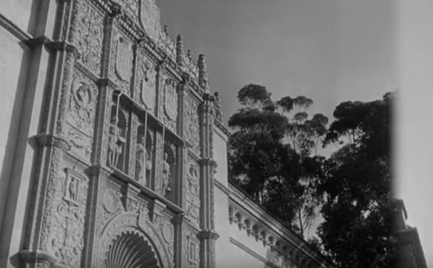
Xanadu’s livestock: the fowl of the air, the fish of the sea, the beast of the field and jungle. Two of each, the biggest private zoo since Noah. Like the pharaohs, Xanadu’s landlord leaves many stones to mark his grave. Since the pyramids, Xanadu is the costliest monument a man has built to himself. Here in Xanadu last
week, Xanadu’s landloard was laid to rest: a potent figure of our century, America’s Kubla Khan, Charles Foster Kane.

