COURSE SCENARIO
UNESCO World Heritage: A Trip Through Mankind’s Shared Inheritance

CLASS 3
TOPIC | 1972 UNESCO Convention. Its origins and evolution
LEARNING CONTENT  - DETAILED  CHARACTERISTICS | This topic raises ethical questions about the preservation of heritage and the participation of other countries. In particular, the point is to present the foundation of the 1972 in the context of global heritage conservation. Although our current understanding of preservation differs significantly from the tenets that sustained 1972 convention, the point is to understand the historical context when it was created and the historical evolution of the concept. Ultimately, the reflection also must be focused on the future developments of heritage conservation.
KEY WORDS | UNESCO list, cultural imperialism, cultural appropriation, ethics.
SUGGESTED TOOLS | Interactive lecture  Power-point presentation  Citizen Kane movie (flipped-classroom methodology)  Discussion  Collaborative learning
TIPS /  METHODOLOGICAL  REMARKS  (If applicable) | Students must watch the movie Citizen Kane at home. Students will need internet access to do the WebQuest. Some of these activities can be prepared before-hand at home (flipped-class methodology)
IMPLEMENTATION  OF THE CLASSES | STEP 1 | As a warming-up, the lecturer will start the lesson asking the students questions about several Egyptian monuments and where they are now. Then, she will explain what happened with Egyptian heritage during the construction of Aswan High Dam.
 | STEP 2 | Students must have been watched Citizen Kane at home. Following Work Card 6, a debate will be opened about the appropriation of heritage shown in the film.
 | STEP 3 | The lecturer will show the students several examples of world heritage that it is not preserved in the countries of origin.
 | STEP 4 | The lecturer will introduce the following section by making the students reflect about the pros and cons of moving heritage to other countries for its preservation. Students will do a WebQuest about the concepts of heritage appropriation and cultural imperialism. See Work Card 5
 | STEP 5 | The lecturer will finish the lesson by presenting the 1972 Convention, explaining its origins of the list and the
 |  | motivation behind establishing a set of criteria to preserve world heritage.

ADDITIONAL MATERIAL 1 WORK CARD (The Constitution of UNESCO)

WORK CARDS
UNESCO WORLD HERITAGE: A TRIP THROUGH MANKIND’S SHARED INHERITANCE

WORK CARD 3: The Constitution of UNESCO

- Listen and read the following discourse: https://fb.watch/kPB_movZBM/
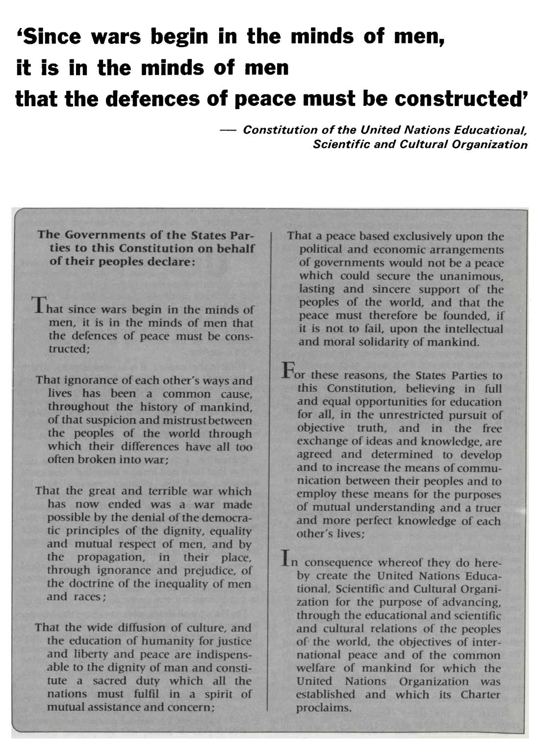

- Underline three key sentences and discuss them with your partners.

