COURSE SCENARIO
UNESCO World Heritage: A Trip Through Mankind’s Shared Inheritance

CLASS 10
TOPIC | Intangible Heritage and the reasons to safeguard it.
LEARNING CONTENT  - DETAILED  CHARACTERISTICS | This lesson addresses the issue of how intangible heritage has become an essential element in the World Heritage List. The lesson starts with a historic review of the conventions and decisions that facilitated the inclusion of intangible and living culture under the protection of the world heritage list. Then, it arises critical questions about the conservation of this type of heritage what and how to conserve it and the implications that this safeguarding process imposes on the people and cultures.
KEY WORDS | Living heritage, intangible heritage, cultural heritage
SUGGESTED TOOLS | Interactive lecture  Power-point presentation  Videos and readings about Intangible Heritage The document of 2003 World Heritage Convention.  Discussion  Group work
TIPS /  METHODOLOGICAL  REMARKS  (If applicable) | It is important to adapt Step 1 and make a careful selection of the extracts to be watched or read in class as, there must be enough time for the exercises.
IMPLEMENTATION  OF THE CLASSES | STEP 1 | The lecturer introduces the 2003 Convention and sets its historical context. Then, the students watch a couple of videos that summarize the importance of this convention that highlights the main advances that are introduced in the document. The students will read some extracts from the document.
 | STEP 2 | After the reading and the videos, students are asked to complete an exercise on different terms that have been mentioned in the previous activity. The point is to elicit the differences between the terms. See Work Card 19.
 | STEP 3 | The lecturer opens a debate about intangible heritage and encourage the students to give examples from their countries of origin. The debate must be directed at the end towards the reasons why the students think that this heritage should be safeguarded.
 | STEP 4 | The teacher will summarize the final objectives of 2003  Convention. Then, on the UNESCO website, students will be instructed to look for different state parties’ opinions about the safeguarding of intangible heritage sites. See Work Card 20.

ADDITIONAL MATERIAL 1 WORK CARD (Consultive Bodies)

WORK CARDS
UNESCO WORLD HERITAGE: A TRIP THROUGH MANKIND’S SHARED INHERITANCE

WORK CARD 10: Consultive Bodies

- Look for information about the following Consultive Bodies:
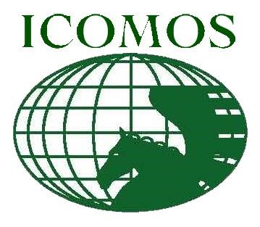
Full name:
Foundation Year:
Headquarters Address (country):
Functions:
Full

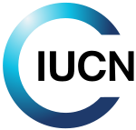
Full name:
Foundation Year:
Headquarters Address (country):
Functions:
Full

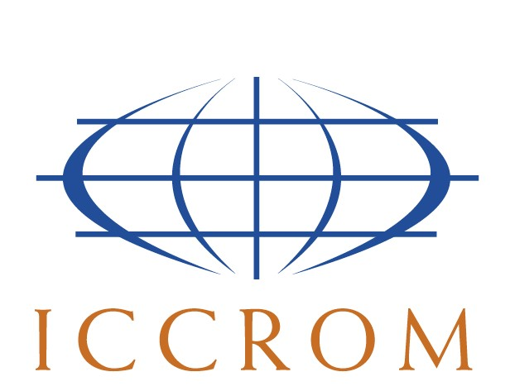
Full name:
Foundation Year:
Headquarters Address (country):
Functions:
Full

