COURSE SCENARIO
UNESCO World Heritage : A Trip Through Mankind’s Shared Inheritance

CLASS 1
TOPIC | Heritage, a socio-cultural construct (construction and values)
LEARNING CONTENT  - DETAILED  CHARACTERISTICS | This topic focuses on the definition of heritage as a social construct. It emphasises that there is not a single unmovable definition and that issues such as politics, culture and history have always determined our vision and conceptualisation of heritage.
KEYWORDS | Heritage, culture, values
SUGGESTED TOOLS | Interactive lecture  Power-point presentation  Videos and readings about the concept of heritage  Handouts for analysis in groups  Discussion
TIPS /  METHODOLOGICAL  REMARKS  (If applicable) | The videos and reading selected about the concept of heritage should show different viewpoints.  We suggest a flipped-classroom methodology for the videos and readings, so the class time is devoted to discussion and analysis.
IMPLEMENTATION  OF THE CLASSES | STEP 1 | Firstly, the concept of social construction is introduced. Then students watch a video that explain how heritage is defined that opens the following discussion. See Work Card 1.
 | STEP 2 | A discussion is open focusing on the elements a society would like to be preserved.
 | STEP 3 | The three types of traditional heritage are presented: historical, artistic, and cultural. The lecturer makes the students reflect about the evolution of these concepts from the early conception of heritage based on its aesthetic value. The lecturer implicitly can try to elicit the criteria implied in the selection of heritage:  - Age  - Function  - Unique value /exclusivity  - Invested time and work.
 | STEP 4 | The lecturer introduces the values of heritage: Sociocultural, Historic. Cultural Symbolic, Social, Religious, Aesthetic and Use.
 | STEP 5 | The students must analyse a heritage element by applying the above-mentioned values and reflect about the value of that particular element for the society. See Work Card 2.

ADDITIONAL MATERIAL 1 WORK CARD (The Value of Heritage)

WORK CARDS
UNESCO WORLD HERITAGE: A TRIP THROUGH MANKIND’S SHARED INHERITANCE

WORK CARD 1: Video and questions, “The Value of Heritage.”

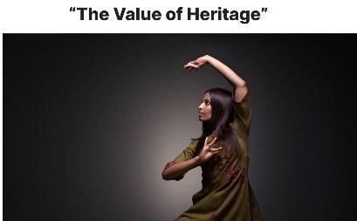

Watch the video “The Value of Heritage” from the UNESCO
webpage and answer the following questions:

https://youtu.be/K1_f-GqaHHo
Figure 1: The Value of Heritage.
Source: https://whc.unesco.org/en/news/1592

- Do you have childhood memories in heritage sites? Which ones are they?

- Why do those scenes remain in your memory?

- Do you feel attached to those places? Why?

- In the future, will you bring your (future) partner of future kids to that site?

- What will you like them to discover there?

