 | Gender Equality in Society
 | CLASS 7 (Scenario 7)
TOPIC | Gender and social space
LEARNING CONTENT - DETAILED CHARACTERISTICS | In this lesson, the students are provided with basic vocabulary related to the topic of gender and space. They also write a short paragraph which describes femininity and masculinity places. The students are also engaged in a debate which mainly deals with choosing the best city policy and protect of women.  During the debate, the students practise expressing arguments, improve their level of politeness and hone their collaborative skills.  Gender space refers to the myriad ways in which space in all its forms - material, discursive, metaphorical, emotional, and the like - is produced by gender norms and relationships. As a result, students learn to see the complexity of the urban processes that shape the quality of life of women and men.
KEY WORDS | space, place, gender, femininity, masculinity
SUGGESTED TOOLS | Teams, Google Doc., padlet.com
TIPS / METHODOLOGICAL REMARKS  (if applicable) | Teams  Peer to peer (in TMs room)  Ideally designed for a maximum of 20 students, the class can be done with a larger number of students. However, the discussions/debates are not as effective as in larger classes and the central activity is on the shoulders of the teacher all the time.
IMPLEMENTATION OF THE CLASSES | STEP 1 | Students are asked about examples of male and female spaces (Work card 1). Each student does it him/herself. Then, they compare their own examples and those of their colleagues (peer-to-peer). Finally, what is common in the group, students try to justify and criticize from the perspective of the genderization process.
 | STEP 2 | The students explain the meaning of the words “gendered space” and then discuss experiences of inclusion and exclusion in space.
 | STEP 3 | The students are divided into groups of 3 or 4 and discuss the following questions:  Which means "androcentrism in urban space" and show examples based on your city / country  What are the negative phenomena related to gender discrimination in urban space?  What changes in the future (as a woman / man) would you like to make in the urban space? Why?  Do you think urban space is safe for women? Why?  Students are reminded to listen carefully to their peers and take notes as they will be asked to present their peers' views to the rest of the class.
 | STEP 4 | When the discussions have ended, the teacher asks a few students to present their peers’ opinions to the rest of the students.
 | STEP 5 | Work card 2  Students are asked to name the phenomenon illustrated in the photos (individual work). The teacher then divides the students into three groups and gives each group the task of creating a definition:  1 group - man spreading;  2 group - gendered space;  3 group - androcentrism.
 | STEP 6 | All students watch the film and then answer the teacher's question:  Do they see such situations?  How do they think, what does the character feel?  https://www.youtube.com/watch?v=b1XGPvbWn0A  Finally, all watch the last film and discuss manspreading in policy:  https://www.youtube.com/watch?v=trsfoQlM0ts&t=49s (from 7:20)
ADDITIONAL MATERIALS | 1 WORK CARD | Gender and space
 | 2 WORK CARD | Gender and space_Pictures

WORK CARD 1 | GENDER AND SPACE
TASK | Please, replace:  3 male spaces  ………………………………………………………………………………………………..………………..  ………………………………………………………………………………………………..………………..  ………………………………………………………………………………………………..………………..  3 female spaces  ………………………………………………………………………………………………..………………..  ………………………………………………………………………………………………..………………..  ………………………………………………………………………………………………..………………..  Compare your answers with those of your friends.  Find the similarities  ………………………………………………………………………………………………..………………..  ………………………………………………………………………………………………..………………..  ………………………………………………………………………………………………..………………..  Make a list of the characteristics that distinguish male and female spaces  ………………………………………………………………………………………………..………………..  ………………………………………………………………………………………………..………………..  ………………………………………………………………………………………………..………………..  ………………………………………………………………………………………………..………………..  ………………………………………………………………………………………………..………………..  ………………………………………………………………………………………………..………………..

WORK CARD 2 | GENDER AND SPACE_PICTURES
TASK | What phenomena are illustrated by the photos?
1  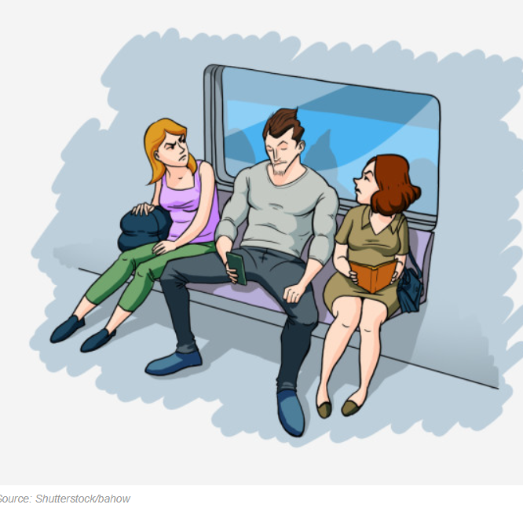 | 2  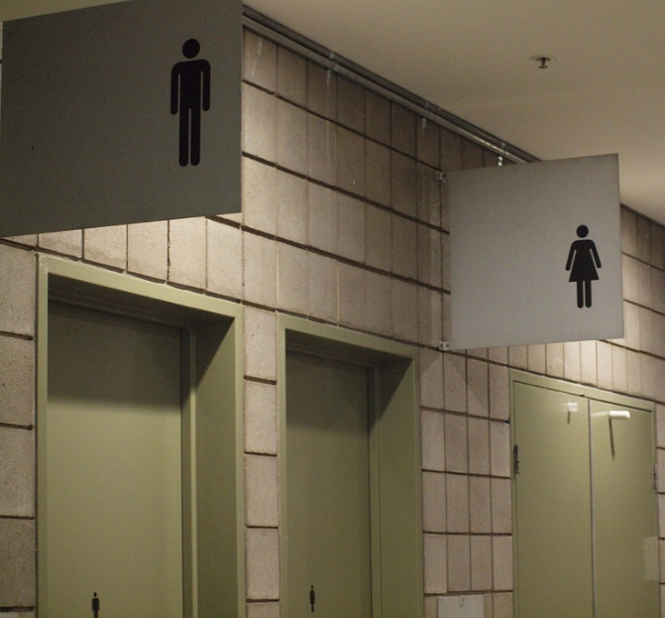 | 3  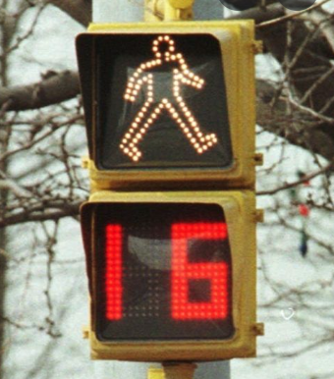
Choose from below:
1.Man spreading
2. Woman spreading
3. Gendered space
4. Androcentrism
5. Femininity space
6. Street harassment

