 | Gender Equality in Society
 | CLASS 6 (Scenario 6)
TOPIC | Gender, education and development
LEARNING CONTENT - DETAILED CHARACTERISTICS | - Increasing students' knowledge of gendered education;  - introducing a gender perspective as an explanation for inequalities in education;  - explain what gender stereotypes hinder girls' education;  - familiarizing students with positive examples of breaking down barriers in education.  During the debate, the students practise expressing arguments, improve their level of politeness and hone their collaborative skills.
KEY WORDS | gender, education, gap, inequality
SUGGESTED TOOLS | Teams, Google Doc., padlet.com
TIPS / METHODOLOGICAL REMARKS  (if applicable) | Content analysis  Analysis of statistical data  Lecture  Discusses  Group work  Ideally designed for a maximum of 20 students, the class can be done with a larger number of students. However, the discussions/debates are not as effective as in larger classes and the central activity is on the shoulders of the teacher all the time.
IMPLEMENTATION OF THE CLASSES | STEP 1 | Classes begin with a search for sex-disaggregate data in education on the world. Aim is analysis of statistical data on the subject of gender gap in schools around the world, and explain how has the picture changed in recent years?  (Source: UNESCO https://unesdoc.unesco.org/ark:/48223/pf0000212715).  The data collected shows the differences between continents and countries. They also testify to the exclusion of girls from the education system in many regions of the world.  Group discussion
 | STEP 2 | Then, students analyse the types of barriers to access to education described in the literature:  https://www.researchgate.net/figure/Barriers-to-and-enablers-of-girls-education_fig1_327281380
 | STEP 3 | The one of the most important reason of differences in educate inequality is gender. Therefore, the teacher ought to focus mainly on its role. When the gender is mentioned, the students are asked a question: Which countries do you think society use gender as a barrier in access to education? Why?  Students do not immediately answer the questions; they are divided into groups of two, three or four. Within five minutes, everyone in the group should give their opinion. (Each group has its own breakout room.) Afterwards, the students present their opinions to all their classmates.
 | STEP 4 | Then, students analyse statistical data of gender gap in education in their country, based on:  https://eige.europa.eu/gender-statistics/dgs/browse/ta/ta_eductrain  compare with the average EU result and comment.
 | STEP 5 | Work card 1  Teacher describes five examples of gender stereotypes and asks: what do you think about the negative consequences of using gender stereotypes in education?  Students are divided into five groups and prepare opinions on the chosen myth.
 | STEP 6 | Work card 2  Malala Yousafzai/ Greta Thunberg/Hermiona Granger as an example for girls/students.  Students are divided into three groups and each of them is responsible to describe one character.
ADDITIONAL MATERIALS | 1 WORK CARD | Myths in education
 | 2 WORK CARD | Gender and education

WORK CARD 1 | MYTHS IN EDUCATION
INTRODUCTION | Myths in education about gender stereotypes might include:  Myth 1: boys are slower than girls to read  Myth 2: girls are naturally quieter than boys  Myth 3: science and maths are boys’ subjects  Myth 4: boys are better at sport than girls  Myth 5: boys and girls can’t work together or be friends with each other…
TASK | What are the negative consequences of using these myths? What do you think?  Myth 1:  ………………………………………………………………………………………………..………………..  Myth 2:  ………………………………………………………………………………………………..………………..  Myth 3:  ………………………………………………………………………………………………..………………..  Myth 4:  ………………………………………………………………………………………………..………………..  Myth 5:  ………………………………………………………………………………………………..………………..

WORK CARD 2 | GENDER AND EDUCATION
What in Hermione Granger's story might inspire schoolgirls?
…………………………………………………………………………………………………………………
…………………………………………………………………………………………………………………
…………………………………………………………………………………………………………………
…………………………………………………………………………………………………………………
…………………………………………………………………………………………………………………
…………………………………………………………………………………………………………………
…………………………………………………………………………………………………………………
…………………………………………………………………………………………………………………
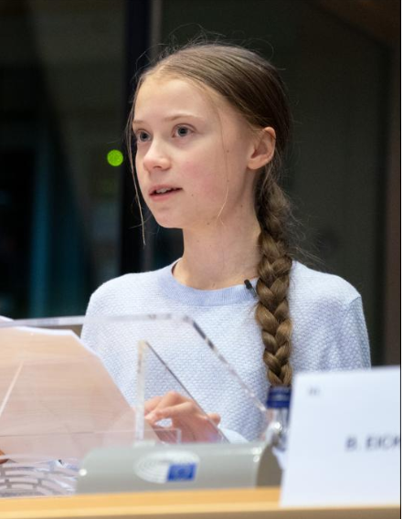 | What in Greta Thunberg’s story might inspire schoolgirls?  …………………………………………………………………………………………………………………  …………………………………………………………………………………………………………………  …………………………………………………………………………………………………………………  …………………………………………………………………………………………………………………  …………………………………………………………………………………………………………………  …………………………………………………………………………………………………………………  …………………………………………………………………………………………………………………  …………………………………………………………………………………………………………………
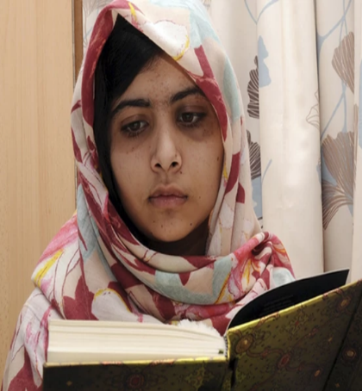 | What in Malala Yousafzai’s story might inspire schoolgirls?  …………………………………………………………………………………………………………………  …………………………………………………………………………………………………………………  …………………………………………………………………………………………………………………  …………………………………………………………………………………………………………………  …………………………………………………………………………………………………………………  …………………………………………………………………………………………………………………  …………………………………………………………………………………………………………………

