 | Gender Equality in Society
 | CLASS 5 (Scenario 5)
TOPIC | Gender in mass media and pop culture
LEARNING CONTENT - DETAILED CHARACTERISTICS | - Increasing students' knowledge of the influence of the mass media on the shaping and dissemination of gender models;  - introducing a gender perspective to knowledge of mass communication;  - explain how the mass media affects the social life of women and men;  - familiarizing students with the results of media research;  - knowing mass media as gender socialisation agents.  During the debate, the students practise expressing arguments, improve their level of politeness and hone their collaborative skills.
KEY WORDS | mass media, gender, sexism, androcentrism
SUGGESTED TOOLS | Power point, Youtube, Menimeter.com, Google Doc.
TIPS / METHODOLOGICAL REMARKS  (if applicable) | Peer-to-peer learning  Direction discussion  Interactive lecture  Ideally designed for a maximum of 20 students, the class can be done with a larger number of students. However, the discussions/debates are not as effective as in larger classes and the central activity is on the shoulders of the teacher all the time.
IMPLEMENTATION OF THE CLASSES | STEP 1 | At the beginning, the teacher presents paradigm of gender media studies, and emphasizes the specificity theory takes gender seriously – as a factor that structures identity and experiences – without assuming permanent or static gender differences.
 | STEP 2 | The teacher divides the students into four groups for each of them to analyze the gap Global Media Monitoring Project (GMMP) for the gender gap.  https://whomakesthenews.org/ Each group makes list the differences between male and female roles. Within five minutes, everyone in the group should give their opinion. (Each group has its own breakout room.) Afterwards, the students present their opinions to all their classmates.
 | STEP 3 | Then, each group analyzes a sample of the news program (internet version) according to the categorization key (Work card 1). Each group analyzes a sample of the news program (web version) according to the categorization key. And then, the group answers the question:  If there is a gender difference, and if so, what is it about?  Interpret the results.
 | STEP 4 | Another analysis includes an excerpt from a popular movie. Students still working in groups research the film according to Bechdel test (Work card 2) but two groups analyse women, and other two groups- men.  Afterwards, the students present their results to all their classmates.
 | STEP 5 | In finally, teachers invite all to watch one of these films about Mass media and gender stereotypes:  https://www.youtube.com/watch?v=koPmuEyP3a0&t=12s  https://www.youtube.com/watch?v=-5gKmFmW2o0  https://www.youtube.com/watch?v=VrQ2E2ERwFE  https://www.youtube.com/watch?v=ckN_LskQsRQ  https://www.youtube.com/watch?v=vE9IbsRgZ38  https://www.youtube.com/watch?v=tm81_nxwUvY
ADDITIONAL MATERIALS | 1 WORK CARD | News program
 | 2 WORK CARD | Bechdel test

WORK CARD 1 | NEWS PROGRAM
TASK | Watch the news program for the following message elements:  - Who presents the program: male or female?  woman man  - How many experts were present during the program and how many women were among them?  woman man  - What did the performing women and men talk about?  topic woman man  health  education  economy  elections  military conflict  environmental protection  ……  - Who were the men and women shown in the program?  roles woman man  parent  politician  teacher  solder  scientist  writer  ……….

Compare the differences between men and women in the mass media.
Do you see the influence of gender stereotypes on the way women and men are portrayed? If so, indicate those results of your analysis that indicate it.
…………………………………………………………………………………………………………………
…………………………………………………………………………………………………………………
…………………………………………………………………………………………………………………
…………………………………………………………………………………………………………………
…………………………………………………………………………………………………………………
…………………………………………………………………………………………………………………

WORK CARD 2 | BECHDEL TEST
INTRODUCTION | The Bechdel test aims to bring attention to and address gender inequality in media.
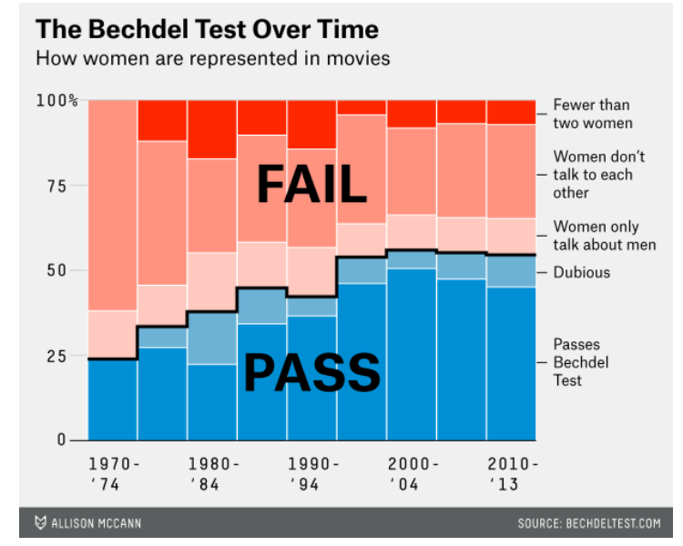
https://fivethirtyeight.com/features/the-dollar-and-cents-case-against-hollywoods-exclusion-of-women/
TASK | - Analyse one episode of your favourite series or movie, based on the Bechdel Test:  - step: It has to have at least two [named] women in it  - step: Who talk to each other  - step: About something besides a man  - Repeat these steps for the male characters  - Compare results.

https://bechdeltest.com/
https://psycnet.apa.org/doiLanding?doi=10.1037%2Fppm0000436

