 | Gender Equality in Society
 | CLASS 3 (Scenario 3)
TOPIC | Gender Identity
LEARNING CONTENT - DETAILED CHARACTERISTICS | - Increasing students' knowledge of sources of identity, the process of building identity, barriers and opportunities etc.;  - introducing a gender perspective to knowledge of binary and non-binary identity;  - explain how gender affects social and individual life;  - familiarizing students with socio-cultural differences in gender identity.  During the debate, the students practise expressing arguments, improve their level of politeness and hone their collaborative skills.  The teacher's attention is focused on the topic of gender identity. It defines deeply ingrained inner feelings about whether someone is male or female, both or not. The gender identity can be the same as the sex assigned at birth (cisgender) or not (transgender). The teacher emphasizes that some people identify as a man (or boy) or woman (or girl) but also as a non-binary person.
KEY WORDS | identity, binary, no-binary person, same, self
SUGGESTED TOOLS | Power point, Youtube, Menimeter.com, Google Doc.
TIPS / METHODOLOGICAL REMARKS  (if applicable) | Peer-to-peer learning  Direction discussion  Interactive lecture  Ideally designed for a maximum of 20 students, the class can be done with a larger number of students. However, the discussions/debates are not as effective as in larger classes and the central activity is on the shoulders of the teacher all the time.
IMPLEMENTATION OF THE CLASSES | STEP 1 | The teacher introduces the definition of "identity," the history of this concept in social sciences and the distinction between idem and ipse identity. Teacher can help with a short film  https://www.youtube.com/watch?v=PaA0mLVQd3k
 | STEP 2 | Then, the students are given TST forms and asked to complete the test themselves (Work card 1). After 10 minutes, the teacher gives the students instructions on how to interpret the answers.
 | STEP 3 | On the basis of the completed test, the students have to complete the next task:  1) Look at list and see how many personal traits and social roles mentioned are appropriate, mainly for one gender or the other(s).  2) Circle the traits on list associated with gender-role expectations.  3) Try to recall when first started to define in terms of such traits as these ones.  4) Now cross out list of the traits related to gender-role expectations.  5) Then compare the answers that different people give.  (Work card 1).
 | STEP 4 | In the second part of the lesson, students guess the identities of the characters in the photo (Work card 2).
 | STEP 5 | After students describe the person shown in the photo according to the criteria listed, they compare themself description with that of other and talk about the differences and similarities in their descriptions (Work card 2).
ADDITIONAL MATERIALS | 1 WORK CARD | Gender identity
 | 2 WORK CARD | Gender identity_Pictures

WORK CARD 1 | GENDER IDENTITY
TASK | WHO AM I?  There are twenty numbered blanks on the page below. Please write twenty answers to the simple question “Who am I?” in these blank. Just give twenty different answers to this question; answer as if you were giving the answers to yourself- not someone else. Write your answers in the order that they occur to you. Don’t worry about logic or “importance.” WHO AM I?
1. ______________________________________________________________________________

2. ______________________________________________________________________________

3. ______________________________________________________________________________

4. ______________________________________________________________________________

5. ______________________________________________________________________________

6. ______________________________________________________________________________

7. ______________________________________________________________________________

8. ______________________________________________________________________________

9. ______________________________________________________________________________

10. _____________________________________________________________________________

11. _____________________________________________________________________________

12. _____________________________________________________________________________

13. _____________________________________________________________________________

14. _____________________________________________________________________________

15. _____________________________________________________________________________

16. _____________________________________________________________________________

17. _____________________________________________________________________________

18. _____________________________________________________________________________

19. _____________________________________________________________________________

20. _____________________________________________________________________________

Mutual:
The TST (Twenty Statement Test) is a long-standing social psychological "test" for use in regards to one's "sense of self." In particular, it helps identify those self-designations which may be due more to our "roles" than who we really are or could be.
The list of answers to the question “Who Am I?” probably include examples of each of the following four types of responses:
- Physical description: I’m thin, I have long hair… etc.
- Social Roles: student, son, member of the football team… etc.
- Personal Traits: “I’m impulsive... I’m smart... etc.
- Existential statements: "I’m a human being", I’m an atheist... etc.
One way of becoming more self-aware is to notice the words you use to describe yourself. Some important facts about our “public selves” are revealed on the official forms we fill out, when we give our name, age, birthplace, marital status, etc. Other, more subtle aspects of our self-images are revealed in the way we introduce ourselves, or the things we choose to reveal in the first few minutes of a new acquaintance. As a result, the answers you just jotted down in response to the question “Who Am I?” provide an outline for an autobiography and give some insights about your self-image.
 | Since an important aspect of self-image is one’s gender-role identification, your answers can also be used to probe when and under what circumstances you began to identify yourself as male or female or non-binary or… etc.
To use your list to explore the process of gender-role socialization, you might do some of the following:
- Look at your list and see how many personal traits and social roles you mentioned are appropriate, mainly for one gender or the other(s).
- Circle the traits on your list associated with gender-role expectations.
- Try to recall when you first started to define yourself in terms of such traits as these ones.
……….……………………………………………………………………………………….……
- Now cross out your list of the traits related to gender-role expectations. Would you feel less secure about who you are by relinquishing such characteristics?
…….……………………………………………………………………………………….……
- Then compare the answers that different people give. Do people of certain ages seem to define themselves more or less in terms of gender-specific traits compared to other ages, e.g., your parents' generation? How would you explain those differences?
……….……………………………………………………………………………………….……

WORK CARD 2 | GENDER IDENTITY_PICTURES
INTRODUCTION | Mutual:  - describe the person shown in the photo according to the criteria listed;  - compare your description with that of your friend;  - talk about the differences and similarities in your descriptions.
 | Guess who?
https://www.istockphoto.com/pl/zdj%C4%99cie/stylowa-sportowa-dziewczyna-ta%C5%84cz%C4%85ca-hip-hop-w-stylowych-ubraniach-na-kolorowym-gm1303660344-395049103
Gender: …………………………………………………………………..…………………………………
Age: ……………………………………………………………………..……………………………………
Favourite hobby: …………………………………………………………………………………..……
Favourite music: …………….:………………………………………………………………………….
Favourite food: …………………………………………………………………………………………..
Hair colour: ………………………………………………………………………………………………..
Nationality: ………………………………………………………………………………………………..

Guess who?
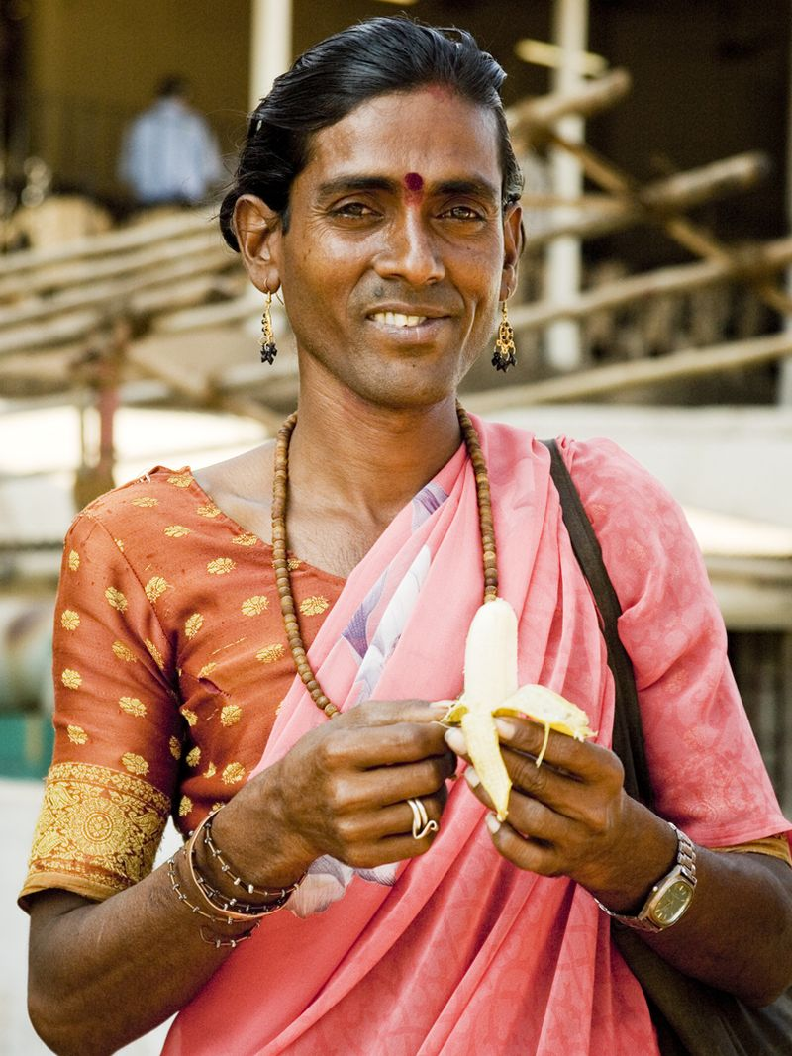
https://pl.wikipedia.org/wiki/Hid%C5%BAra#/media/Plik:Hijra.jpg
Gender: …………………………………………………………………..…………………………………
Age: ……………………………………………………………………..……………………………………
Favourite hobby: …………………………………………………………………………………..……
Favourite music: …………….:………………………………………………………………………….
Favourite food: …………………………………………………………………………………………..
Hair colour: ………………………………………………………………………………………………..
Nationality: ………………………………………………………………………………………………..

Guess who?
https://www.istockphoto.com/pl/zdj%C4%99cie/portret-kaukaskiego-m%C4%99%C5%BCczyzny-wyizolowany-na-niebieskim-tle-studia-w-neonowym-gm1208845898-349575863
Gender: …………………………………………………………………..…………………………………
Age: ……………………………………………………………………..……………………………………
Favourite hobby: …………………………………………………………………………………..……
Favourite music: …………….:………………………………………………………………………….
Favourite food: …………………………………………………………………………………………..
Hair colour: ………………………………………………………………………………………………..
Nationality: ………………………………………………………………………………………………..

From Eleen A. Baumann, Richard G. Mitchell, Jr., and Caroline Hodges Persell. 1989. Encountering Society: Student Resource Manual to accompany Persell, Understanding Society, Third Edition. New York: Harper & Row. Exercise 5, “Twenty Statement Test,” p. 305.

