 | Gender Equality in Society
 | CLASS 15 (Scenario 15)
TOPIC | Gender Equality Plans
LEARNING CONTENT - DETAILED CHARACTERISTICS | Class on gender equality plans will culminate the entire course on gender equality in society. Their role will be to draw attention to the importance of such program solutions in the process of shaping the conditions of actual gender equality in various areas (especially research, innovation, and academic education, however, in the nearest future, also in business and politics at multiple levels, etc.). During the class, students can learn about crucial EU documents based on which stakeholders (research organizations, universities and public bodies) have (or want to have) EU funds and are obliged to have the GEP in force. They will also be familiarized with minimum mandatory process-related requirements and recommended content-related requirements. The teacher, basin on the GEAR tool and their own experience, will also discuss the process of creating this document.
KEY WORDS | gender equality plan, target/group, dedicated resources, actions, participatory formula
SUGGESTED TOOLS | laptop, projector, PPT, Youtube, flipchart/schoolboard
TIPS / METHODOLOGICAL REMARKS  (if applicable) | - Preferred formula: f2f;  - Flipped class for the purposes of statistical data (SCIENCE & HIGHER EDUCATION SECTOR);  - Ideally designed for a maximum of 20 students, the class can be done with a larger number of students. However, the discussions are not as effective as in larger classes and the central activity is on the shoulders of the teacher all the time;  - The class requires a min. B1 level of English proficiency.
IMPLEMENTATION OF THE CLASSES | STEP 1 | The classes begin with an overall outline of the EU's Gender Equality Strategy 2020-2025, emphasising research and innovation and the Horizon Europe GEP requirements (see: Work cards 1, 2a and 2b).
 | STEP 2 | Next, the teacher introduces the students to the GEAR tool, explaining what a gender equality plan is and specific steps to be taken to successfully develop, implement and monitor a GEP in an organization (see: Work card 3). She/he will also refer to her/his own experiences in this area (if possible).
 | STEP 3 | At the next stage, students are divided into five teams (following the five areas recommended by the European Commission (1. WLB and organizational culture, 2. gender balance in leadership and decision-making, 3. gender equality in recruitment and career progress, 4. integrating gender dimension into research and teaching content, 5. measures against gender-based violence incl. sexual harassment) and have the task of designing at least three specific activities within a given area for each of the three target groups/dedicated resources (students / academic teachers / management and support staff) actions based on the prepared matrix (see: Work card 4). They have about half an hour to complete this task.
 | STEP 4 | Afterwards, the results of each group's work are discussed together, and the proposed solutions are improved and corrected.
 | STEP 5 | Finally, a GEP prototype is created on the basis of the components, which was to emphasize the role of the group process and participatory formula in the development of such solutions.
ADDITIONAL MATERIALS | 1 WORK CARD | Gender Equality Plans
 | 2a WORK CARD | Gender Equality Plans_Documents
 | 2b WORK CARD | Gender Equality Plans_Documents
 | 3 WORK CARD | GEAR tool
 | 4 WORK CARD | Gender Equality Plans

WORK CARD 1 | GENDER EQUALITY PLANS
COMMUNICATION FROM THE COMMISSION TO THE EUROPEAN PARLIAMENT, THE COUNCIL, THE EUROPEAN ECONOMIC AND SOCIAL COMMITTEE AND THE COMMITTEE OF THE REGIONS
A Union of Equality: Gender Equality Strategy 2020-2025
available at: https://eur-lex.europa.eu/legal-content/EN/TXT/?uri=CELEX%3A52020DC0152
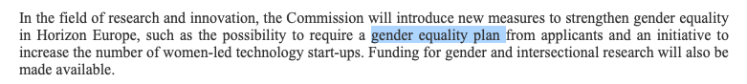

WORK CARD 2a | GENDER EQUALITY PLANS_DOCUMENTS
Horizon Europe, Work Programme 2021-2022
13. General Annexes (European Commission Decision C(2022)2975 of 10 May 2022)
available at: https://ec.europa.eu/info/funding-tenders/opportunities/docs/2021-2027/horizon/wp-call/2021-2022/wp-13-general-annexes_horizon-2021-2022_en.pdf
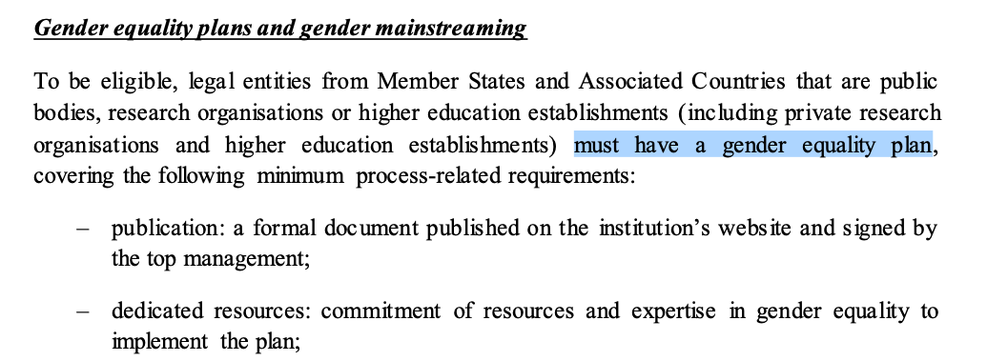
WORK CARD 2b | GENDER EQUALITY PLANS_DOCUMENTS
Horizon Europe guidance on gender equality plans
available at: https://op.europa.eu/en/publication-detail/-/publication/ffcb06c3-200a-11ec-bd8e-01aa75ed71a1
available at: https://eige.europa.eu/gender-mainstreaming/toolkits/gear/horizon-europe-gep-criterion

WORK CARD 3 | GEAR TOOL
GEAR tool
available at: https://eige.europa.eu/gender-mainstreaming/toolkits/gear/step-step-guide
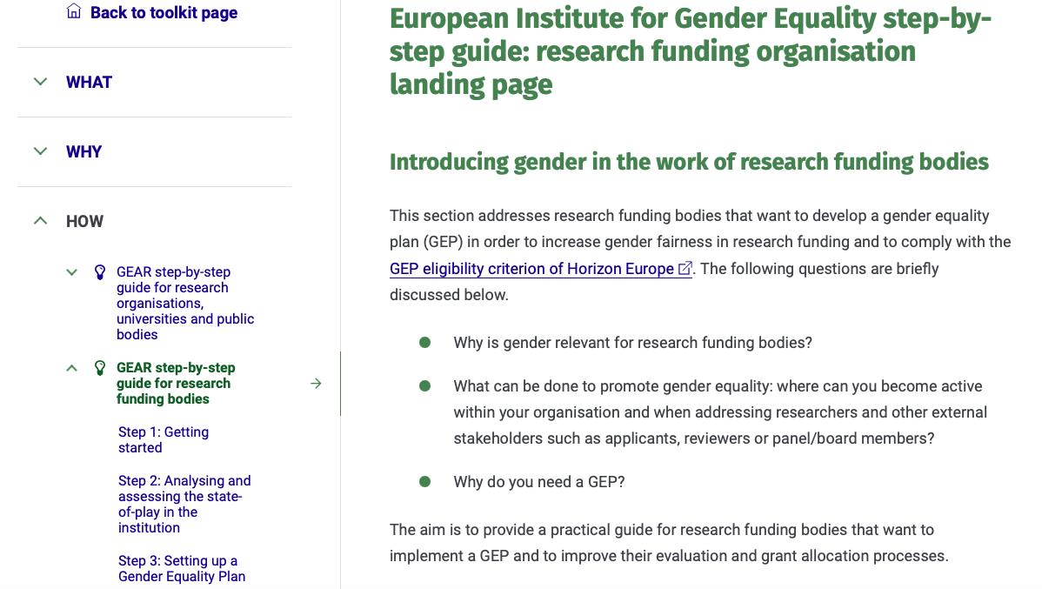

WORK CARD 4 | GENDER EQUALITY PLANS
Matrix (to fill)
available at: https://docs.google.com/document/d/105B2X0XB6-z4mxXspF-HUFtI23dLqAhx/edit?usp=sharing&ouid=105549461712655249048&rtpof=true&sd=true

