 | Gender Equality in Society
 | CLASS 14 (Scenario 14)
TOPIC | Gender (in)equality in private sphere - part 2
LEARNING CONTENT - DETAILED CHARACTERISTICS | The second part of the classes on gender (in)equality in the private sphere will be focused on the third element determining the issue of actual gender equality - the occurrence of violence in the family and violence against women.  Firstly, based on data (prepared by the teacher and students as part of their own work), the phenomenon's scale will be determined.  This, in turn, will provide a basis for identifying existing legal solutions against this phenomenon. The teacher will discuss both the guarantees found in both international law (CEDAW, the Istanbul Convention and the ECHR), as well as the procedures provided by national law (in the case of Poland, this will be the Blue Card procedure and the new rapid response procedure for perpetrators of domestic violence). Anti-examples of behaviours that, in practice, contribute to the maintenance of inequality will also be pointed out.
KEY WORDS | domestic violence, violence against women, psychical violence, mental violence, sexual (including marital rape), economic violence, FGM, early and forced marriages, "honour" crimes, gaslighting, cycles of domestic violence, Blue Card, procedures available to the individuals, Istanbul Convention
SUGGESTED TOOLS | laptop, projector, PPT, Youtube, flipchart/schoolboard
TIPS / METHODOLOGICAL REMARKS  (if applicable) | - Preferred formula: f2f;  - Flipped class for the purposes of statistical data (PRIVATE SPHERE, SAFETY) and identification of reasons why domestic violence victims don't leave (see: Work card 2);  - Ideally designed for a maximum of 20 students, the class can be done with a larger number of students. However, the discussions are not as effective as in larger classes, and the main activity is on the shoulders of the teacher all the time;  - The class requires a min. B1 level of English proficiency.
IMPLEMENTATION OF THE CLASSES | STEP 1 | The class will begin by recalling three key factors that influence de facto gender equality in the family: female labour force participation, the family relations model practised (discussed previously) and the possible incidence of domestic violence and violence against women.
 | STEP 2 | Afterwards, the third determinant of gender equality in the family - the incidence of domestic violence and violence against women - will be discussed.  First, the teacher will ask students to combine the definition with a specific form of violence. Thanks to that, students will know terms such as psychical violence, mental violence, sexual (including marital rape), economic violence, FGM, early and forced marriages, "honour" crimes, gaslighting (see: Work card 1). Then, the teacher will present statistics on the phenomena' incidence, indicating that by its nature, it is severely underestimated. Students will have an opportunity to compare it with their research results in the PRIVATE SPHERE, SAFETY).
 | STEP 3 | Next, the cycles of domestic violence will be discussed (tension build-up phase, acute violence phase, honeymoon phase) and the reasons for the "perpetuation" of the phenomenon. The discussion with students will also be based on their reflections after watching the material about the victims of domestic violence (see: Work card 2).
 | STEP 4 | In the next part of the course, the teacher will present what possibilities of counteracting and punishing the occurrence of domestic violence are provided for by law. In the first place, national solutions will be indicated (in the case of Poland - the Blue Card procedure (see: Work card 3) and the new rapid response procedure for perpetrators of domestic violence). Then, the teacher will present the international guarantees and the related procedures available to the individuals (CEDAW, ECHR), selected ECtHR jurisprudence on the phenomenon (and the consequences of adopting it), and finally, the role of the Istanbul Convention (also known as anti-violence convention) and GREVIO committee reports (see: Work card 4).
 | STEP 5 | As a summary of the classes, the teacher will point out (as a warning) examples of bad practices of states in this area (see: Work cards 5a, 5b and 5c), but also positive initiatives aimed at making society aware of the occurrence of violence against women and domestic violence by addressing this issue in the mass media (Work cards 6a and 6b).
 | STEP 6 | Since the discussed issue may arouse strong emotions, the teacher should provide additional space for students' statements after the end of the class.

ADDITIONAL MATERIALS | 1 WORK CARD | Gender (in)equality in private sphere
 | 2 WORK CARD | Gender (in)equality in private sphere_Video
 | 3 WORK CARD | The Blue Card
 | 4 WORK CARD | Gender (in)equality in private sphere
 | 5a WORK CARD | Gender (in)equality in private sphere_Pictures
 | 5b WORK CARD | Gender (in)equality in private sphere
 | 5c WORK CARD | Gender (in)equality in private sphere_Pictures
 | 6a WORK CARD | Gender (in)equality in private sphere_Video
 | 6b WORK CARD | Gender (in)equality in private sphere_Video

WORK CARD 1 | GENDER (IN)EQUALITY IN PRIVATE SPHERE
TASK | Combine the definition with specific form of violence:
Form of violence | Definition
domestic violence
violence against women
psychical violence
mental violence
sexual violence (including marital rape)
economic violence
FGM
early and forced marriages
"honour" crimes
gaslighting

- any intentional conduct that seriously impairs another person’s psychological integrity through coercion or threats
- all procedures that involve partial or total removal of the external female genitalia, or other injury to the female genital organs for non-medical reasons
- is a form of psychological abuse in which a person or group causes someone to question their own sanity, memories, or perception of reality; people who experience it may feel confused, anxious, or as though they cannot trust themselves
- all acts of physical, sexual, psychological or economic violence that occur within the family or domestic unit or between former or current spouses or partners, whether or not the perpetrator shares or has shared the same residence with the victim
- a violation of human rights and a form of discrimination against women and shall mean all acts of gender-based violence that result in, or are likely to result in, physical, sexual, psychological or economic harm or suffering to women, including threats of such acts, coercion or arbitrary deprivation of liberty, whether occurring in public or in private life
- crimes committed in the name of so-called honour
- any act which causes physical harm as a result of unlawful physical force. Physical violence can take the form of, among others, serious and minor assault, deprivation of liberty and manslaughter
- any sexual act performed on the victim without cons
- marriage of individuals whose level of physical, emotional, sexual and psychosocial development makes them unable to freely and fully consent to marriage
- any act or behaviour which causes economic harm to an individual. Economic violence can take the form of, for example, property damage, restricting access to financial resources, education or the labour market, or not complying with economic responsibilities, such as alimony

WORK CARD 2 | GENDER (IN)EQUALITY IN PRIVATE SPHERE_VIDEO
Why domestic violence victims don’t leave
Video available at: https://www.youtube.com/watch?v=V1yW5IsnSjo&t=2s
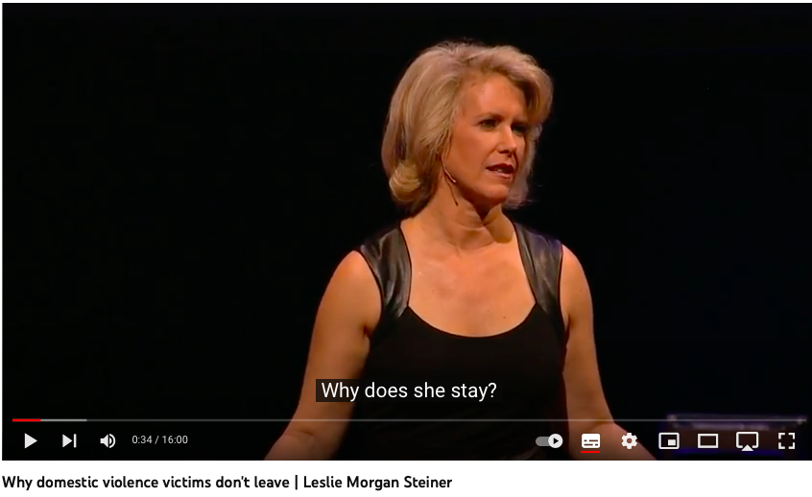

WORK CARD 3 | THE BLUE CARD
https://www.niebieskalinia.info/images/2.06.22_ANG_en_EN.pdf
THE BLUE CARD – B
INFORMATION FOR PEOPLE AFFECTED BY DOMESTIC VIOLENCE (in English)
WORK CARD 4 | GENDER (IN)EQUALITY IN PRIVATE SPHERE
Form and guidance for submitting an individual communication to CEDAW Committee
available at: https://www.ohchr.org/en/documents/tools-and-resources/form-and-guidance-submitting-individual-communication-treaty-bodies

Application form to European Court of Human Rigts and notes for filling in
available at: https://echr.coe.int/Pages/home.aspx?p=applicants/forms&c=

GREVIO Country-monitoring work
https://www.coe.int/en/web/istanbul-convention/country-monitoring-work

WORK CARD 5a | GENDER (IN)EQUALITY IN PRIVATE SPHERE_PICTURES
WORK CARD 5b | GENDER (IN)EQUALITY IN PRIVATE SPHERE
Istanbul Convention: Poland to leave European treaty on violence against women
https://www.bbc.com/news/world-europe-53538205
WORK CARD 5c | GENDER (IN)EQUALITY IN PRIVATE SPHERE_ PICTURES

WORK CARD 6a | GENDER (IN)EQUALITY IN PRIVATE SPHERE_VIDEO
 | https://www.youtube.com/watch?v=7i5kiFDunk8
WORK CARD 6b | GENDER (IN)EQUALITY IN PRIVATE SPHERE_ VIDEO
 | https://www.youtube.com/watch?v=cLd0dN25i5g

