 | Gender Equality in Society
 | CLASS 1 (Scenario 1)
TOPIC | Sex and gender in social sciences - introduction to sociology of gender
LEARNING CONTENT - DETAILED CHARACTERISTICS | - Increasing students' knowledge of differences between sex and gender;  - introducing a gender perspective to knowledge of femininity and masculinity;  - explain how gender affect social life;  - familiarizing students with socio-cultural differences of gender;  - knowing agends of gender socialization.  During the debate, the students practise expressing arguments, improve their level of politeness, and hone their collaborative skills.
KEY WORDS | gender, sex, female, male, femininity, masculinity
SUGGESTED TOOLS | Power point, Youtube, Menimeter.com, Google Doc.
TIPS / METHODOLOGICAL REMARKS  (if applicable) | Flipper class  (https://xyonline.net/sites/xyonline.net/files/2019-08/Davis%2C%20Handbook%20of%20Gender%20and%20Women%27s%20Studies%20-%20Sage%20%282006%29.pdf p.35 The Shadow and the Substance: The Sex/Gender Debate Wendy Cealey Harrison)  Peer-to-peer learning  Direction disciusson  Interactive lecture  Ideally designed for a maximum of 20 students, the class can be done with a larger number of students. However, the discussions/debates are not as effective as in larger classes and the central activity is on the shoulders of the teacher all the time.
IMPLEMENTATION OF THE CLASSES | STEP 1 | At the beginning, all students watch film explaining the differences in conceptualizing the concept of sex and gender.  https://study.com/academy/lesson/sex-and-gender-in-society-differences-preferences-characteristics.html  Then, the teacher divides the students into four groups. Each group is to list the differences between the understanding of these two concepts.
 | STEP 2 | Within five minutes, everyone in the group should give their opinion. (Each group has its own breakout room.) Afterwards, the students present their opinions to all their classmates.
 | STEP 3 | After explaining the basic concepts, the teacher asks you to participate in a mini-survey. Consecutively, he asks three questions:  what features does a woman have?  what features does a man have?  what features does man have?  Students enter three answers each on the mentimeter form.  After completing the task, the teacher shows the results of the whole group and invites them to a focused discussion.  Suggested questions:  Are there features common to a woman and a man? If so, what are they?  Are there features common to a woman and a human? If so, what are they?  Are there common features between a man and a human? If so, what are they?  (Work card 1)  [Group discussion]
 | STEP 4 | After the discussion, the teacher divides the students into four groups. Each group (4-5 people) analyzes the text "Adam" and follows the instructions in Work card 2.  He saves the results of his work.  The group then analyzes the text "Abigail" and writes down the results after 10 minutes.  Finally, each group compares the results of the two analyzes and draws conclusions.  One person from each group presents these conclusions to all. The teacher summarizes this part of the students' work and proposes conclusions.
 | STEP 5 | Finally, the teacher takes up the topic of socio-cultural differentiation of femininity and masculinity and suggests watching a movie:  https://study.com/academy/lesson/sexism-gender-differences-and-contexts.html
 | STEP 6 | After watching the movie, the teacher asks students about their own examples (from travels, other films, books) of different understandings of femininity and masculinity.
ADDITIONAL MATERIALS | 1 WORK CARD | Sex and gender
 | 2 WORK CARD | Femininity Masculinity

WORK CARD 1 | SEX AND GENDER
INTRODUCTION | The teacher asks you to participate in a mini-survey. Consecutively, he asks three questions:  what features does a woman have?  what features does a man have?  what features does man have?  Students enter three answers each on the mentimeter form.  After completing the task, the teacher shows the results of the whole group and invites them to a focused discussion.
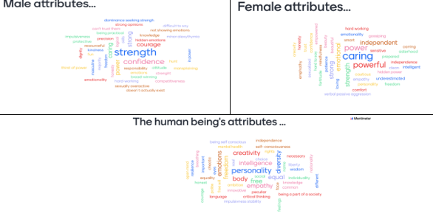
TASK | Suggested questions:  Are there features common to a woman and a man? If so, what are they?  Are there features common to a woman and a human? If so, what are they?  Are there common features between a man and a human? If so, what are they?

WORK CARD 2 | FEMININITY MASCULINITY
TASK | First step: read the text below:
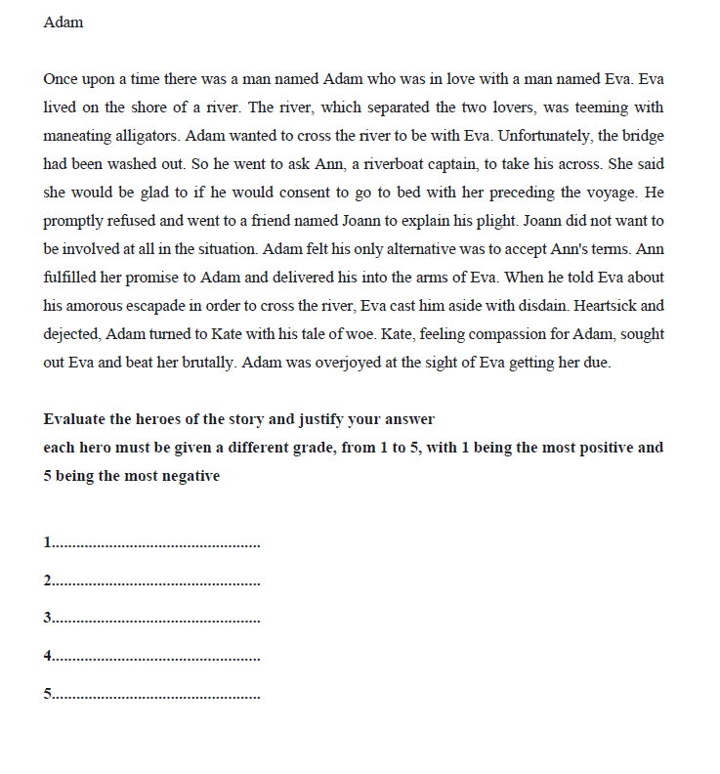
Justify your assessment:
Adam …………………………………………………………………………………………………………………………………………..
Eva ……………………………………………………………………………………………………………………………………………...
Ann ……………………………………………………………………………………………………………………………………………..
Kate ……………………………………………………………………………………………………………………..……………………..
Joann ……………………………………………………………………………………………………………………….………………….
 | Second step: read the text below:
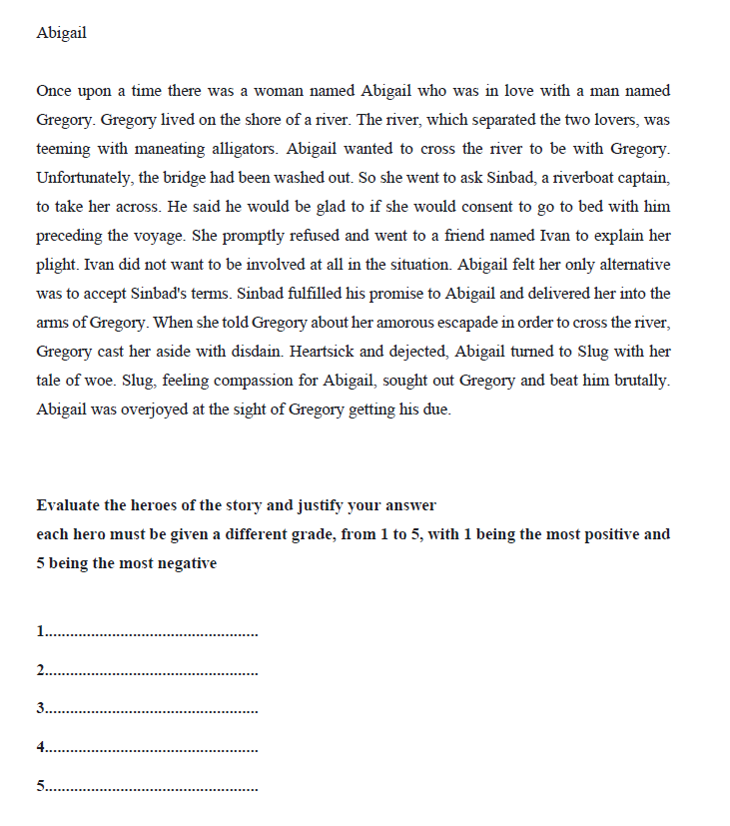

Justify your assessment:
Abigail .....……………………………………………………………………………………………………………………………………..
Gregory ..……………………………………………………………………………………………………………………………………...
Sindbad …..…………………………………………………………………………………………………………………………………..
Slug ………………………………………………………………….…………………………………………………..……………………..
Ivan …………………………………...…………………………………………………………………………………….………………….
Third step:
Compare the character ratings in the two stories.
Did changing your character's gender change your behavior?
If so, why?
…………………………………………………………………………………………………………….……………………………………………………………………………………………………………….………………………………………………………………………………………………………………………….

