Computer-assisted translation
Course scenario

CLASS 9
TOPIC | Terminology Management Systems (Part 2)
LEARNING CONTENT - DETAILED CHARACTERISTICS | Topics to be covered: Automatic Term Extraction, Noise and silence, Term extraction methods, Structure of terms, Terms according to length, Statistical term extraction methods, Machine learning systems, Practical task
KEY WORDS | automatic term extraction, statistical term extraction, machine learning term extraction
SUGGESTED TOOLS | MS PowerPoint / Canvas (or similar)  Automatic term extraction tools (e. g. SDL Trados Extract or similar)
TIPS / METHODOLOGICAL REMARKS  (if applicable) | - This class is the continuation of the 1st class on terminology management systems, thus some things that could not be covered during the 1st class could be covered in this class.  - The class will focus on automatic terminology extraction methods and tools,  - Examples and terms need to be selected according to students’ language knowledge or specialisation of (e.g. English-German, Spanish-English, law).  - Minimum CEFR Level required: B1 (Reading, Writing, Listening and Speaking).
IMPLEMENTATION OF THE CLASSES | STEP 1 | Give a self-assessment quiz from the previous class
 | STEP 2 | Present relevant term extraction methods, present finding of scientific research for different languages, overview relevant tools and their pros and cons.
 | STEP 3 | Introduce and demonstrate terminology extract systems (e. g. SDL Trados extract or similar)
 | STEP 4 | Give a practical task for students
 | STEP 5 | Review results of the practical task.

ADITIONAL MATERIAL 1 (EXEMPLARY TABLE)
The table presents the distribution of terms according to the length in the Lithuanian language.
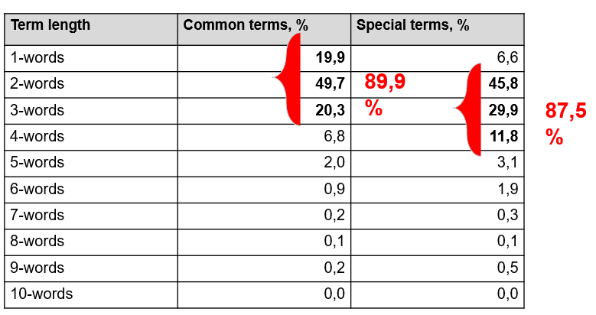
Source: Original
ADITIONAL MATERIAL 2 (EXEMPLARY PRACTICAL TASK)
    - Make a toy termbase with TMS (e. g. using SDL TRADOS Multiterm). This example is for English-Lithuanian.
homicide squad nužudymų tyrimo grupė
spurious padirbtas, suklastotas, netikras
infringe a copyright pažeisti autoriaus teisę, pažeisti patento teisę, pažeisti prekės ženklo teisę
debenture bond akcinės bendrovės obligacijos sertifikatas
porridge avižinė košė
do porridge sėdėti kalėjime
rebuttal procedure atsikirtimo procedūra
amalgamation susijungimas, susivienijimas
amalgamate susijungti, susivienyti
felonious nusikalstamas
felonious act nusikaltimas
suicide savižudybė
mature ateiti teriminui mokėti
fixed interest rate nekintamas palūkanų dydis, nustatytas palūkanų dydis
intermittent nenuolatinis, trumpalaikis, su protrūkiais

    - Translate the special law text with translation memory system and the created termbase
Law sentences
The Homicide Squad is part of the Major Crime Section, which is commanded by Inspector Chris Beach. The Homicide Squad is responsible for investigations involving homicide, felonious or suspicious deaths, suicide and accidental death.
He also farmed, preached, and taught school, and incidentally "flooded the country with spurious money."
CAN YOU INFRINGE A COPYRIGHT WHILE ANALYZING A COMPUTER PROGRAM?
Statoil has a debenture bond for EUR 500 million, with a fixed interest rate of 5.125%, maturing in 31/12/2011.
Mary was extremely tall woman; she was 7ft tall. Mary Smith was responsible for at least two felonious acts in the country. Everyone thought, that the judge was quite right making her do porridge.
Therefore, I use a rebuttal procedure that works quite well. When you believe an exam answer is debatable, prepare a written or typed rebuttal.
Where two or more companies propose to amalgamate, they shall present a scheme of amalgamation to the Department for approval.

