Computer-assisted translation
Course scenario

CLASS 8
TOPIC | Terminology Management Systems (Part 1)
LEARNING CONTENT - DETAILED CHARACTERISTICS | Topics to be covered: The importance of terminological management in translation; Computational means for terminology; Internet: social networks, blogs, online terminology databases; Terminology management systems: main functions; Storage; Retrieval; Term base building; Pros and cons, Practical task
KEY WORDS | terminology management system (TMS)
SUGGESTED TOOLS | MS PowerPoint / Canvas (or similar)  SDL Multiterm (or similar)  Access to terminology databases
TIPS / METHODOLOGICAL REMARKS  (if applicable) | - The topic is very important since consistent and correct terminology ensures the quality of translation.  - Finding the right terminology is usually a very difficult and time-consuming task during the process of translation, so it is important for students to learn about available internet resources, terminology management systems, automatic terminology extraction.  - It is advisable to hold this class in a computer lab with necessary software installed. The alternative would be allowing students to bring their own laptops.  - The exemplary terminology need to be selected according to students’ language knowledge or specialisation of (e.g. English-German, Spanish-English, philology) (see English example below).  - Depending on available time the practical task could be given for doing in class or as a homework.  - Minimum CEFR Level required: B1 (Reading, Writing, Listening and Speaking).
IMPLEMENTATION OF THE CLASSES | STEP 1 | Revise midterm results
 | STEP 2 | Discuss about the importance of terminology in the process of translation. Give examples of seemingly known areas with the abundance of unknow terms.
 | STEP 3 | Present students with the solutions for terminology management.
 | STEP 4 | Introduce to terminology management systems (e.g. SDL Trados MultiTerm or similar) by demonstrating the main features and functions of the software
 | STEP 5 | Give a practical task
 | STEP 6 | Review result of the practical task

ADITIONAL MATERIAL 1 (PICTURE)
Picture demonstrates importance of terminology in different areas
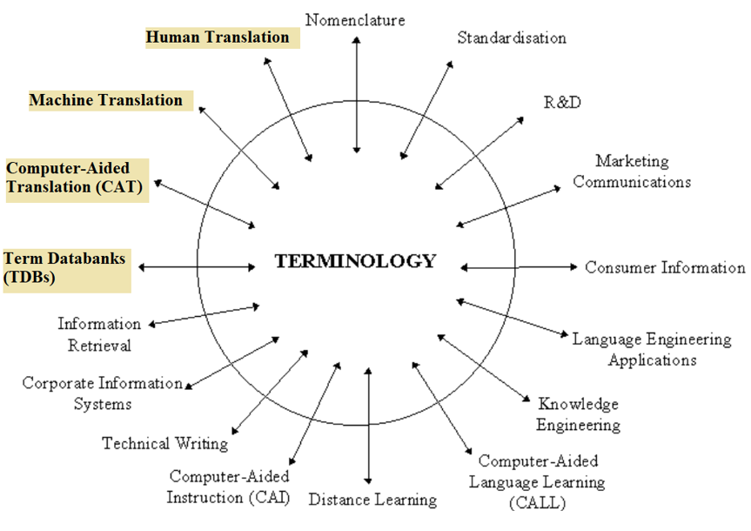
Source: http://www.computing.surrey.ac.uk/ai/pointer/report/section1.html
ADITIONAL MATERIAL 2 (PICTURE)
Pictures demonstrate abundance of unknown words in seemingly simple environments.
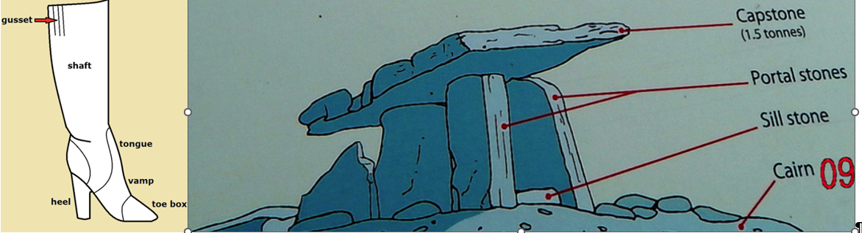
Source: https://academic-accelerator.com/encyclopedia/fashion-boot, https://www.geograph.ie/photo/4010501
ADITIONAL MATERIAL 3 (EXEMPLARY PRACTICAL TASK)
Give students a task to create 15-30 bilingual term dictionary with chosen TMS on specific topic and with specific terminology fields (e. g. status, definition, part of speech).

