Computer-assisted translation
Course scenario

CLASS 5

TOPIC | Translation Memories (Part 1)
LEARNING CONTENT - DETAILED CHARACTERISTICS | Topics to be covered: Core CAT tools: Translation memory, Additional TM functions, How does a TM system work?, Segmentation, 100% match, Context match, Perfect match, Fuzzy match, Term match, Sub-segment match, Demo task
KEY WORDS | translation memory, segmentation, exact match, perfect match, fuzzy match, termbase
SUGGESTED TOOLS | MS PowerPoint / Canvas (or similar)  SDL Trados Studio (or similar)  SDL Multiterm (or similar)
TIPS / METHODOLOGICAL REMARKS  (if applicable) | - Translation Memories are the central technology among CAT tools, so it important to cover theoretical and practical aspects of translation memories,  - It is advisable to hold this class in a computer lab with necessary software installed. The alternative would be allowing students to bring their own laptops.  - After presenting the main concepts, it is necessary to perform practical demonstration of translation with TM system. The texts for the demo need to be prepared in advance.  - The exemplary texts need to be selected according to students’ language knowledge or specialisation of (e.g. English-German, Spanish-English) (see English example below).  - The demonstration of TM systems should include but not limited to demonstration of the following functions: creating and configuring a project, selecting languages, exact match, fuzzy match, term match, placeables, dates, copying target, saving, using machine translation, exporting TM.  - Minimum CEFR Level required: B1 (Reading, Writing, Listening and Speaking).
IMPLEMENTATION OF THE CLASSES | STEP 1 | Present main concepts of translation memories
 | STEP 2 | Introduce to Translation memory software (e. g. SDL Trados Studio or similar)
 | STEP 3 | Perform demo translation of exemplary texts with students repeating the task on their computers

ADITIONAL MATERIAL 1 (PICTURES)
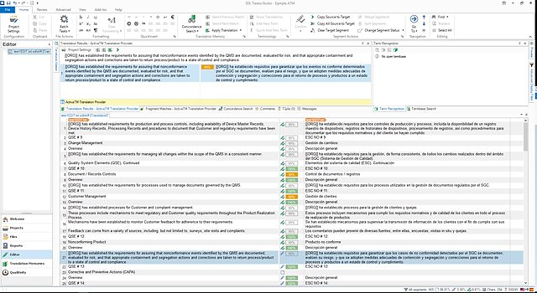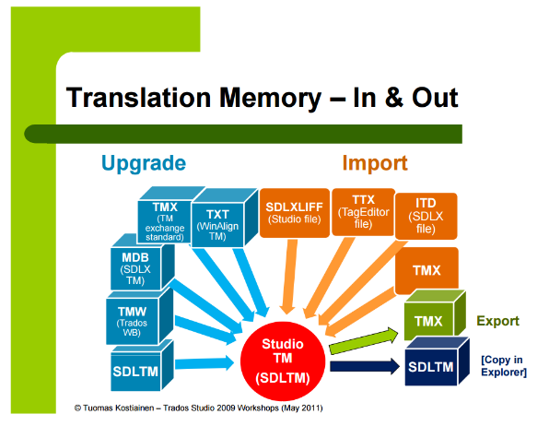
ADITIONAL MATERIAL 2 (EXEMPLARY ENGLISH TEXT FOR DEMO TASK)
train1.docx
A Wonderful Day
Today is a wonderful day. Today is a wonderful day. Today is a wonderful day. Today is a very short day. Today is a nice day.
Figure 1. Wonderful day.
5 students attend the course in computer-assisted translation. 7 students attend the course in computer-assisted translation. 10 students attend the course in computer-assisted translation.
The sentence was written in 9 October 2022. The Russian fighter crashed in August of 2005. The sentence was written in 10/10/2022.
The euro was introduced on 1 January 1999 in 11 Member States and on 1 January 2001 in Greece. In Lithuania the euro was introduced on 1/1/2015.
The printer cable is 6 ft long. The printer cable is 8 ft long.
Today, the DAX was down 11.98 points (= 0.55%) to 4.312.
Climate Change
Climate change refers to long-term shifts in temperatures and weather patterns. These shifts may be natural, such as through variations in the solar cycle. But since the 1800s, human activities have been the main driver of climate change, primarily due to burning fossil fuels like coal, oil and gas.

