Computer-assisted translation

CLASS 4
TOPIC | Parallel Corpora and Alignment
LEARNING CONTENT - DETAILED CHARACTERISTICS | Topics to be covered: Parallel corpora, Parallel corpora vs. translation memories, Alignment of texts, Why would you need alignment? Types of alignment, SDL Trados WinAlign (or similar), TMX files, Alignment for translators vs. alignment for researchers, Alignment problems, Practical alignment of given texts
KEY WORDS | Parallel corpus, alignment, translation memory exchange, TMX
SUGGESTED TOOLS | MS PowerPoint / Canvas (or similar)  Automatic aligner (e. g. SDL Trados WinAlign, LF Aligner)
TIPS / METHODOLOGICAL REMARKS  (if applicable) | - As the class is designed for learning practical skills of aligning texts, it is important to be able to provide students to the access to the relevant software (e.g. SDL Trados WinAlign or similar). Prior to the class a lecturer needs to test the software.  - Parallel texts need to be prepared prior to the class. The texts need to be selected according to students’ language knowledge or specialisation of (e.g. English-German, Spanish-English).  - The size of the files should be so that students could align them during the duration of the class.  - Minimum CEFR Level required: B1 (Reading, Writing, Listening and Speaking).
IMPLEMENTATION OF THE CLASSES | STEP 1 | Give a self-assessment quiz from the previous class
 | STEP 2 | Present: rationale for alignment of texts, types of alignment, typical problems and situations of alignment
 | STEP 3 | Introduce to alignment software (e.g. SDL Trados WinAlign or similar)
 | STEP 4 | Give students an aligning task
 | STEP 5 | Review results of the aligning task

ADITIONAL MATERIAL 1 (PICTURE)
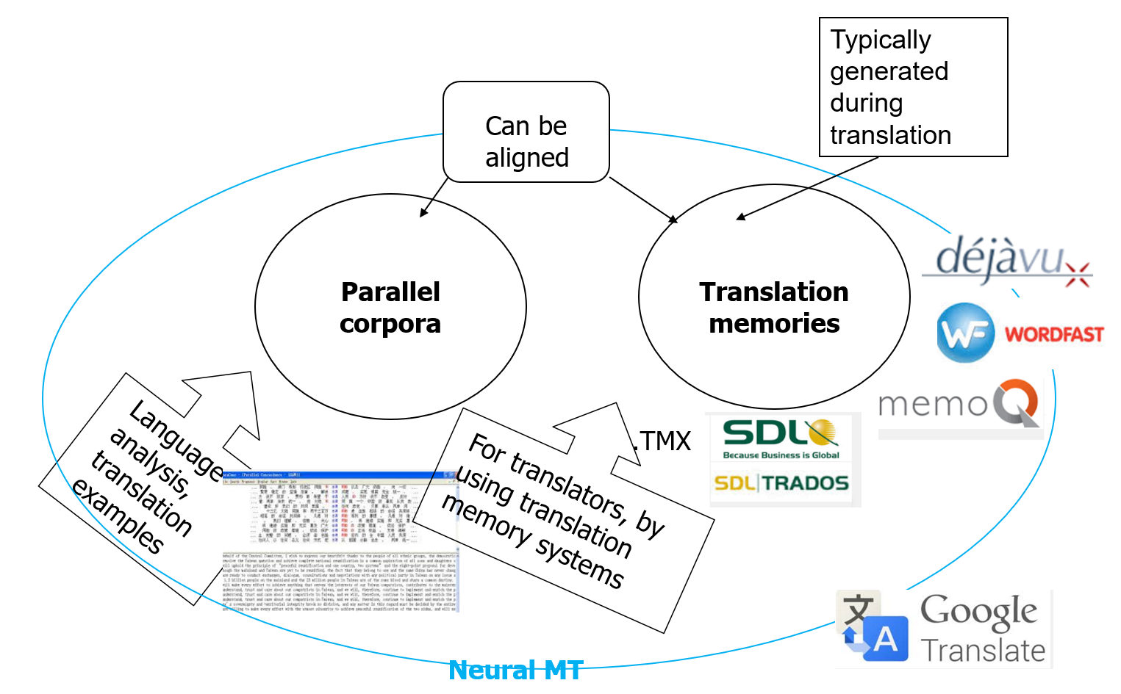
ADITIONAL MATERIAL 2 (PARALLEL FILES FOR PRACTICAL TASK)
Note: Parallel files need to be of the format that can be handled by chosen aligning software (e.g. Trados WinAlign can handle .doc/.docx files)
