Computer-assisted translation
Course scenario

CLASS 2
TOPIC | Data Capturing into Electronic Form
LEARNING CONTENT - DETAILED CHARACTERISTICS | Topics to be covered: Why is it necessary?; Three ways of data capturing into electronic form; Types of scanners; How a scanner works; Optical character recognition (OCR); Computer vision; Factors affecting the accuracy of OCR; OCR software; Pros and cons of the method; Voice/ speech recognition; How speech recognition works; Dictation systems; Pros and cons of the method; Practical task
KEY WORDS | scanning, optical character recognition, computer vision, speech recognition
SUGGESTED TOOLS | MS PowerPoint / Canvas (or similar)  Access to online OCR tools (e.g. onlineocr.net, Google Docs)  Access to online voice recognition tools
TIPS / METHODOLOGICAL REMARKS  (if applicable) | - Renew and test information about demonstrated tools and links prior to the class,  - Prepare scanned texts for practical tasks with different layouts, different resolutions and alphabets,  - OCR and voice recognition examples and tasks need to be selected according to students’ language knowledge or specialisation of (e.g. English-German, Spanish-English).  - Minimum CEFR Level required: B1 (Reading, Writing, Listening and Speaking).
IMPLEMENTATION OF THE CLASSES | STEP 1 | Give a self-assessment quiz from the previous class.
 | STEP 2 | Present the double importance of capturing paper information to electronic paper: 1) ability to use CAT tools; 2) reducing the usage of paper.
 | STEP 3 | Present scanners and OCR, software, pros and cons
 | STEP 4 | Demonstrate existing OCR tools (e.g. onlineocr.net, Google Docs)
 | STEP 5 | Present voice recognition, software, pros and cons
 | STEP 6 | Demonstrate existing dictation systems (e.g. GoogleDocs)
 | STEP 7 | Give students a practical task: 1) using OCR; 2) using voice recognition software

ADITIONAL MATERIAL 1 (GRAPHS AND ILLUSTRATION OF PAPER PRODUCTION)
Production volume of paper and paperboard
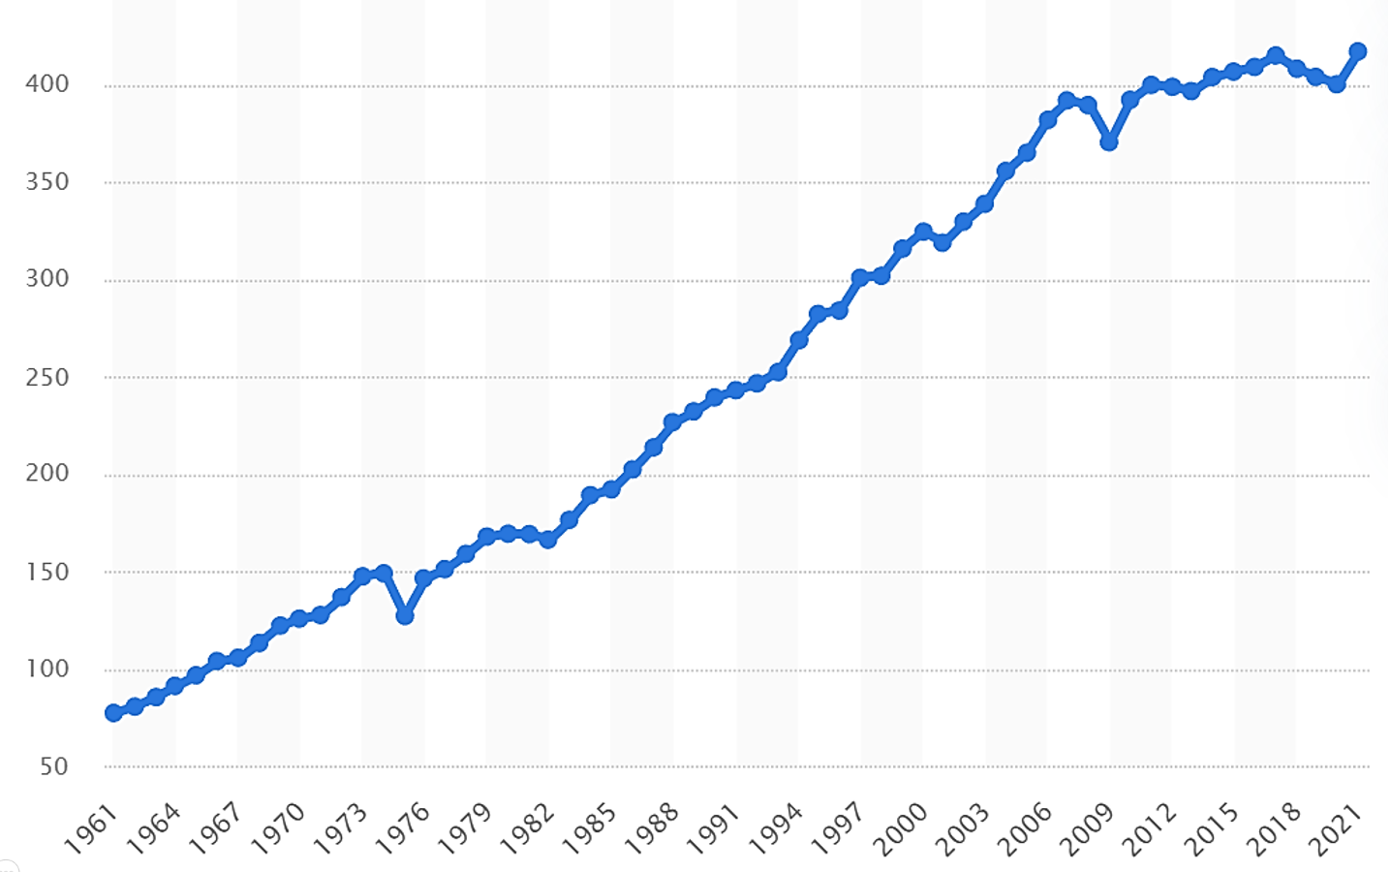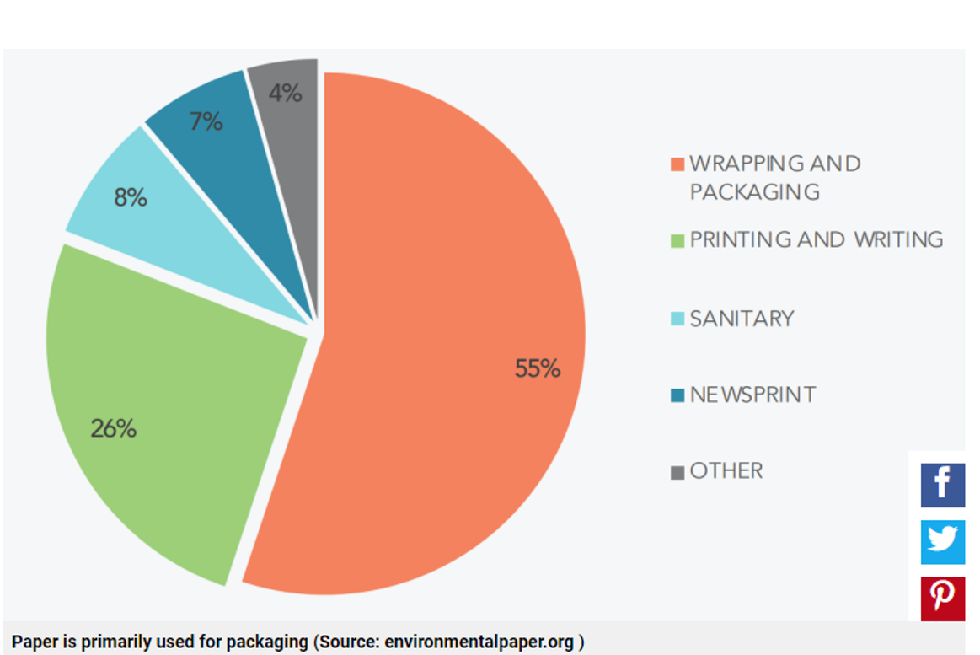
Source: https://www.statista.com/statistics/270314/global-paper-and-cardboard-production/
ADITIONAL MATERIAL 2 (DIFERENT TYPES OF SCANNER PICTURES, PICTURES ILLUSTRATING TWO PROCESSES)
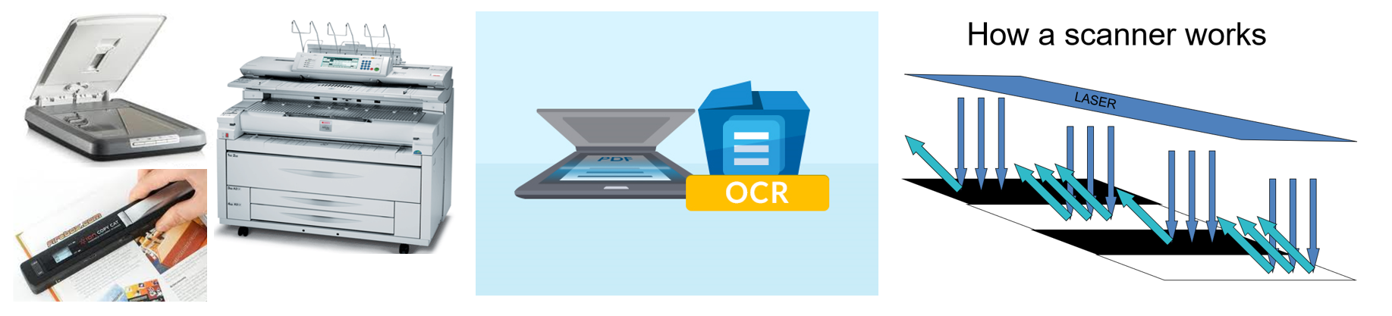
ADITIONAL MATERIAL 2 (FILES WITH SCANNED TEXT)
