Computer-assisted translation
Course scenario

CLASS 15
TOPIC | Artificial Intelligence and Translation
LEARNING CONTENT - DETAILED CHARACTERISTICS | Topics to be covered: Main concepts of AI, history of AI, neuron, how the machine learns, word embeddings, large language models, generative pretrained transformers, AI and translation
KEY WORDS | Artificial intelligence (symbolic, general, narrow, generative transformer), neuron, machine learning, word embeddings, large language models, generative pretrained transformers
SUGGESTED TOOLS | MS PowerPoint / Canvas (or similar)  Access to an AI chatbot (ChatGPT or similar)  Access to an AI image generator (DALL-E or similar)
TIPS / METHODOLOGICAL REMARKS  (if applicable) | - The topic is very dynamic; thus information and tools need to be reviewed and tested prior to the lecture.  - AI examples and tasks need to be selected according to students’ language knowledge or specialisation of (e.g. English-German, Spanish-English).  - Minimum CEFR Level required: B1 (Reading, Writing, Listening and Speaking).
IMPLEMENTATION OF THE CLASSES | STEP 1 | Give a self-assessment quiz from previous lecture.
 | STEP 2 | Explain new AI technologies and latest generative transformer developments that are capable of translating texts. Present basic concepts and principles of AI technologies.
 | STEP 3 | Discuss the overall importance and perspectives of AI technologies for the translation industry.
 | STEP 4 | Screen-demonstrate freely accessible AI-powered tools.
 | STEP 5 | Give students a practical task
 | STEP 6 | Review results of the task
 | STEP 7 | Present exam topics for the final test.

ADITIONAL MATERIAL 1 (PICTURE)
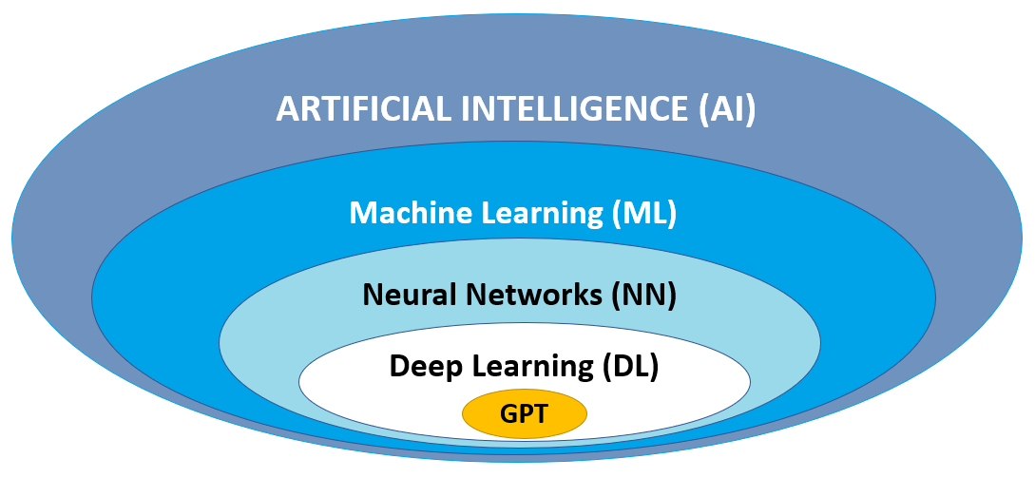
Source: Original
ADITIONAL MATERIAL 2 (PICTURE OF A TIMELINE)
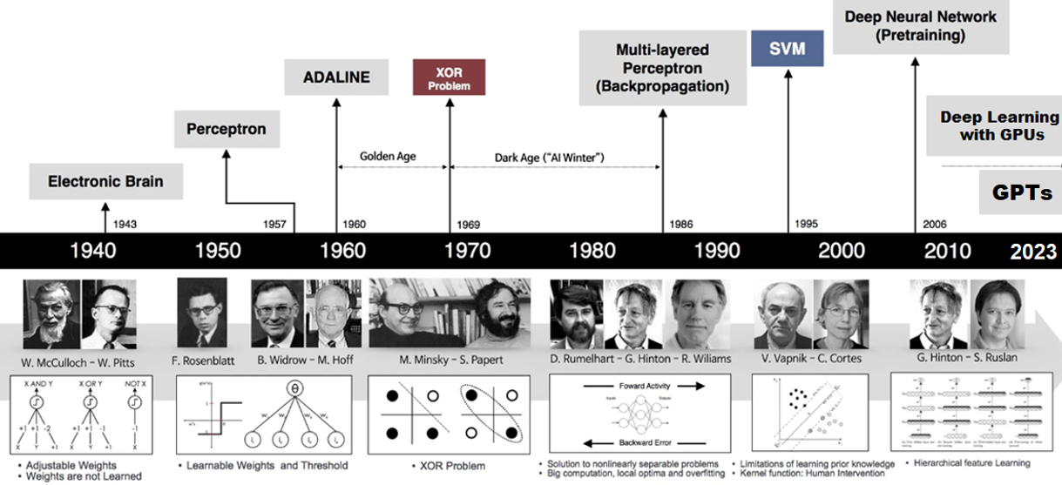
Source: https://sefiks.com/2017/10/14/evolution-of-neural-networks/

