Computer-assisted translation
Course scenario

CLASS 13
TOPIC | Machine Translation (Part 1)
LEARNING CONTENT - DETAILED CHARACTERISTICS | Topics to be covered: History of MT; ALPAC report; History timeline; Rule-based MT, statistical MT, neural MT; Statistical and neural machine translation: data is the most important; Is MT useful?; For what is not useful; Main terminology; The level of automation; Practical task
KEY WORDS | machine translation (MT)
SUGGESTED TOOLS | MS PowerPoint / Canvas (or similar)  Access to Machine Translation systems (Google Translate or similar)
TIPS / METHODOLOGICAL REMARKS  (if applicable) | - The topic is very dynamic; thus information about MT and MT tools need to be reviewed and tested prior to the class.  - MT examples and practical tasks need to be selected according to students’ language knowledge or specialisation of (e.g. English-German, Spanish-English).  - Minimum CEFR Level required: B1 (Reading, Writing, Listening and Speaking).
IMPLEMENTATION OF THE CLASSES | STEP 1 | Give a self-assessment quiz from the previous class
 | STEP 2 | Present and discuss main concepts, history, types of machine translation.
 | STEP 3 | Screen-demonstrate functions and capabilities of various online MT systems (e. g. Google translate, DeepL or similar).
 | STEP 4 | Give students a practical MT systems comparison task.
 | STEP 5 | Review results of the task.

ADITIONAL MATERIAL 1 (PICTURE)
The picture shows historic developments.
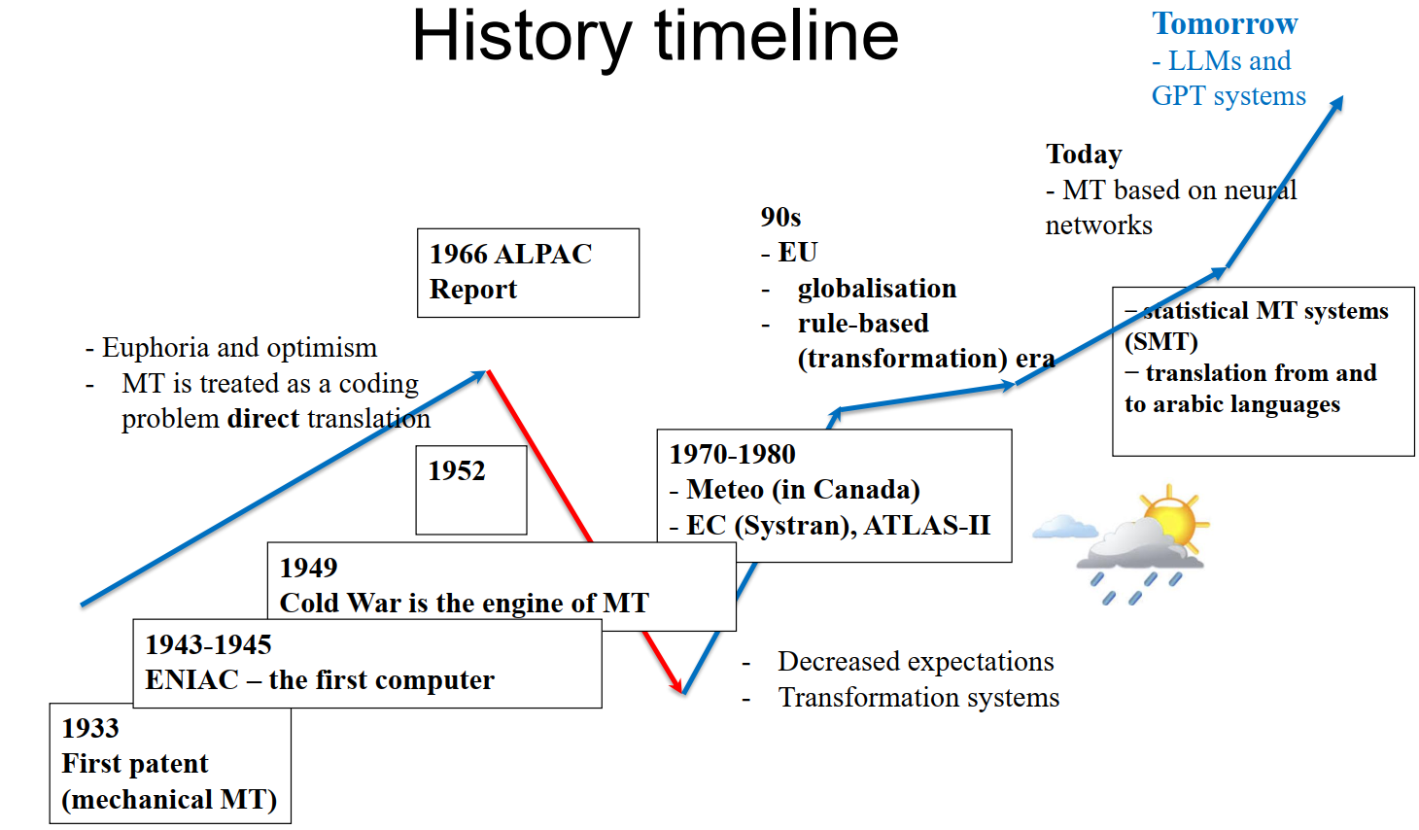
Source: Original
ADITIONAL MATERIAL 2 (PICTURE)
The picture shows the level of automation of different types of translation
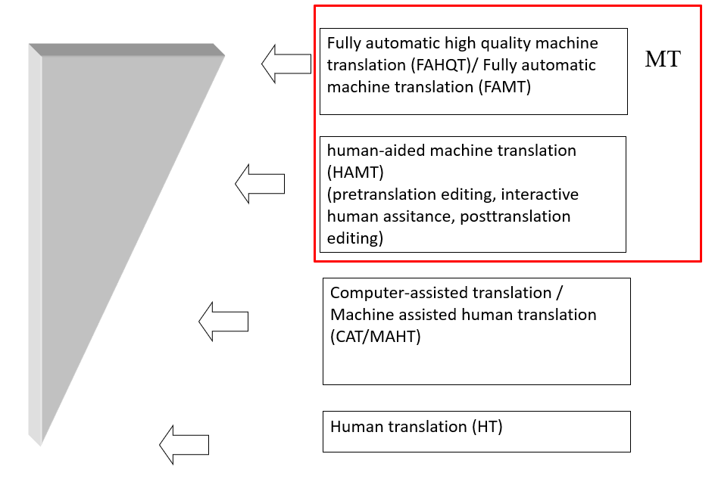
Source: Original
ADITIONAL MATERIAL 3 (WORK CARD)
Practical task: The quality assessment of MT system
- https://translate.google.com/
- https://www.bing.com/translator
- https://www.deepl.com/translator

- Paste in the translation into the table.
- Evaluate and fill necessary fields.

WHITE CHRISTMAS
This is a fun awareness-raising activity based on the song I’m dreaming of a white Christmas by Irving Berlin, sung by Bing Crosby. Most people have had the experience of hearing a song in their own or another language, and misunderstanding some of the lines of the lyric. There are two reasons for this. Firstly, we may hear wrongly, either because the singer pronounces strangely, or because the language has in-built ambiguities and homophones. Secondly, we may interpret wrongly.

MT system | Translation | Overall quality (1-5) | Number of correct sentences | Number of non- translated words
1. google
3. Deepl
4. bing

