Computer-assisted translation
Course scenario

CLASS 12
TOPIC | Diagnostic and Quality Assurance tools
LEARNING CONTENT - DETAILED CHARACTERISTICS | Topics to be covered: Quality in Translation, Quality assurance (QA) tools, Diagnostic tools, QA vs diagnostic tools, What are diagnostic tools for?, SDL Trados Studio diagnostics, What are QA tools for? QA tools, Practical task
KEY WORDS | quality assurance tools, diagnostic tools
SUGGESTED TOOLS | MS PowerPoint / Canvas (or similar)  SDL Trados Studio (or similar)
TIPS / METHODOLOGICAL REMARKS  (if applicable) | - The topic is very dynamic; thus information and tools need to be reviewed and tested prior to the class.  - Minimum CEFR Level required: B1 (Reading, Writing, Listening and Speaking).
IMPLEMENTATION OF THE CLASSES | STEP 1 | Give a self-assessment quiz from the previous class.
 | STEP 2 | Present and discuss main concepts of diagnostic and quality assurance tools.
 | STEP 3 | Screen-demonstrate the diagnostic and QA functions in a selected CAT tool (e.g. SDL Trados or similar).
 | STEP 4 | Give students a practical diagnostic and QA task.
 | STEP 5 | Review results of the task.

ADITIONAL MATERIAL 1 (PICTURE)
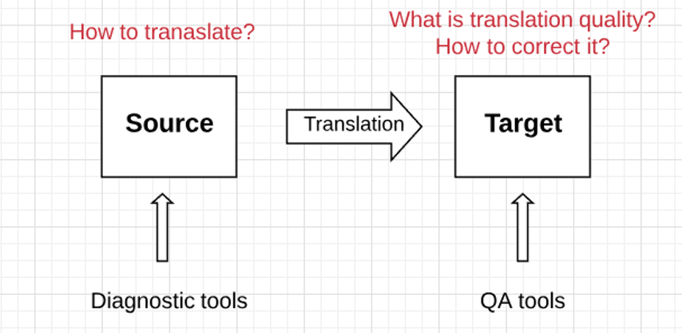
Source: Original
ADITIONAL MATERIAL 2 (WORK CARD)
- Fill up the table for a given file (e. g. train2.docx file from Class 6).
- Export analysis report from SDL TRADOS to Excel file.

Total number of
Characters
Words
Segments
Number of translated
Words
Characters
Segments
Number of not- translated
Words
Characters
Segments
Number of
Context match (C)
Repetitions
Number of matches
100%
95-99%
New (%)

