Computer-assisted translation
Course scenario

CLASS 11
TOPIC | Out of the Ordinary Localisation
LEARNING CONTENT - DETAILED CHARACTERISTICS | Topics to be covered: Mainstream localisation vs. out of the ordinary localisation, Tools of out of the ordinary localisation, Healthcare and safety, Digital divide, Information poverty, Large and small languages
KEY WORDS | mainstream localisation, out of the ordinary localisation, non-profit localisation, information poverty,
SUGGESTED TOOLS | MS PowerPoint / Canvas (or similar)
TIPS / METHODOLOGICAL REMARKS  (if applicable) | - Students may be requested to read the article (Anastasiou and Schäler 2010) prior to the class.  - The class is dedicated to showing the other side of the coin of localisation focusing on the importance of non-profit localisation.  - Minimum CEFR Level required: B1 (Reading, Writing, Listening and Speaking).
IMPLEMENTATION OF THE CLASSES | STEP 1 | Give a self-assessment quiz from the previous class
 | STEP 2 | Discuss the information that students learned from the article.
 | STEP 3 | Present the importance of out of the ordinary localisation to the society and existing tools.

ADITIONAL MATERIAL 1 (PICTURE)
The picture represents proportion of large and small languages. Large languages are not necessarily with the largest presence on the web.
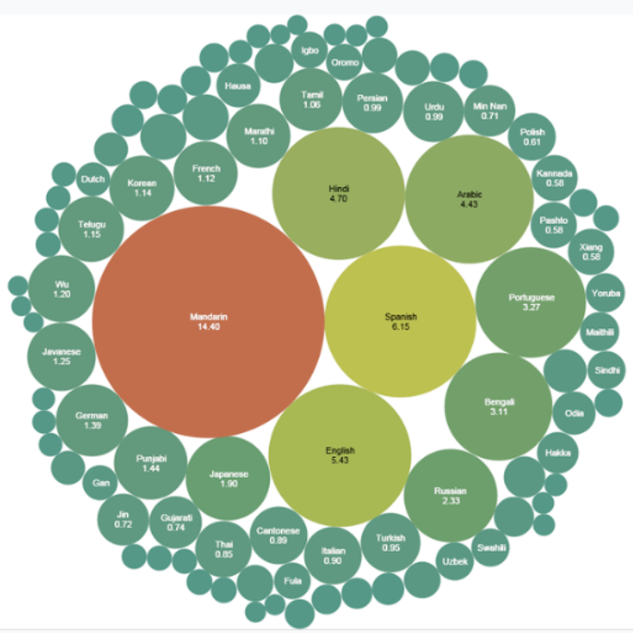
Source: https://en.wikipedia.org/wiki/List_of_languages_by_number_of_native_speakers
ADITIONAL MATERIAL 2 (ARTICLE)
Anastasiou D., Schäler R. (2010) Translating Vital Information: Localisation, Internationalisation, and Globalisation. Political Science. https://www.researchgate.net/publication/287413752_Translation_and_Web_Localization/

