Computer-assisted translation
Course scenario

CLASS 10
TOPIC | Localisation
LEARNING CONTENT - DETAILED CHARACTERISTICS | Topics to be covered: Globalisation (G11N), Internationalization (I18N), Localisation (L10N), Translation and localisation, Advantages of localisation: Economic factor, Language and culture, Social factor, Aspects of localisation, Examples of localised fonts, icons, colours, products, photos and visuals, Examples of localisation blunders, Localisation tools, Skills, Practical localisation task
KEY WORDS | globalisation, internationalisation, localisation, mainstream localisation
SUGGESTED TOOLS | MS PowerPoint / Canvas (or similar)  Localisation software (e. g. Lokalise – https://www.lokalise.com)
TIPS / METHODOLOGICAL REMARKS  (if applicable) | - The topic is very dynamic; thus information and tools need to be reviewed and tested prior to the class.  - Localisation examples and tasks need to be selected according to students’ language knowledge or specialisation of (e.g. English-German, Spanish-English).  - Minimum CEFR Level required: B1 (Reading, Writing, Listening and Speaking).
IMPLEMENTATION OF THE CLASSES | STEP 1 | Give a self-assessment quiz from the previous class.
 | STEP 2 | Present and discuss main concepts of localisation
 | STEP 3 | Introduce to localisation software (e.g. Lokalise or similar)
 | STEP 4 | Give students a practical localisation task.
 | STEP 4 | Review results of the localisation task

ADITIONAL MATERIAL 1 (PiCTURE)
The picture demonstrated relationship between Globalisation, Localisation and Internationalisation.
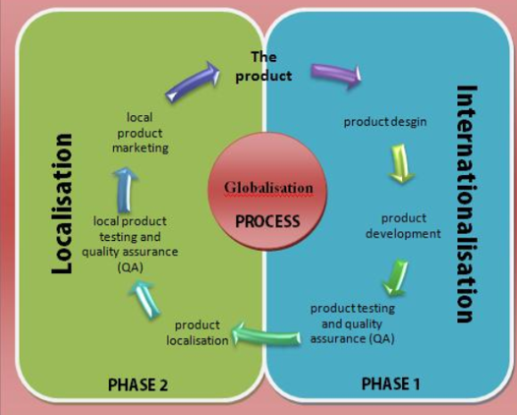
Source: https://www.researchgate.net/publication/281958002_Linguistic_and_Multilingual_Issues_in_Virtual_Worlds_and_Serious_Games_a_General_Review
ADITIONAL MATERIAL 2 (PICTURE)
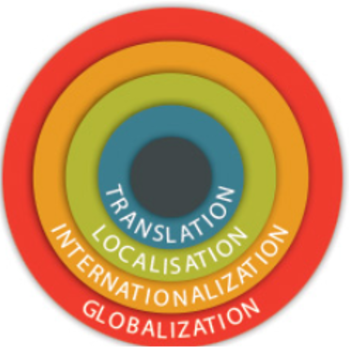
Source: https://guides.co/g/a-guide-to-localisation-and-translation/7078
ADITIONAL MATERIAL 3 (PRACTICAL TASK)
Give to localise a website.

