Computer-assisted translation
Course scenario

CLASS 1
TOPIC | Introduction
LEARNING CONTENT - DETAILED CHARACTERISTICS | Topics to be covered: Self-introduction; The scope of the course; Machine translation vs computer assisted translation; Main concepts; Internet and translation; Mailing lists; Forums; Blogs; Virtual conferences; Internet search; Google search tricks; Filter bubble; Alternative search engines; Practical task
KEY WORDS | computer-assisted translation, machine translation, search engine
SUGGESTED TOOLS | MS PowerPoint / Canvas (or similar)  Access to an internet browser  Moodle, Mentimeter or Kahoot could be used for larger groups of students
TIPS / METHODOLOGICAL REMARKS  (if applicable) | - Present the scope of the course before each class, highlighting the current topic.  - Tasks and examples need to be adopted to students’ language knowledge or specialisation of (e.g. English-German, Spanish-English)  - Minimum CEFR Level required: B1 (Reading, Writing, Listening and Speaking).
IMPLEMENTATION OF THE CLASSES | STEP 1 | Self-introduction by the lecturer and by everyone in the class. Moderated by a lecturer. Students are asked about their experience with translation and professional translation, as well as their experience with translation tools. Survey tools could be used for larger groups of students
 | STEP 2 | Support the class by the presentation software (e g. PowerPoint/Canvas or similar). Presenting the scope of the course based on classification into Human translation, Computer assisted translation, and Machine translation.
 | STEP 3 | Discuss the importance of Internet tools and online resources for the translation. Present with various examples
 | STEP 4 | Focus on possibilities of Internet and capabilities of search engines, exemplified by real-life examples
 | STEP 5 | Give a practical task for finding translation equivalents of specific terms with the help of search engines.

ADDITIONAL MATERIAL 1 (TABLE)
Table shows the distinction between different groups of translation tools. The original table is modified to include new actual tools (GPT and quality assurance tools)
Human translation (HT) | Computer Assisted Translation tools (CAT) | Machine translation (MT)
- Spell checkers  - Word processors (e.g. MS Word)  - Electronic resources (e.g. dictionaries on CD)  - Internet (e.g. www, e-mail, on-line dictionaries) | - Data capture tools  - Corpora and corpus analysis tools  - Terminology management systems  - Translation memories  - Localisation and web page translation tools  - Diagnostic and quality assurance tools | - Machine translation systems  - Generative pretrained transformers (GPT)
Source: Bowker, Lynne. (2002) Computer-Aided Translation Technology. University of Ottawa Press.
ADDITIONAL MATERIAL 2 (PICTURE)
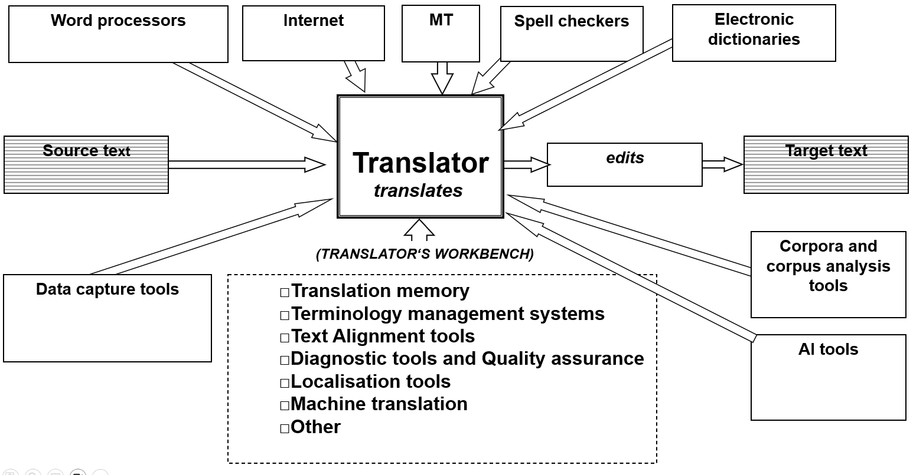
ADDITIONAL MATERIAL 3 (ONLINE MATERIAL, PICTURE)
Be aware of personalised Search
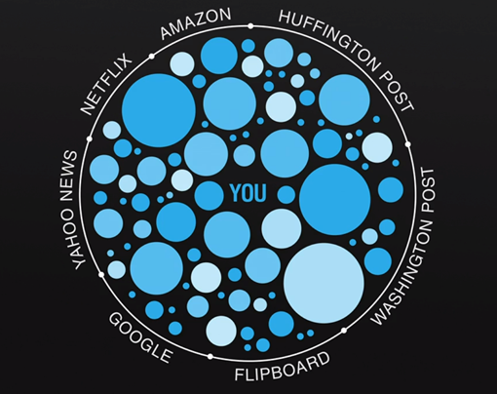
Source: (https://www.stateofdigital.com/beware-of-personalised-search-and-online-filter-bubbles/)
ADDITIONAL MATERIAL 4 (ONLINE MATERIAL)
Google search tricks (e.g. from http://time.com/4116259/google-search-2/
ADITIONAL MATERIAL 2 (WORK CARD)
Note: Select words for translation according to students’ knowledge of languages. The below example is for English and Lithuanian.
Source Word | Translation | Found Alternatives | Duration (mins) | Notes (how it was found) | Location (website)
hand bailer (example) | Semtuvas | Semėjas, kaušas, semtuvėlis | 6 min | Google search  “hand bailer” | https://www.sailing.lt/produktas/e-8209-parduotuve/jachtu-iranga/semtuvelis-didelis3/
Traškis
Bendrasis programavimo dokumentas
Network interface card (NIC)
…

