COURSE SCENARIO
Spain: Society, Culture, and Economy in a global context

CLASS 7
TOPIC | Spanish gastronomy: food, wines, and habits
LEARNING CONTENT - DETAILED CHARACTERISTICS | Students can learn the culinary aspects of Spain, such as habits, food, or drinks.
KEY WORDS | Spain; food; drinks; wines, culinary habits; famous chefs from Spain; exportation.
SUGGESTED TOOLS | Computer with internet connection and Microsoft Office or similar.
TIPS / METHODOLOGICAL REMARKS  (If applicable) | During the class, students are aimed to collaborate and participate actively with the group dynamics, develop their critical thinking, and express their questions to the professor. After the lesson has finished, students must review the contents learnt and complete the additional tasks for a deeper and wider comprehension of the contents.
IMPLEMENTATION OF THE CLASSES | STEP 1 | Students participate in a discussion with brainstorming about everything they know about the Spanish gastronomy. Afterwards, the professor summarises the Power Point presentation and recommends additional bibliography to complete and expand the students’ knowledge and understanding.
 | STEP 2 | Students answer the tasks related to the contents learned while the “Additional material 1 work card (Let’s make a restaurant menu)”. The professor helps them by answering their questions, offering examples, and reinforcing the participation and collaboration.
 | STEP 3 | The professor starts a dialogue about the previous tasks by asking directly about the answers. While discussing, the professor directs the debate by contrasting and relating different points of view, adding more information, or addressing spontaneous questions to the students to improve their critical reasoning.
 | STEP 4 | The professor compiles the answers and opinions of the students and, as a conclusion, gives a short speech that summarises the content taught.
 | STEP 5 | The professor presents the “Additional material 2 work card (What food and drinks are from Spain?)”. aimed for the next session and explains it briefly to check if there are any questions.

ADDITIONAL MATERIAL 1 WORK CARD (Let’s make a restaurant menu)
In pairs, fill the following menu with the appetisers, main courses, desserts and drinks you remember. But be careful, you can only use genuine Spanish food and drinks. Afterwards, 3 or 4 classmates collect as many as you can.

ADDITIONAL MATERIAL 2 WORK CARD (What food and drinks are from Spain?)
In pairs, select the Spanish food or drinks and, if you know the name, write it below the picture.

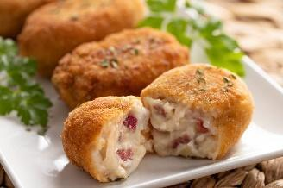 | 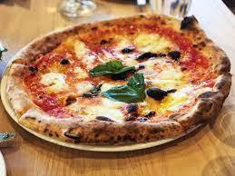 | 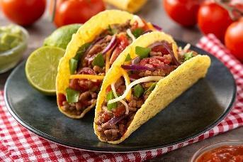 | 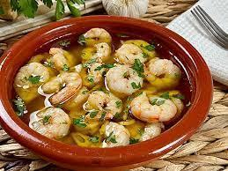
_________________ | _________________ | _________________ | _________________
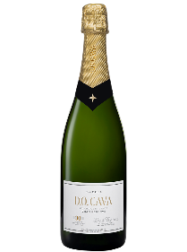 | 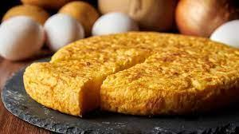 |  | 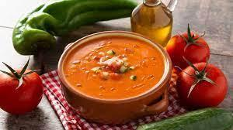
_________________ | _________________ | _________________ | _________________
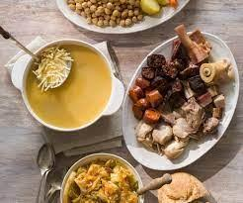 | 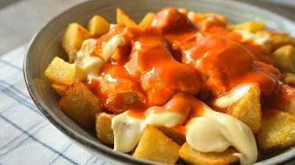 |  | 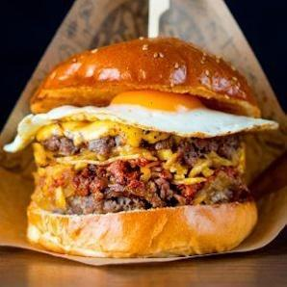
_________________ | _________________ | _________________ | _________________

Solution:
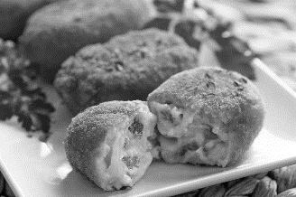 | 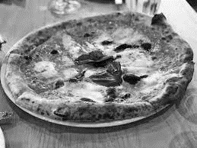 | 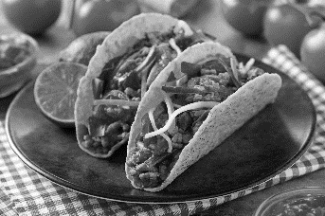 | 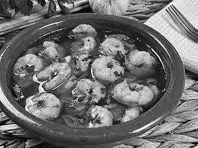
Croquetas (Spain) | Pizza (Italy) | Tacos (Mexico) | Gambas al ajillo (Spain)
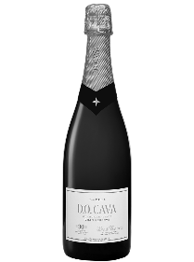 | 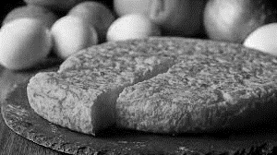 |  | 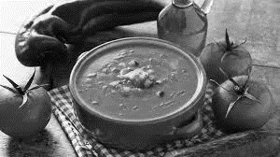
Cava (Spain) | Tortilla Española (Spain) | Gin tonic (England, India) | Gazpacho (Spain)
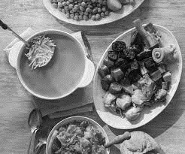 | 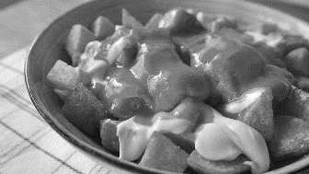 |  | 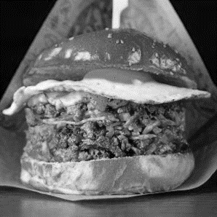
Cocido (Spain) | Patatas bravas (Spain) | Albariño (Spain) | Hamburger (USA, Germany)

