CLASS 6
TOPIC | Green Cities
LEARNING CONTENT - DETAILED CHARACTERISTICS | Introduction in a "green city" concept that refers to a city or urban area designed and developed with a strong focus on environmental sustainability and promoting a high quality of life for its residents. It encompasses various aspects of urban planning, design, and management that prioritize sustainable practices, resource efficiency, and the well-being of both people and the environment. Successful sustainable green cities in the world – best examples. Green innovations and Nature-based solutions.
KEY WORDS | Nature Based Solutions, Green Cities, Bionic Cities
SUGGESTED TOOLS | Interactive lecture  Power-point presentation  Videos and readings  Handouts for analysis in groups  Discussion
TIPS / METHODOLOGICAL REMARKS  (if applicable) | …………………………
IMPLEMENTATION OF THE CLASSES | STEP 1 | Presentation: Key features and characteristics of a green city. Sustainable Transportation, Energy Efficiency, Green Buildings and Infrastructure, Efficient Resource Management, Biodiversity and Green Spaces, Climate Resilience, Healthy and Livable Environments, Community Engagement.
 | STEP 2 | Video - successful examples of nature integration in cities worldwide: What Is the Most Sustainable City in the World? (Going Green Media)  https://www.youtube.com/watch?v=fsWr0LfM_uQ
 | STEP 3 | Presentation: Nature-Based Solutions for Urban Challenges. Addressing urban challenges (e.g., heat island effect, air pollution, stormwater management) through nature-based solutions. Examples of nature-based solutions and their effectiveness
 | STEP 4 | Case Studies and Best Practices: Singapore - Lessons learned and key factors contributing to success.  Work Card 1
 | STEP 5 | Green buildings best practices - Students learn about the main characteristics of green buildings and do independent internet research  Work card 2
 | Step 6 | Presentation: A brief introduction in concept of Bionic Cities: combines the ideas of biology and technology to create a highly advanced and sustainable urban environment. It envisions a city that mimics the efficient and adaptive systems found in nature, integrating technology to enhance sustainability, resilience, and the well-being of its inhabitants. Best examples: Masdar City, United Arab Emirates, Singapore's "Gardens by the Bay", The Green Spiral, Paris, Smart Forest City, Mexico, HafenCity, Hamburg, Germany.

ADITIONAL MATERIAL 1 - WORK CARD

WORK CARD 1 - CASE STUDIES AND BEST PRACTICES: SINGAPORE - LESSONS LEARNED AND KEY FACTORS CONTRIBUTING TO SUCCESS

А. Video (15 min): Singapore Green Plan 2030 (Ministry of Sustainability and the Environment, Singapore) https://www.youtube.com/watch?v=oNFeOl7pW9s

B. Based on the information obtained in the video, answer the question: What are the main areas that Singapore will work on?

List the three key factors that you believe are the foundation of Singapore's success.

ADITIONAL MATERIAL 2 - WORK CARD

WORK CARD 2 - Green Building Practices

- Read the text.
Green building practices encompass a range of design, construction, and operational strategies aimed at minimizing the environmental impact of buildings while promoting resource efficiency, occupant health, and sustainability. The benefits of green buildings include reduced energy and water costs, improved occupant comfort and health, lower environmental impact, increased
property value, and a contribution to global sustainability goals. Green building practices are
increasingly being adopted by developers, architects, and building owners worldwide as part of their commitment to environmental responsibility and creating more sustainable built environments.

Here are some key aspects of green building practices:

- Energy Efficiency: Green buildings prioritize energy efficiency by incorporating measures such as efficient insulation, high-performance windows, energy-efficient lighting systems, and optimized HVAC (Heating, Ventilation, and Air Conditioning) systems.
These measures help reduce energy consumption and greenhouse gas emissions.
- Renewable Energy: Green buildings often integrate renewable energy sources, such as solar panels or wind turbines, to generate on-site clean energy. This reduces reliance on fossil fuel-based electricity and contributes to a more sustainable energy mix.
- Water Efficiency: Green buildings employ various water-saving measures, including low- flow fixtures, water-efficient landscaping, rainwater harvesting systems, and greywater recycling. These practices help conserve water resources and minimize strain on local water supplies.
- Sustainable Materials: Green buildings prioritize the use of environmentally friendly and sustainably sourced materials. This includes using recycled content, locally sourced materials, and products with low embodied energy. Additionally, green buildings focus on reducing waste during construction and demolition by implementing recycling and waste management practices.
- Indoor Environmental Quality (IEQ): Green buildings prioritize occupant health and well- being by ensuring good indoor air quality, optimal thermal comfort, and ample daylight.
This involves utilizing low-emitting materials, proper ventilation systems, and providing access to natural light and views.
- Site and Land Use: Green buildings consider the surrounding site and its impact on the environment. This includes strategies such as preserving green spaces, minimizing site disturbance, promoting biodiversity, and managing stormwater runoff through
techniques like permeable paving and green roofs.
- Life Cycle Assessment: Green building practices take into account the entire life cycle of a building, from design and construction to operation and eventual demolition. Life cycle assessment helps evaluate the environmental impacts of a building over its entire
lifespan and informs decisions that optimize sustainability.
- Green Building Certifications: Various green building certification systems exist globally, such as LEED (Leadership in Energy and Environmental Design), BREEAM (Building Research Establishment Environmental Assessment Method), and Green Star. These certification programs provide frameworks and standards for assessing and recognizing green building practices.

- Choose one of the following global examples of green buildings and do your own internet research. Summarize the information in 100 words

ACROS Fukuoka - the Japanese Babylon

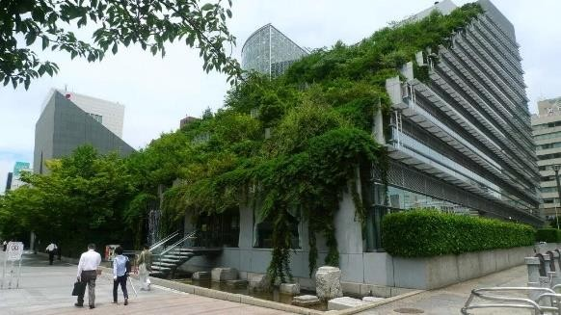

Manitoba Hydro Place

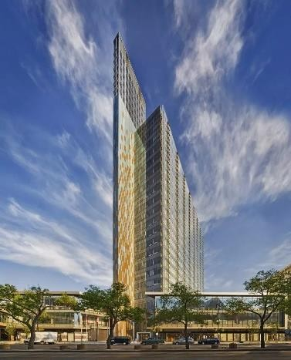

Nanjing Towers, China

