CLASS 5
TOPIC | Urban Nature and Ecosystem Services: Embracing Nature in the Cityscape
LEARNING CONTENT - DETAILED CHARACTERISTICS | The subject of this class is introduction to Environmental Sustainability in Urban Planning: By prioritizing environmental sustainability in urban planning, cities can create more resilient, healthy, and vibrant places for people to live, work, and thrive. Environmental sustainability plays a crucial role in urban planning for several reasons: Climate Change Mitigation, Preservation of Natural Resources, Enhanced Resilience, Quality of Life and Well-being, Economic Benefits.
KEY WORDS | Environmental Sustainability, Ecosystem Services, Urban Biodiversity
SUGGESTED TOOLS | Interactive lecture  Power-point presentation  Videos and readings  Handouts for analysis in groups  Discussion
TIPS / METHODOLOGICAL REMARKS  (if applicable) | …………………………..
IMPLEMENTATION OF THE CLASSES | STEP 1 | Presentation: Understanding the concept of nature in urban environments. Benefits of integrating nature in cities for human well-being and ecological sustainability. Ecosystem Services and Biodiversity in Urban Areas: Exploring the importance of biodiversity in urban ecosystems. Understanding the ecosystem services provided by urban nature
 | STEP 2 | Students are asked to browse the Internet and find  information about the term Green Infrastructure.
 | STEP 3 | Urban Green infrastructure: Students learn about the elements of green infrastructure and discuss the relationship between green elements and public benefits (ecosystem services)  See Work Card 1
 | STEP 4 | Exercise: Mapping Urban Ecosystem Services  Objective: To raise awareness among students about the various ecosystem services provided by urban environments and to encourage critical thinking about the benefits and challenges of managing and preserving these services. See Work Card 2.

ADITIONAL MATERIAL 1 – WORK CARD

WORK CARD 1 - URBAN NATURE AND ECOSYSTEM SERVICES: EMBRACING NATURE IN THE CITYSCAPE

А. Video: What is green infrastructure? https://www.youtube.com/watch?v=ph_G3HmYI80 (Department of Planning and Environment, New South Wels, Australia)

Discuss with your colleagues and formulate briefly - What is green infrastructure?

В. List at least 6 elements of green infrastructure in your city (or in a city known to you)

С. Explore the figure. Make proposals on the link between green infrastructure elements and ecosystem benefits (services) for people.

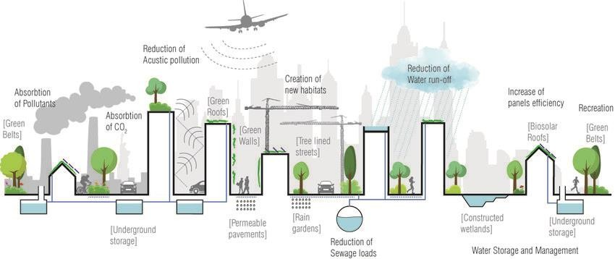

Source: Catalano, Chiara & Baumann, Nathalie. (2017). Biosolar Roofs: A Symbiosis between Biodiverse Green Roofs and Renewable Energy. City Green. 42-49.

ADITIONAL MATERIAL 2 - WORK CARD

WORK CARD 2 - Exercise: Mapping Urban Ecosystem Services

MATERIALS NEEDED:
- Large map or satellite image of a local urban area
- Markers, sticky notes, or labels
- Printouts or cards describing different ecosystem services (e.g., clean air, flood mitigation, biodiversity, recreational spaces)

INSTRUCTIONS:
Ecosystem Service Identification (5 minutes):
- Distribute printouts or cards describing different ecosystem services (e.g., clean air, water purification, noise reduction, climate regulation, pollination, recreational spaces).
- Divide students into small groups.
- Instruct each group to identify and discuss the ecosystem services they believe are present in the given urban area.
- Ask groups to select three to five ecosystem services they consider most important or relevant to the urban context.

MAPPING EXERCISE (20 minutes):
- Provide each group with a large map or satellite image of the local urban area.
- Instruct groups to mark or label the identified ecosystem services on the map using markers, sticky notes, or labels.
- Encourage students to discuss and debate the location and distribution of each service and consider factors that influence their presence or absence.

GROUP PRESENTATIONS AND DISCUSSION (20 minutes):
- Ask each group to present their mapped ecosystem services to the class.
- Facilitate a discussion by asking questions such as:
  - Are certain ecosystem services more prevalent or concentrated in specific areas? Why?

  - How do human activities, infrastructure, and land use impact the provision of ecosystem services in urban areas?
  - What are the potential trade-offs or conflicts between different ecosystem services?
  - How can urban planning and management practices enhance or threaten the provision of ecosystem services?

Reflection and Wrap-up (5 minutes) - the importance of considering ecosystem services in urban planning and decision-making.

