CLASS 4
TOPIC | Urban Planning
LEARNING CONTENT - DETAILED CHARACTERISTICS | The subject of this class is introduction to the process of organizing and shaping the physical, social, and economic aspects of cities and urban areas. It involves creating a vision, setting goals, and making decisions to guide the development and growth of urban spaces in a coordinated and sustainable manner. Urban planning aims to improve the quality of life for residents, enhance environmental sustainability, and promote equitable and efficient land use.
KEY WORDS | Urban Planning, Holistic Approach
SUGGESTED TOOLS | Interactive lecture  Power-point presentation  Videos and readings about famous urban planners and their achievements  Handouts for analysis in groups  Discussion
TIPS / METHODOLOGICAL REMARKS  (if applicable) | …………………………
IMPLEMENTATION OF THE CLASSES | STEP 1 | Presentation: Urban planning – interdisciplinary approach; interconnectedness of social, environmental, and economic factors.
 | STEP 2 | Patrick Geddes and his contributions to the field of urban planning and regional development in the late 19th and early 20th centuries: Regional Survey and Analysis; Conurbation and Regional Planning; Civic Survey and Participation; "Place-Work-Folk" Concept; Conservation and Renewal. Students are introduced to the history of a prominent urbanist and derive key words describing his ideas about the modern city as a human environment  See Work card 1
 | STEP 3 | Presentation: Urban Planning in action. Place-Based Approach - the uniqueness of each place and the importance of designing and planning based on its specific characteristics and needs. Taking into account the local culture, traditions, natural environment, and social fabric of a place to create sustainable and meaningful urban environments.
 | STEP 4 | Presentation, Preserving Heritage: Strategies for Renovating Historic Cities. Understand the importance of preserving and renovating historic cities for cultural, economic, and social reasons. Challenges and opportunities associated with renovating historic urban areas. Strategies and best practices for successful renovation and adaptive reuse of historic buildings and urban spaces in Europe. Understand the principles of heritage conservation and sustainable development in the context of historic cities.
 | STEP 5 | Video and Discussion: The historic city centre of Bruges - a prominent World Heritage Site of UNESCO. Case Study: urban renewal project Kaaidistrict Brugge

ADITIONAL MATERIAL 1 – WORK CARD

WORK CARD 1 - PATRICK GEDDES AND HIS CONTRIBUTION TO URBAN PLANNING

- Read the text below (from Online Courses for Architects & Designers – https://www.re- thinkingthefuture.com/architectural-community/a10012-patrick-geddes-and-his-contribution-to- urban-planning/ ).

Scotsman Sir Patrick Geddes is regarded as the modern-day father of city planning. Born on 2 October 1854 in Ballater, Aberdeenshire, Sir Patrick believed town planning was more than just “place” planning. Instead, it was primarily “people” planning. He considered the planner in charge of transforming the city’s personality and goals into something people could relate to, arguing that the city was not a machine but rather a complex tapestry or organism. Geddes’s concepts
on building with nature to make it an integral part of the physical contour of the cityscape to form the basis of planning are just as relevant today as they were in his day. Henceforth, this article will discuss planning from Sir Patrick Geddes’s perspective and outline his contributions to urban planning.
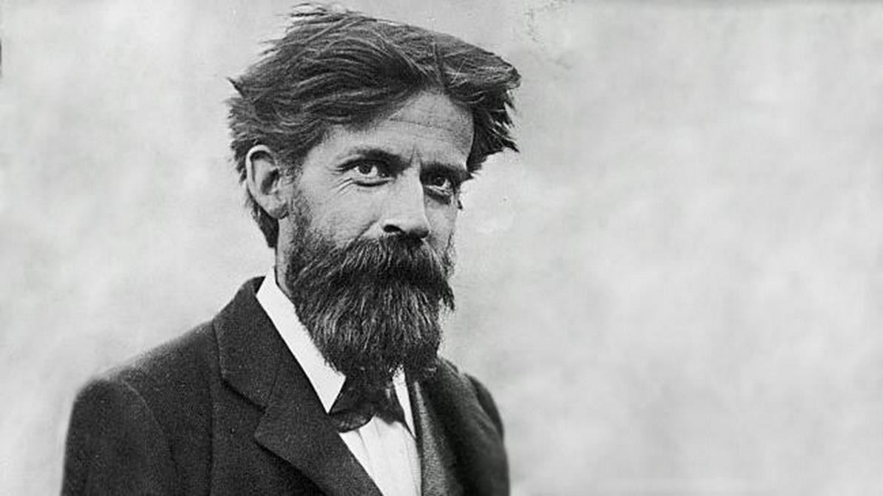
Portrait of Sir Patrick Geddes _©Scottish Historic Buildings Trust

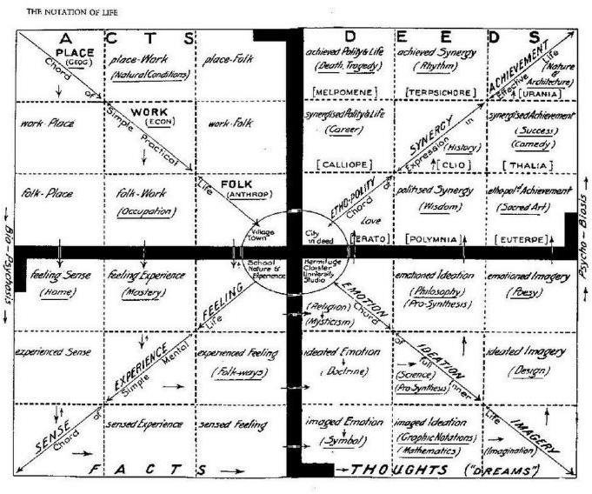
The Concept of Ecological Planning for Cities
The Concept of Ecological Planning _©Sir Patrick Geddes

Sir Geddes’s city concept included open green spaces, parks, gardens, trees and blue infrastructure. He believes that the well-being and magnificence of a city, working with and in collaboration with nature, was essential. His close contact with the countryside heavily influences this concept throughout his childhood. As a result, nature was included in his town plans as an essential component of the urban environment that had to be constructed following the natural environment. Not just to beautify a city but also as an essential component and presence in the built environment, building alongside nature and treating nature as an essential component of the cityscape’s physical contour.
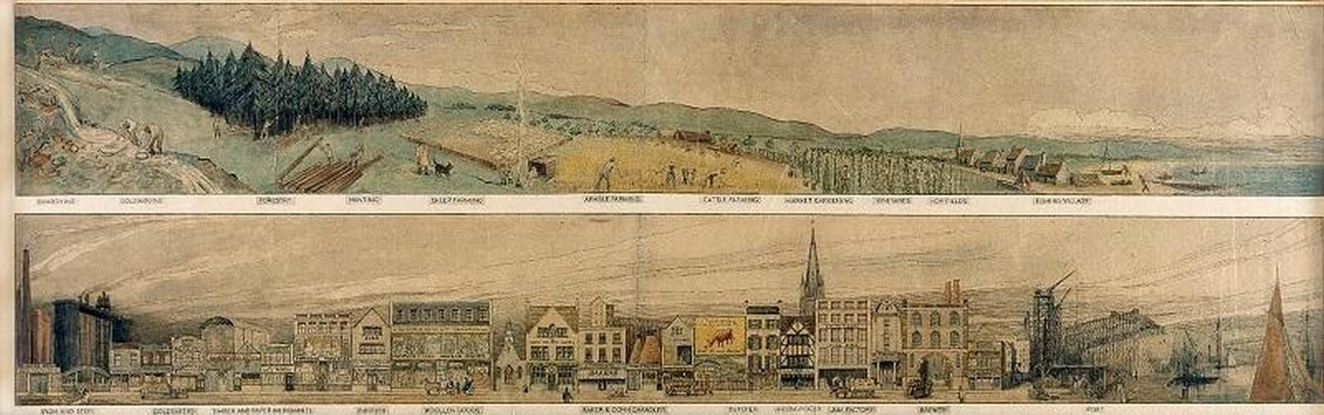
Native Habitat and Their Urban Manifestations _©Sir Patrick Geddes

His fundamental strategy lays out welcoming, healthy, culturally rich,
and environmentally friendly cities for everyone — men and women, rich and poor, old and young — without substantially destroying existing structures and causing excessive expense. In a couple of reports, Sir Geddes commends the different civil planning experts for their endeavours towards upgrades, however overall he pointedly censures their mechanical, inefficient and costly plans of city improvement, for ignoring what is important and can be reestablished with less expense and exertion.

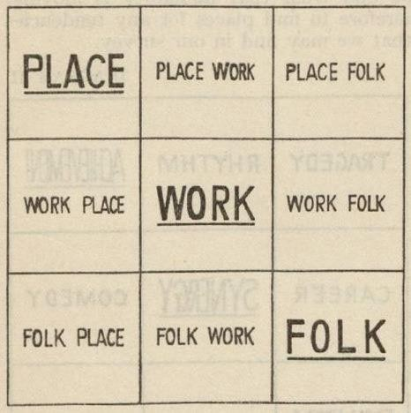
The Principles of Planning According to Geddes
The Principles of Planning _©Sir Patrick Geddess

Contrary to popular misconception, town planning was not a brand-new subfield of engineering, sanitation, architecture, building, or gardening. It was not even a new specialization to be added to the ones already there; Sir Geddes claimed its bigger goal was to bring them all together “in the interest of civic well-being.” He brought the medical science-based concepts of “diagnostic survey” and “conservative surgery,” which served as the foundation for the entire planning process, to town planning.
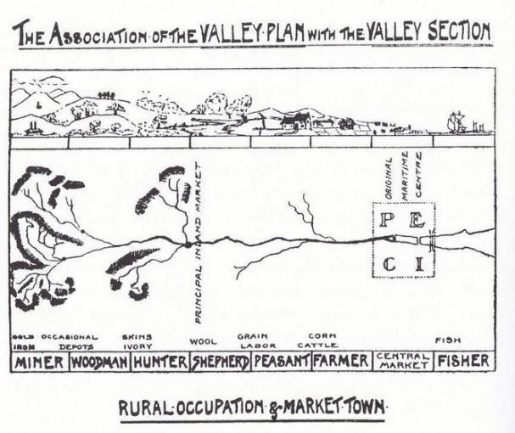
Cities in Evolution _©Sir Patrick Geddes
Although the concept of “diagnosis before treatment” proposed by Sir Geddes was novel
in the field of town planning at the time and is still underappreciated today, it may now seem too obvious to merit attention. The goal of conservative surgery was to make the city better with as little human and financial expense as possible. He believed every city had its rundown areas with decaying houses, filthy neighbourhoods, congested and narrow streets, and natural systems that had been neglected but could be improved and renewed without resorting to drastic and costly destruction methods or removing them. His town plans were based on his belief that the city was an organism rather than a machine whose parts could be easily thrown away.

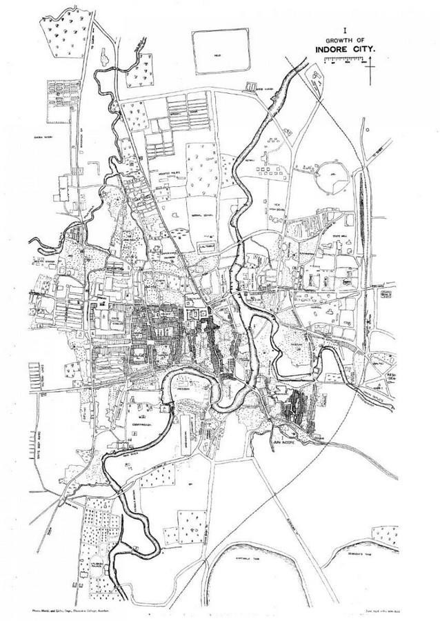
Contribution to Urban Planning

The Making of Indian Cities _©Sir Patrick Geddes

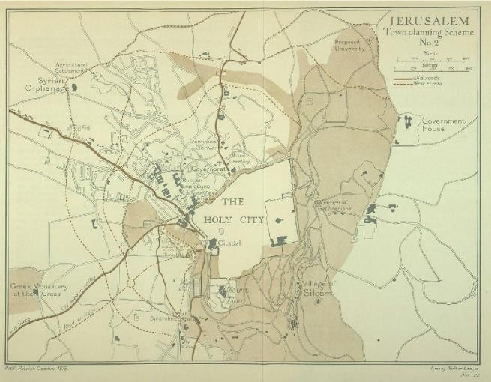
Geddes believed that adaptation involved two parties. Regional cultures, on the one hand, adapt their local environment to meet human needs, but the social and ecological conditions of their particular environment limit these adaptations. Therefore, the complementary process that is just as significant to the adaptation of ecosystems by their inhabitants is the adaptation of local cultures to particular conditions in the ecosystem. Nature and culture are inseparable and mutually supportive in a healthy system. If the 21st century is to mark the end of ecological overshoot and reintegration of humanity into natural processes and limits, this is the essential lesson that humanity must relearn on a global and local scale. Geddes accepted that ʻour most prominent need today is to see life as wholeʼ because he comprehended that solid networks rely upon sound environments and a sound biosphere and because how we configure relies on how we see the world and ourselves.
Plan for Jerusalem _©Sir Patrick Geddes

In terms of ecological planning and design, ecological economics, and bioregionalism, Sir Patrick Geddes’s work can be seen as a precursor. Even though they aren’t always credited with being the result of his work, many of Sir Geddes’s ideas are still influential today. His hypotheses have normally been adjusted in language and setting to contemporary talk. In any case, there are major illustrations of manageable improvement to be reasoned from Sir Geddesʼs work.

Conclusion
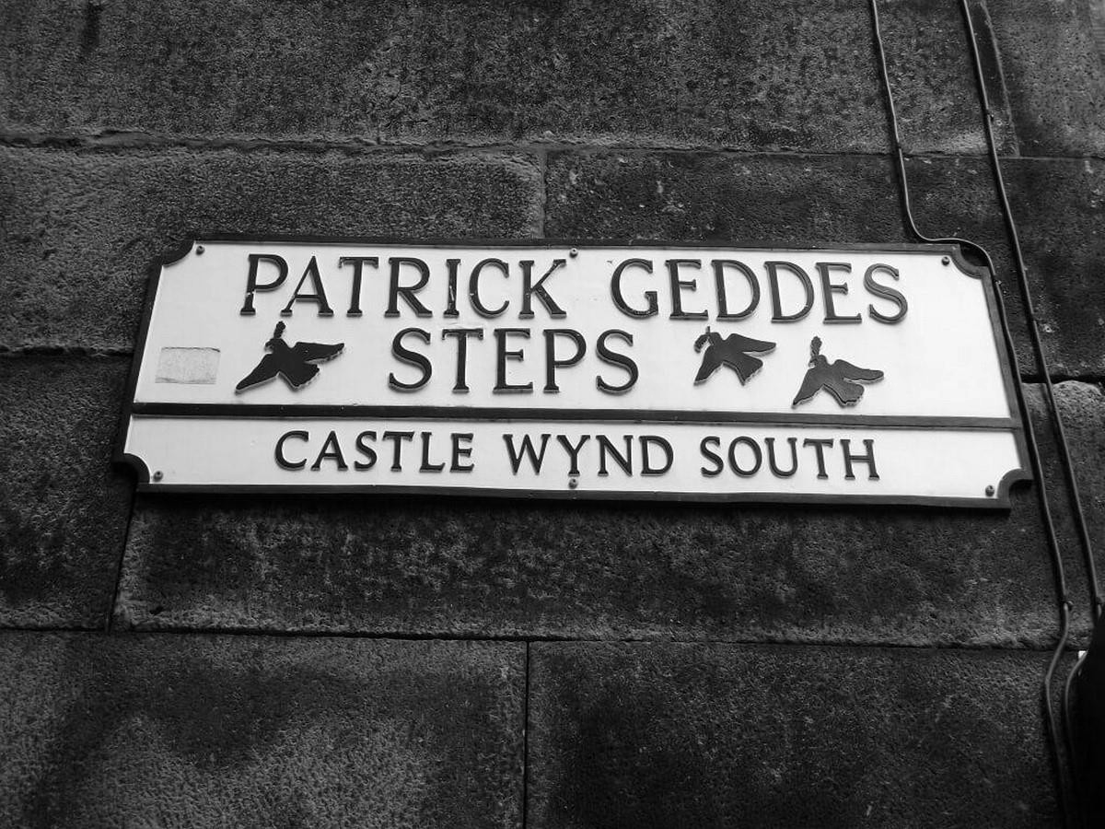

Sir Patrick Geddes’s Legacy _©Question of Cities

In conclusion, the bioregional planning approach, which integrates ecological, socio-cultural, and economic considerations on a regional scale, is one of the key Geddessian impulses that still require additional consideration in the contemporary context of sustainable development. the accentuation on transdisciplinary training as an essential for informed city interest and social change; and a comprehensive approach to design and decision-making that takes into account the contributions of various human knowledge fields.

- List five key words describing Geddes' vision of the modern city.

ADITIONAL MATERIAL 2 - WORKCARD

WORK CARD 2 - CONCEPT STUDY URBAN RENEWAL PROJECT KAAIDISTRICT BRUGGE

Video: https://circularports.vlaanderen-circulair.be/library/kaaidistrict-brugge-be/

- Discuss with your colleagues the arguments FOR and the arguments AGAINST the renovation project of the port district in Bruges.

- Research one of the three innovative zones (retail cluster, food hub, makers' district) in more detail. Find out what similar zones exist in your city, how they function, and what benefits they bring to their communities.

