COURSE SCENARIO
Spain: Society, Culture, and Economy in a global context

CLASS 2
TOPIC | The organization of the State
LEARNING CONTENT - DETAILED CHARACTERISTICS | Students can learn Spain’s official languages, main political parties and how the parliamentary monarchy, the Crown and the administrative, executive, legislative and judiciary organizations are structured.
KEY WORDS | Crown; administrative, executive, legislative and judiciary organizations; Spanish Socialist Workers Party and People's Party; Spanish, Aranese, Basque, Catalan, Valencian, and Galician languages.
SUGGESTED TOOLS | Computer with internet connection and Microsoft Office or similar.
TIPS / METHODOLOGICAL REMARKS  (If applicable) | During the class, students are aimed to collaborate and participate actively with the group dynamics, develop their critical thinking, and express their questions to the professor. After the lesson has finished, students must review the contents learnt and complete the additional tasks for a deeper and broader comprehension of the contents.
IMPLEMENTATION OF THE CLASSES | STEP 1 | Students participate in a discussion with brainstorming about everything they know about the structure of administrative, executive, legislative and judiciary organizations of the State. Afterwards, the professor summarizes the Power Point presentation “The organization of the State” and recommends additional bibliography to complete and expand the students’ knowledge and understanding.
 | STEP 2 | Students answer the tasks related to the contents learned with the “Additional material 1 work card (Administrative structure of Spain)”. The professor helps them by answering their questions, offering examples, and reinforcing participation and collaboration.
 | STEP 3 | The professor starts a dialogue about the previous tasks by asking directly about the answers. While discussing, the professor directs the debate by contrasting and relating different points of view, adding more information, or addressing spontaneous questions to the students to improve their critical reasoning.
 | STEP 4 | The professor compiles the answers and opinions of the students and, as a conclusion, gives a short speech that summarizes the content taught.
 | STEP 5 | The professor presents the “Additional material 2 work card (Languages of Spain)” aimed for the next session and explains it briefly to check if there are any questions.

ADDITIONAL MATERIAL 1 WORK CARD (Administrative structure of Spain)
Place the names of the autonomous communities of Spain in the following map: Andalusia, Aragon, Asturias, Balearic Islands, Basque Country, Canary Islands, Cantabria, Castile and Leon, Castilla-La Mancha, Catalonia, Madrid, Extremadura, Galicia, La Rioja, Navarre, Murcia, and Valencian Community.
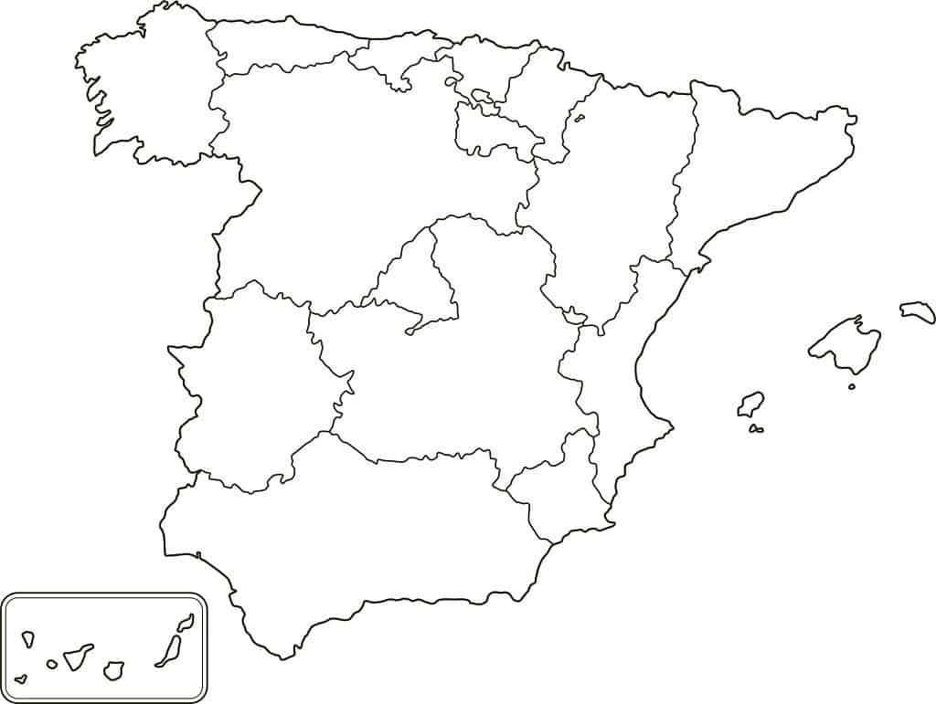
Source: https://proyectomapamundi.com/europa/espana/#Espana_-_mapa_de_comunidades_autonomas
Solution: https://en.wikipedia.org/wiki/Autonomous_communities_of_Spain

ADDITIONAL MATERIAL 2 PICTURE (Languages of Spain)
In the previous map, colour the co-official languages (Aranese/Catalan in purple, Basque in green, Valencian in orange, and Galician in blue) of Spain in this map.
Solution: https://www.epuzzle.info/es/rompecabezas/jugar/educacion/117766-lenguas-oficiales-de-espa%C3%B1a#5x4

