CLASS 2
TOPIC | The challenges facing modern cities
LEARNING CONTENT - DETAILED CHARACTERISTICS | This topic focuses on the main challenges of contemporary cities, influenced by the processes of urbanization and climate change: 1.Rapid urbanization and population. 2. Infrastructure and Services pose challenges in meeting the needs of a growing population. 3.Environmental Sustainability: environmental issues such as air pollution, waste generation, water scarcity, and greenhouse gas emissions. 4.Affordable Housing and Socioeconomic Inequality; 5.Transportation and Mobility. 6.Social Cohesion and Inclusion: Cities are diverse, with varying socioeconomic, cultural, and ethnic backgrounds. 7. Resilience to Disasters and Climate Change. 6. Economic Development and Job Creation. 7.Governance and Planning. Addressing these challenges requires collaboration among government bodies, urban planners, community organizations, and citizens. Innovative approaches, sustainable practices, and technology-enabled solutions are often employed to make cities more resilient, inclusive, and sustainable.
KEY WORDS | Urbanization, Environmental Issues, Human Well being
SUGGESTED TOOLS | Interactive lecture  Power-point presentation  Videos and readings about the population growth and environmental issues  Handouts for analysis in groups  Discussion
TIPS / METHODOLOGICAL REMARKS  (if applicable) | ……………
IMPLEMENTATION OF THE CLASSES | STEP 1 | The introduction to the topic begins with Esri's Story Map (or other actual information from ESRI’s The Living Atlas) on the pace of urbanization in the world  https://storymaps.esri.com/stories/2018/anthropocene-atlas/1-human-reach.html#
 | STEP 2 | Students discuss information (graphical representations) on world population growth rates and pressures on resources. Possible factors for this growth - economic, social, environmental - are also discussed.  See Work Card 1
 | STEP 3 | Presentation about the largest cities in the world at this time. The lecturer focuses on the challenges these cities face - social, infrastructural, environmental
 | STEP 4 | Students are provided with a short text on the ten most significant contemporary challenges facing modern cities. Each student ranks these challenges in order of importance. Students discuss the results in groups.  See Work Card 2
 | STEP 5 | The theme concludes by highlighting the link between urban environmental sustainability and human well-being

ADITIONAL MATERIAL - WORK CARD 1

WORK CARD 1 - WORLD POPULATION GROWTH AND RESOURCE STRESS

Esri's Story Map on the pace of urbanization in the world https://storymaps.esri.com/stories/2018/anthropocene-atlas/1-human-reach.html#
А. Take a look at the charts presented below.
В. Identify five main reasons which you think are influencing the growth of the world's urban population.
С. Which two of these causes have the greatest impact on urban population growth in your country?
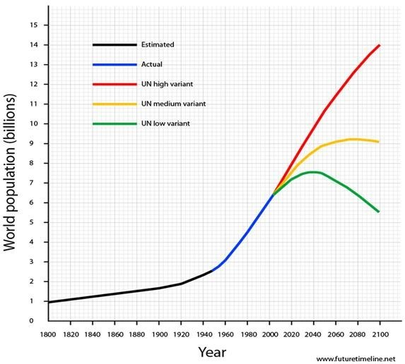

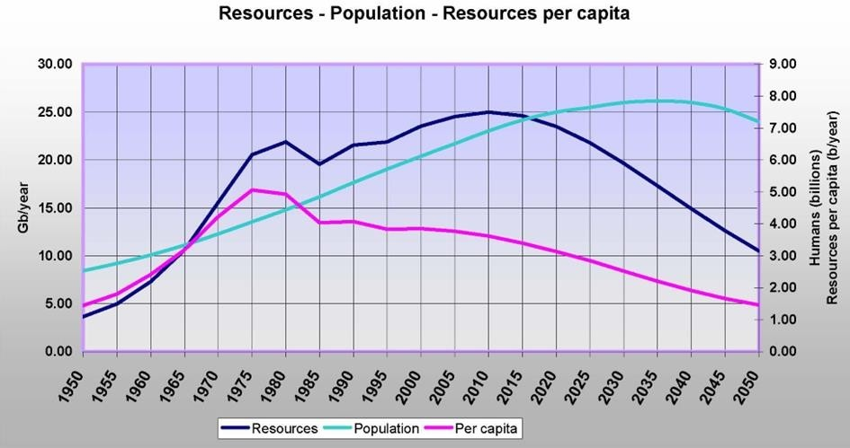
Source: https://www.futuretimeline.net/subject/society-demographics.htm

ADITIONAL MATERIAL - WORK CARD 2
Work Card 2 - Environmental Sustainability of Modern Cities

А. Read the annotated text on the ten most significant environmental challenges facing modern cities.
В. Rank them in order of importance, considering the development of the city you live in.
С. Discuss the results with your colleagues. Justify your ranking.

1. Air Pollution: Poor air quality resulting from vehicle emissions, industrial activities, and other sources poses significant health risks to urban populations.
2. Climate Change: Rising global temperatures, increased frequency of extreme weather events, and sea-level rise threaten the resilience and sustainability of cities.
3. Water Scarcity: Growing populations, inadequate infrastructure, and changing climate patterns contribute to water scarcity and the need for effective water management strategies.
4. Waste Management: Increasing volumes of waste generation, insufficient recycling and disposal systems, and improper waste management practices create environmental and health hazards.
5. Urban Heat Island Effect: Urban areas with high concentrations of concrete and asphalt experience elevated temperatures, impacting energy consumption, air quality, and overall comfort.
6. Biodiversity Loss and Habitat Fragmentation: Urbanization leads to the loss of natural habitats, fragmentation of ecosystems, and a decline in biodiversity, affecting ecological balance and urban resilience.
7. Green Space Preservation: Ensuring the preservation and creation of parks, green spaces, and urban forests is vital for enhancing the quality of life, mitigating heat island effects, and supporting biodiversity.
8. Sustainable Transportation: Promoting sustainable transportation modes such as public transit, cycling infrastructure, and pedestrian-friendly design reduces traffic congestion, air pollution, and energy consumption.
9. Energy Efficiency and Renewable Energy: Reducing energy consumption, promoting energy-efficient buildings, and increasing the use of renewable energy sources are crucial for mitigating climate change and improving urban sustainability.

10. Environmental Justice: Ensuring equitable distribution of environmental benefits and burdens, addressing environmental inequalities, and empowering marginalized communities in decision-making processes are essential for achieving sustainable and just cities.

