CLASS 15
TOPIC | Green Spaces as Community Catalysts: Engaging Urban Residents in Urban Nature
LEARNING CONTENT - DETAILED CHARACTERISTICS | Topic: Community-led initiatives that promote the use, stewardship, and development of urban nature. Social, cultural, and economic benefits of community involvement in urban nature conservation and enhancement. Exploring the role of urban green and blue spaces as vibrant community hubs.  Educating and involving residents in urban nature conservation efforts
KEY WORDS | Nature-Inspired Projects, Eco-solutions, Community
SUGGESTED TOOLS | Interactive lecture  Power-point presentation  Videos and readings  Handouts for analysis in groups  Discussion
TIPS / METHODOLOGICAL REMARKS  (if applicable) | ……………………
IMPLEMENTATION OF THE CLASSES | STEP 1 | Presentation. “Adopt a River” for Sustainable Development: locally focused, global initiative that aims to protect, restore, and sustain freshwater ecosystems to assist and promote the sustainable development of communities
 | STEP 2 | Video: What is Adopt-a-River, source: UNEP https://restorerivers.org; https://youtu.be/z_8tiTj_kdk
 | STEP 3 | Best examples - "adopt a river" initiatives in urban environments  Work card 1.
 | STEP 4 | Presentation: Planning and Implementing Nature-Inspired Projects. Steps for planning and implementing nature-focused projects in urban environments. Strategies for collaboration with stakeholders, policymakers, and community members
 | STEP 5 | Work card 2.  People and Trees: The Importance of Community in Urban Forestry

ADITIONAL MATERIAL 1 - WORK CARD

WORK CARD 1. - BEST EXAMPLES - "ADOPT A RIVER" INITIATIVES IN URBAN ENVIRONMENTS

- Read the text about successful "adopt a river" initiatives in urban environments.
These examples demonstrate the power of community engagement and collective action in revitalizing and conserving urban rivers. By adopting a river and actively participating in cleanup activities, restoration projects, and educational initiatives, these organizations and communities have made a positive impact on the health and well-being of their urban water bodies.

  - The river Thames (London, United Kingdom): The Thames21 organization has initiated an "Adopt a River" program along the River Thames in London. The program engages local communities, schools, and businesses in regular cleanup activities, ecological
surveys, and habitat restoration projects. Volunteers work together to enhance the water quality and biodiversity of the river, while also raising awareness about the
importance of urban river conservation.
  - The Los Angeles River (Los Angeles, USA): The Friends of the Los Angeles River (FoLAR) is a prominent organization that has led the "Adopt a River" program for the
revitalization and conservation of the Los Angeles River. Through community engagement and volunteer efforts, FoLAR has organized large-scale river cleanups, habitat restoration projects, and educational programs. Their initiatives have played a
significant role in transforming the river into a vibrant and ecologically rich urban space.

  - The Brantas River (Malang, Indonesia): The Malang River Community (Komunitas
Sungai Malang) launched the "Adopt the Brantas River" program to address pollution and degradation issues. This community-led initiative involves regular cleanups, tree planting activities, and awareness campaigns to promote sustainable practices and encourage local residents to take ownership of the river's well-being.
  - The Chicago River (Chicago, USA): The Friends of the Chicago River organization has established the "Adopt-a-River" program to engage volunteers and organizations in the protection and restoration of the Chicago River. The program involves various activities, including cleanup events, native plantings, and citizen science projects, all aimed at
improving the river's water quality and enhancing its ecological functions.

  - The Chao Phraya River (Bangkok, Thailand): The "Love Chao Phraya River" campaign was initiated by a collaboration between government agencies, businesses, and
community groups to address pollution and habitat degradation in the Chao Phraya River. The campaign involves regular cleanups, educational activities, and efforts to reduce waste and pollution to restore and protect the river's health.

- Choose one of these examples and do internet research for further information. Identify five main benefits for the local population of such initiatives.

ADITIONAL MATERIAL 2 - WORK CARD
WORK CARD 2. - People and Trees: The Importance of Community in Urban Forestry

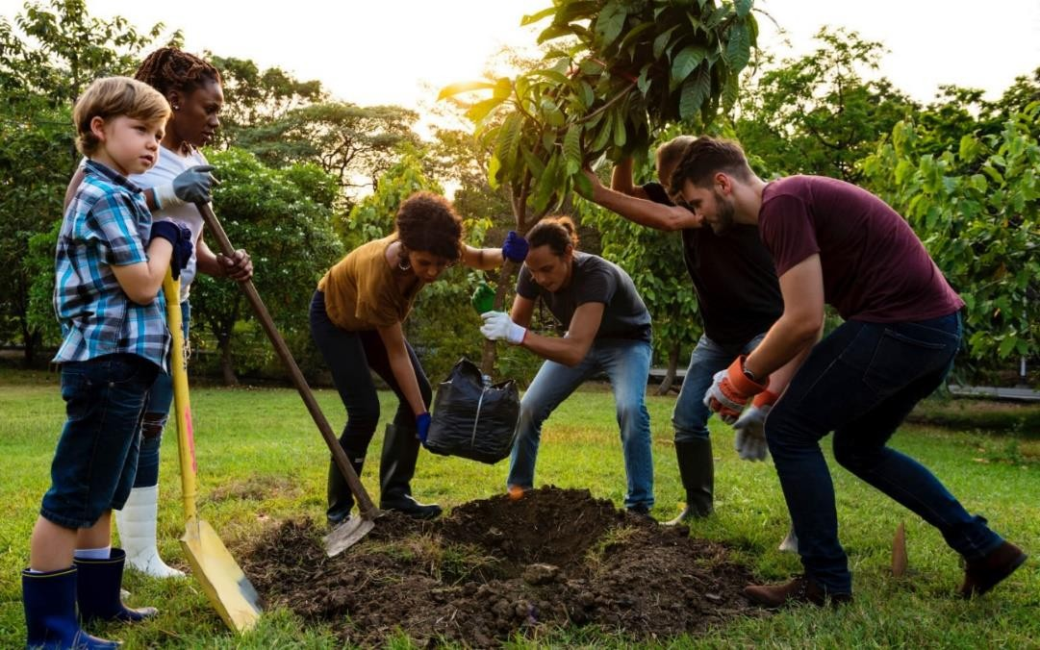

Source: “How You Can Plant a Tree and Help to Save the Planet.” TreeClicks, www.treeclicks.com/plant-a-tree

- Read the paper "Not by trees alone: Centering community in urban forestry"
(https://naturalareasnyc.org/media/pages/in-print/research/c407ef2956-1651590866/campbell- et-al-2022-not-by-trees-alone.pdf)

The paper identifies several key problems, ideas, and conclusions related to urban forestry and community engagement:
Problems:
  - Urban forestry and greening efforts can inadvertently exacerbate existing inequities. Particularly the case when these efforts do not consider the needs and capacities of historically marginalized communities.
  - There is a lack of support for human capacity and care in urban forestry. This is a significant issue as it limits the potential for community engagement and the development of sustainable urban green spaces.
  - The functions of the urban forest are often not re-envisioned to align with the needs and priorities of the community. This can lead to a disconnect between the community and the urban green spaces.

Ideas:
Urban forestry should focus on the needs, capacities, and priorities of historically marginalized communities to foster more equitable and sustainable cities. Three themes are suggested to promote this community-centered approach: enhancing human capacity and care, extending
community organizing beyond the green silo, and reimagining the functions of the urban forest. Inspiration for this approach stems from the innovative efforts of residents, practitioners, and decision-makers striving to create "just cities".
Conclusions:
Urban forestry and greening initiatives can significantly improve communities and reduce inequities when centered on the community. For a community forestry ethos in the field,
prioritizing the needs, capacities, and concerns of historically marginalized communities. Further assert that diversity, equity, and inclusion are integral to sustainability and resilience in urban forestry.

- Imagine you are a city planner in your hometown. Based on what you've learned from the paper, propose a plan for implementing community-centered urban forestry in your city. What steps would you take? Who would you need to involve? What factors should be considered when selecting tree species for planting?

