CLASS 14
TOPIC | Urban Biodiversity: Unveiling the Hidden Gems in Our Cities – II. Parks-Museums and Botanical Gardens
LEARNING CONTENT - DETAILED CHARACTERISTICS | Comparative analysis, promoting analytic and intercultural skills and enriching knowledge, along with hands-on exercise for
KEY WORDS
SUGGESTED TOOLS | Interactive lecture  Power-point presentation  Videos and readings  Handouts for analysis in groups  Discussion
TIPS / METHODOLOGICAL REMARKS  (if applicable) | ……………………………….
IMPLEMENTATION OF THE CLASSES | STEP 1 | Presentation. Botanical gardens as green infrastructure components within cities - promote human health, cultural expression, and ecological sustainability. Biodiversity Conservation: preservation of plant diversity, including endangered and rare species. Botanical gardens as educational hubs, offering opportunities for visitors to learn about plants, ecosystems, and sustainable practices. Therapeutic and Well-being Benefits.
 | STEP 2 | Work card 1.  Bulgarian case studies: Euxinograd and Vrana
 | STEP 3 | Presentation: Attention – invasive species in the city!
 | STEP 4 | Work card 2. Hidden Gems in Your City  Hidden Gems in Your City

ADITIONAL MATERIAL 1 - WORK CARD

WORK CARD 1. - UNVEILING THE HIDDEN GEMS IN OUR CITIES – II. PARKS- MUSEUMS AND BOTANICAL GARDENS

- Conduct a comparative analysis of the Euxinograd and Vrana Park-Museum.

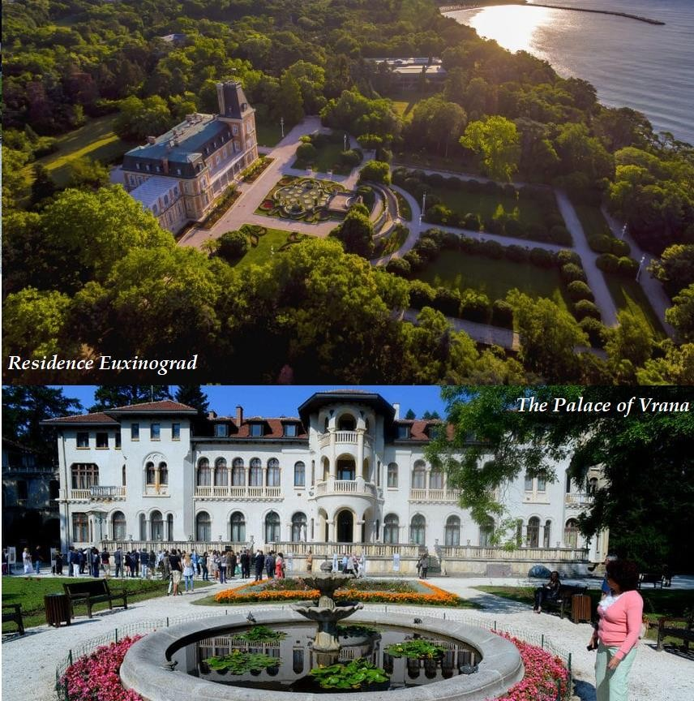

Source’s: https://freesofiatour.com/blog/palace-vrana/ , https://visit.varna.bg/en/euxinograde.html

Euxinograd is a late 19th-century Bulgarian former royal summer palace and park located on the Black Sea coast, 8 kilometers north of downtown Varna. The palace is currently a
governmental and presidential retreat hosting cabinet meeting in the summer and offering access for tourists to several villas and hotels. The palace and park are one of the finest examples of post-Liberation architecture in Bulgaria. The palace was designed in the style of an 18th-century French château, with a high metal-topped mansard roof, figured brickwork, balconies, and a clock tower. The park is home to over 310 plant species from Asia, South America, North Africa, and Southern France
Source: https://en.wikipedia.org/wiki/Euxinograd
Vrana Palace is a royal palace located on the outskirts of Sofia, the capital of Bulgaria. It is today the official residence of the former royal family of Bulgaria. The palace complex includes a large park and two buildings, a two-story hunting lodge built in 1904, and a palace
constructed mainly between 1909 and 1914. The palace combines Byzantine influences, Bulgarian National Revival traditions, Art Nouveau, and French classicism. The park is home to over 400 plant species and has been declared a national monument of landscape architecture.
Source: https://en.wikipedia.org/wiki/Vrana_Palace

- Desing a garden
Based on the knowledge gained from studying Euxinograd and Vrana Park-Museum, design a garden/park using “Online Garden Design Software” https://www.smartdraw.com/garden-
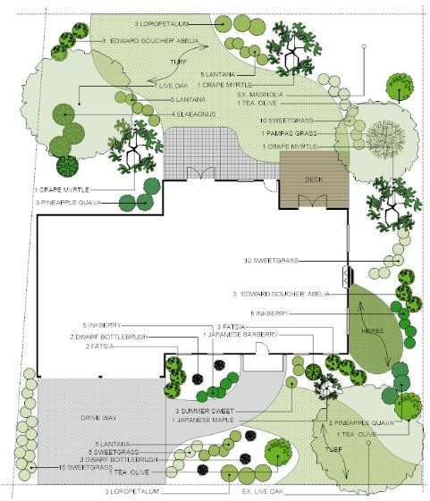
plan/garden-design-layout-software.htm? .
Source: https://www.smartdraw.com/garden-plan/garden-design-layout-software.htm

The design should include:
  - A layout of the garden - Consider the overall design and organization of the garden, including pathways, plant placement, and areas for relaxation and education. Think
about how the layout can enhance the visitor's experience and promote interaction with the plant species.
  - A list of plant species to be included, with a focus on native species which are pollinator friendly - When compiling a list of plant species to include in the garden, prioritize native species that are known to attract and support pollinators like bees, butterflies, and birds.
Research the specific plants that are native to your area and beneficial to local
pollinators, considering their bloom times, colors, and the types of pollinators they attract.

Additional resources/tools:
Botanic Gardens Conservation International - https://www.bgci.org/resources/bgci-tools-and- resources/
Plants For Bees - https://www.buzzaboutbees.net/plants-for-bees.html

ADITIONAL MATERIAL 2 - ASSIGNEMENT

Hidden Gems in Your City

A. Choose a park, garden or museum in your country/city that has impressed you and write a brief description of its unique features, historical significance, or any interesting facts about it.

