CLASS 13
TOPIC | Urban Biodiversity: Unveiling the Hidden Gems in Our Cities – I. Birds in the city
LEARNING CONTENT - DETAILED CHARACTERISTICS | Topic: Discovering the surprising biodiversity that thrives within urban environments. Highlighting the importance of urban biodiversity for ecosystem health and resilience. Showcasing innovative projects and practices that protect and enhance urban biodiversity, fostering coexistence between humans and wildlife.
KEY WORDS | Urban Biodiversity, Avian Ecology
SUGGESTED TOOLS | Interactive lecture  Power-point presentation  Videos and readings  Handouts for analysis in groups  Discussion
TIPS / METHODOLOGICAL REMARKS  (if applicable) | ………………
IMPLEMENTATION OF THE CLASSES | STEP 1 | Presentation: Urban Avian Ecology - how urban environments influence bird populations. Challenges and opportunities faced by birds in urban settings, including habitat fragmentation, noise pollution, artificial lighting, and availability of resources
 | STEP 2 | Video: Common Urban Bird Species in Europe  https://www.youtube.com/watch?v=CXcAx16yl6E
 | STEP 3 | Presentation. Benefits of Birds in the City: Ecological, economic, and cultural benefits provided by urban birds. Role in pollination, seed dispersal, pest control, and as indicators of environmental health. Contribution to the aesthetic value of urban landscapes and inspire human connection with nature.
 | STEP 4 | Citizen Science: City bird watching can contribute to citizen science initiatives focused on monitoring bird populations and distribution patterns.  Work card 1
 | STEP 5 | City Bird Watching as recreational activity.  Work card 2.

ADITIONAL MATERIAL 1 - WORK CARD
WORK CARD 1. - Birds in urban areas

1. Introduction:
Birds in urban areas represent a fascinating intersection of wildlife and human development.
Urban areas are characterized by high human population densities, artificial structures, and often, a lack of traditional wildlife habitats. However, they also provide new types of resources such as food from human activities and warm, sheltered spots for nesting. As a result, some
bird species have adapted remarkably well to city life, while others struggle to survive. Human attitudes and actions can significantly influence bird behavior in urban settings. For instance, providing bird feeders or planting native vegetation can attract certain species, while noise
pollution or pet cats can deter them. Interestingly, cultural differences between cities can also affect bird populations. For example, a study found that residents of Berlin encouraged birds more than residents of Seattle, leading to variations in bird behavior across these cities.
Urban environments can also expose birds to new threats. Trace metals from anthropogenic activities, such as lead and zinc, can accumulate in birds, affecting their health and survival.
In conclusion, urban areas present a dynamic and complex environment for birds. Understanding how birds adapt to and are affected by urban settings is crucial for their conservation in an increasingly urbanized world Clucas, B., & Marzluff, J. (2012).
Source: Clucas, B., & Marzluff, J. (2012). Attitudes and Actions Toward Birds in Urban Areas: Human Cultural Differences Influence Bird Behavior. The Auk,
129(1). DOI: 10.1525/auk.2011.11121

A. Bird Watching in Urban Areas
- Visit the Swiss Ornithological Institute's website, specifically the page on “Birds in Urban Areas”:
https://www.vogelwarte.ch/en/birds/watching-birds/birds-in-urban-areas

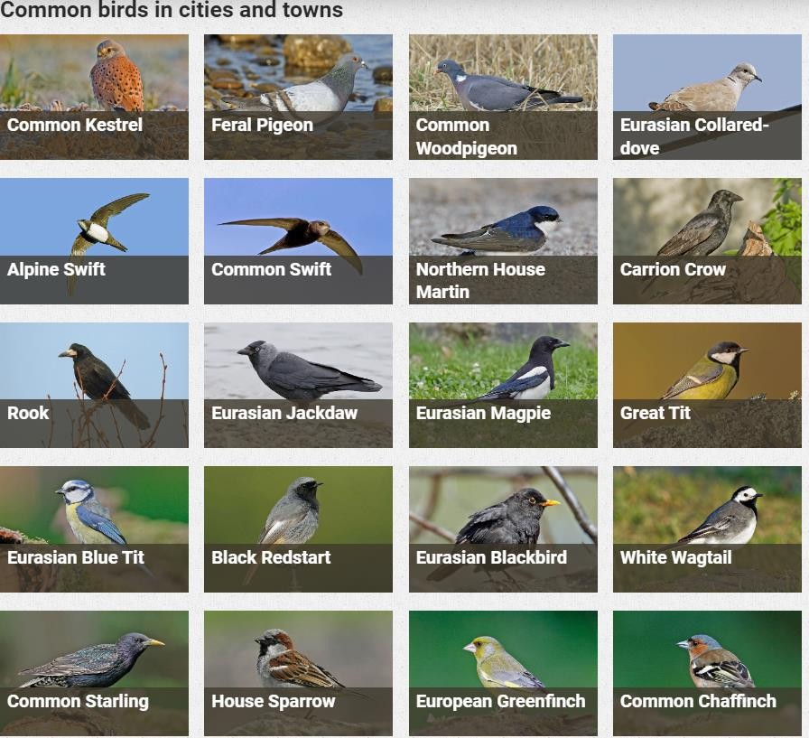
Source: https://www.vogelwarte.ch/en/birds/watching-birds/birds-in-urban-areas

  - Take notes on the types of birds commonly found in urban areas and the challenges they face.
  - Spend an hour observing birds in an urban setting. Document the species you see, their behaviors, and the types of environments they inhabit (parks, rooftops, streets, etc.).
(- Optionally mobile Apps for identification of birds can be used like “Picture Bird”)
  - As a group, discuss your individual findings. Identify common themes or interesting differences in the types of birds observed or their behaviors.

Questions:
- What were the most common bird species you observed in the urban setting, and how did their behaviors differ from what you expected based on your initial research on the Swiss
Ornithological Institute's website?
- During your group discussion, what were some of the most interesting differences in bird observations made by different group members, and what factors might explain these differences?

ADITIONAL MATERIAL 2 - QUIZZ

Urban Bird Feeding: Implications and Opportunities

- Read the paper "Feeding birds in our towns and cities: global research opportunity"
- https://onlinelibrary.wiley.com/doi/epdf/10.1111/j.0908-8857.2008.04271.x

- Quiz: Understanding Urban Bird Feeding and Its Ecological Implications

  - What is the main topic of the paper by Darryl N. Jones and S. Reynolds?
    - Bird migration patterns
    - Bird feeding in urban areas
    - The impact of climate change on bird populations
    - The role of birds in pollination
  - According to the paper, what does bird feeding in urban areas provide an important opportunity for?
    - Bird watching
    - Urban planning
    - Research in urban ecology
    - Increasing bird populations
  - What is one potential implication of bird feeding in urban areas discussed in the paper?
    - It can lead to overpopulation of certain bird species
    - It can cause birds to become dependent on human food
    - It can disrupt the natural behavior of birds
    - All of the above

  - What is urban ecology?
    - The study of the relationship between humans and nature in urban areas
    - The study of urban planning and design
    - The study of pollution in cities
    - The study of the impact of urbanization on wildlife
  - Why might bird feeding practices in different cities or towns vary?
    - Different types of birds live in different areas
    - Different cities have different laws and regulations about bird feeding
    - Cultural attitudes towards bird feeding may vary
    - All of the above
  - What is a case study?
    - A detailed investigation of a particular instance or event
    - A general survey of a broad topic
    - A theoretical analysis of a hypothetical situation
    - A statistical analysis of a large dataset
  - What might a research project on bird feeding in your local area involve?
    - Observing and recording bird behavior
    - Surveying local residents about their bird feeding habits
    - Analyzing the impact of bird feeding on local bird populations
    - All of the above
  - What is the purpose of an action plan in a research project?
    - To outline the steps for data collection, analysis, and reporting
    - To provide a summary of the research findings
    - To argue for the importance of the research topic

    - To provide a literature review of previous research on the topic

  - According to the paper, why is it important to study the impact of bird feeding on urban ecology?
    - It can help us understand the relationship between humans and nature in urban areas
    - It can inform policies and regulations about bird feeding
    - It can provide insights into the behavior and ecology of urban bird populations
    - All of the above
  - What is one way that bird feeding could potentially impact the urban ecosystem?
    - It could lead to an increase in bird-related noise pollution
    - It could attract other wildlife to urban areas
    - It could lead to an imbalance in bird species diversity
    - All of the above

