CLASS 12
TOPIC | Nature-Based Recreation: Nurturing Health and Well-being in Urban Residents – II. Pop-Up Parks
LEARNING CONTENT - DETAILED CHARACTERISTICS | Topic: Innovative approaches to urban recreation: temporary installations that transform underutilized urban spaces, such as parking lots, vacant lots, or streets, into vibrant recreational areas for a limited period of time.
KEY WORDS | Pop-Up Parks
SUGGESTED TOOLS | Interactive lecture  Power-point presentation  Videos and readings  Handouts for analysis in groups  Discussion
TIPS / METHODOLOGICAL REMARKS  (if applicable) | ………………………………
IMPLEMENTATION OF THE CLASSES | STEP 1 | Presentation: Concept “Pop-Up Parks” - aim to create accessible and inclusive recreational spaces within the urban fabric, offering opportunities for community engagement, social interaction, and outdoor activities.
 | STEP 2 | Students do independent internet research and discuss the results. Benefits and Best Examples  Work card 1.
 | STEP 3 | Read the article (10 min) “Four Inspiring Examples of Innovative Parks and Rec Programs” source: https://www.civicplus.com/blog/pr/innovative-parks-and-rec-programs
 | STEP 4 | Workshop. Reimagining Urban Parks: Generating Ideas for Innovative Recreation Spaces  Work card 2.

ADITIONAL MATERIAL 1 - WORK CARD

WORK CARD 1. - Pop-Up Park’ Benefits

- Read the text. Rank the benefits listed in order of importance. Justify your choice:

  - Activation of Underutilized Spaces: Pop-Up Parks revitalize neglected or vacant areas, making them accessible and inviting for community members to gather and enjoy
outdoor activities.
  - Increased Social Interaction: These temporary parks provide opportunities for people to connect, socialize, and engage in shared experiences, fostering a sense of community and belonging.
  - Affordable Recreation: Pop-Up Parks offer low-cost recreational options for urban residents, making outdoor activities accessible to individuals who may not have access to traditional parks or recreational facilities.
  - Flexibility and Adaptability: The temporary nature of these parks allows for experimentation, flexibility, and adaptation to different locations, seasons, and community needs.
  - Promotion of Sustainable and Creative Urban Design: Pop-Up Parks encourage
innovative and sustainable design practices by repurposing existing urban spaces, reducing waste, and showcasing temporary installations that spark creativity and imagination.
By promoting Pop-Up Parks, cities can create dynamic and engaging recreational spaces that enhance the urban experience, activate underutilized areas, and foster a sense of community, health, and well-being.

- Best Examples: Do your own internet research, learn more about Cheonggyecheon Stream, South Korea

Cheonggyecheon Stream

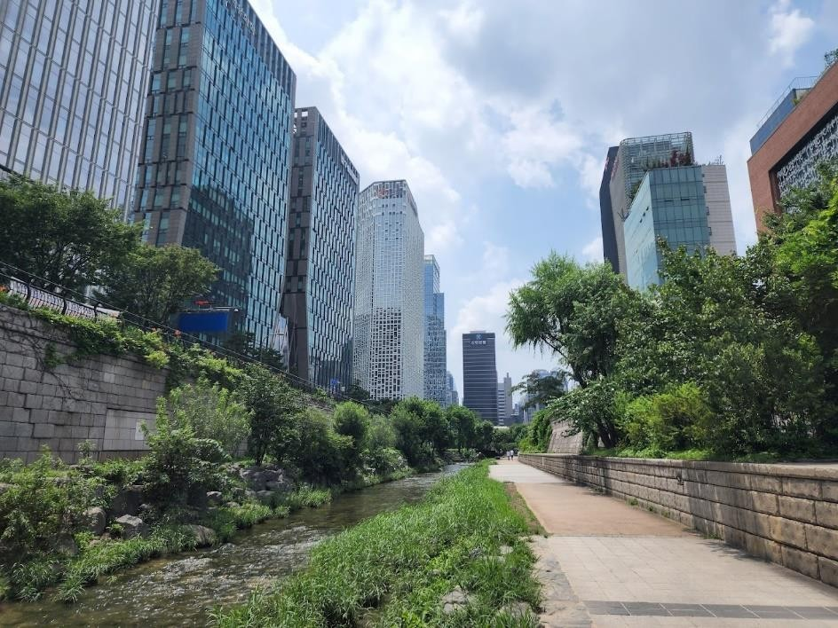

Source:https://lh3.googleusercontent.com/p/AF1QipMBFzXc3zJbHRsenElXou- ZfWU8Bug6W-X7ffdj=s1360-w1360-h1020

- Find out about your city or a neighboring city - whether similar innovative approaches to recreation are being implemented. Present the information to your colleagues.

ADITIONAL MATERIAL 2 – Workshop
Workshop: Reimagining Urban Parks: Generating Ideas for Innovative Recreation Spaces

Workshop Objective: To foster creativity and generate innovative ideas for urban parks that promote recreation, community engagement, and well-being in the urban environment.
Duration: Half-day workshop (approximately 3-4 hours)
Materials needed:
- Large whiteboard or flip chart paper
- Markers or colored pens
- Sticky notes or index cards
- Design magazines or images of existing parks (optional)
- Laptops or tablets for online research (optional) Workshop Structure:
- Introduction (15 minutes)
  - Welcome participants and introduce the workshop's objective and importance of innovative urban parks for recreation.
  - Provide a brief overview of successful examples of innovative urban parks to inspire participants.
- Icebreaker Activity: Park Experience Sharing (15 minutes)
  - Ask participants to briefly share their memorable experiences or favorite features from parks they have visited.
  - Encourage participants to highlight specific aspects of those parks that made the experience enjoyable or unique.

- Presentation: Current Challenges and Opportunities (30 minutes)
  - Present an overview of the current challenges and opportunities related to urban parks, such as limited space, environmental sustainability, inclusivity, and evolving recreation trends.

  - Discuss the importance of considering diverse user groups, technological integration, environmental considerations, and community engagement in park design.
- Brainstorming Session: Idea Generation (60 minutes)
  - Divide participants into small groups of 4-6 people.
  - Provide each group with sticky notes or index cards and markers.
  - Assign each group a specific focus area for innovative park features, such as sustainable design, interactive technology, health and wellness, cultural integration, or community engagement.
  - Instruct groups to brainstorm ideas within their assigned focus area, encouraging them to think outside the box and be creative.
  - Each group should write down their ideas on individual sticky notes or index cards, with one idea per note.
- Idea Sharing and Group Discussion (45 minutes)
  - Ask each group to present their ideas to the larger group.
  - Facilitate a discussion after each presentation, allowing participants to ask questions, provide feedback, and offer suggestions for improvement.
  - Encourage participants to build upon each other's ideas and inspire cross- pollination of concepts between groups.

- Idea Development and Refinement (45 minutes)
  - After idea sharing, reconvene the small groups.
  - Instruct each group to select one or a combination of their ideas that they find most promising and refine it further.
  - Provide materials for groups to sketch or visually represent their refined ideas on large whiteboards or flip chart paper.
  - Encourage participants to consider practicality, feasibility, and user experience when refining their ideas.
- Group Presentations and Feedback (30 minutes)
  - Ask each group to present their refined ideas to the larger group.
  - Facilitate a constructive feedback session, allowing participants to share their thoughts, suggestions, and potential improvements.
  - Emphasize the importance of collaboration and the value of diverse perspectives in shaping innovative urban park designs.
- Conclusion and Wrap-up (15 minutes)
  - Summarize the key ideas and insights generated during the workshop.
  - Thank participants for their contributions and encourage them to continue exploring and advocating for innovative urban park designs in their communities.

