COURSE SCENARIO
Spain: Society, Culture, and Economy in a global context

CLASS 10
TOPIC | Overview of Tourism Sector in Spain
LEARNING CONTENT - DETAILED CHARACTERISTICS | •Introduction to the tourism sector in Spain: History and evolution  •Characteristics of the Spanish tourism sector: inbound and outbound tourism, popular destinations, types of tourism  •Impact of tourism on the Spanish economy: Employment, revenue, and GDP contribution  •Challenges and opportunities for the Spanish tourism industry: sustainability, innovation, and digital transformation
KEY WORDS | Inbound tourism; Outbound tourism; Sun and beach tourism; Cultural tourism; Sustainable tourism; Digital transformation; Revenue and GDP contribution
SUGGESTED TOOLS | • PowerPoint presentation  • Videos and documentaries about Spanish tourism  • Interactive maps and infographics  • Case studies and success stories of Spanish tourism companies  • Online resources, such as government reports and industry publications
TIPS / METHODOLOGICAL REMARKS  (If applicable) | • Encourage students to share their personal experiences and perceptions about Spanish tourism  • Use interactive tools, such as polls and quizzes, to engage students and assess their understanding  • Assign group projects or presentations to encourage collaboration and creativity  • Provide real-world examples and case studies to illustrate key concepts  • Use role-playing activities or simulations to simulate real-life scenarios and challenges faced by the Spanish tourism industry
IMPLEMENTATION OF THE CLASSES | STEP 1 | Introduction to the tourism sector in Spain  • Overview of the history and evolution of Spanish tourism  • Importance of tourism in the Spanish economy  • Types of tourism and popular destinations in Spain
 | STEP 2 | Characteristics of the Spanish tourism sector  • Inbound and outbound tourism in Spain  • Sun and beach tourism and cultural tourism  • Sustainable tourism and digital transformation in the Spanish tourism industry
 | STEP 3 | Impact of tourism on the Spanish economy  • Employment, revenue, and GDP contribution of the tourism sector  • Examples of successful Spanish tourism companies
 | STEP 4 | Challenges and opportunities for the Spanish tourism industry  • Sustainability challenges and initiatives in Spanish tourism  • Innovation and digital transformation in the Spanish tourism industry  • Opportunities for growth and development in the Spanish tourism industry
 | STEP 5 | Conclusion and wrap-up (5 minutes)  • Recap of key concepts and takeaways from the class session  • Opportunities for further learning and exploration of the Spanish tourism industry

ADDITIONAL MATERIAL 1 (WORK CARD, PICTURE, RECORDING, QUIZ, PRESENTATION, ASSIGNMENTS)
• Assignment: Research and present on a successful Spanish tourism company (hotel company, travel agency, airline, …) highlighting its business model, marketing strategy, and impact on the industry.

ADDITIONAL MATERIAL 2 (WORK CARD, PICTURE, RECORDING, QUIZZ, PRESENTATION, ASSIGNEMENTS)
Interactive map: Explore popular destinations in Spain and learn about their cultural and historical significance.
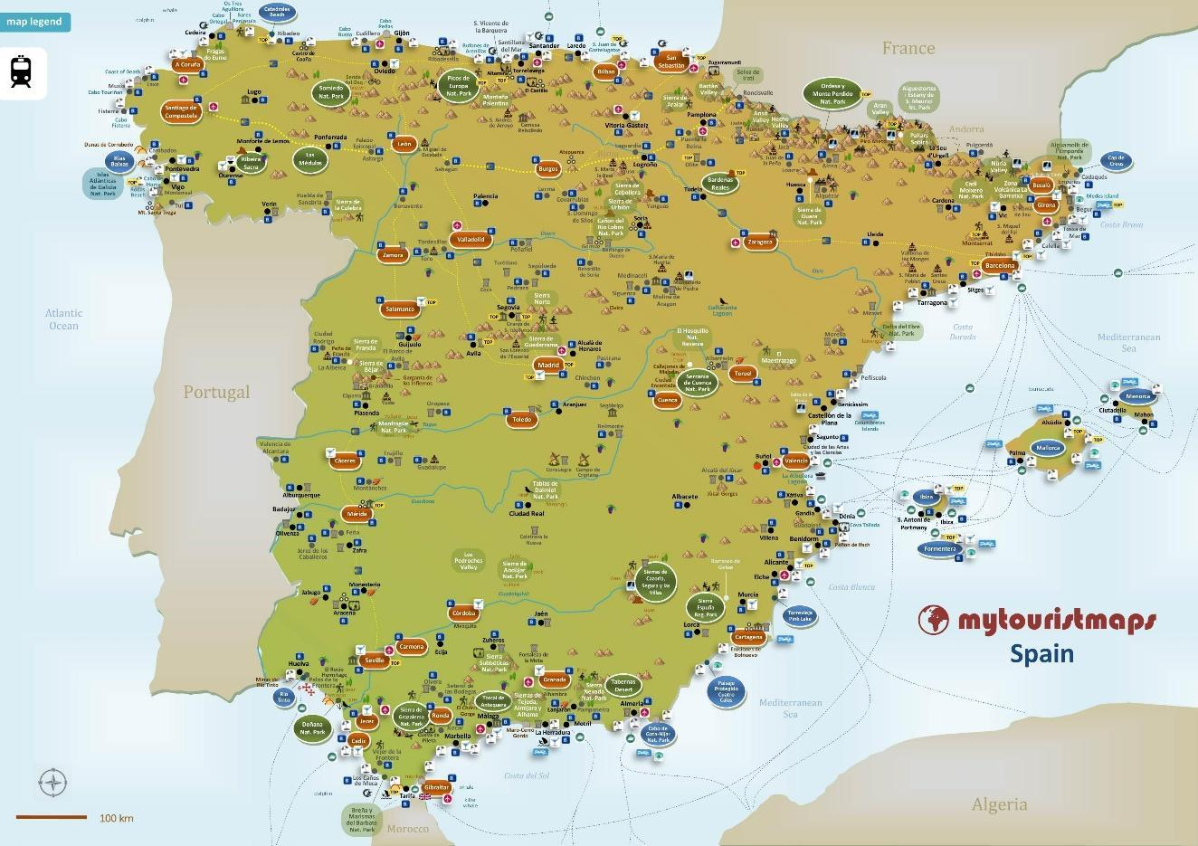
Source: https://maps-spain.com/maps-spain-tourist/spain-tourist-map

