CLASS 9
TOPIC | Media pedagogy and media literacy
LEARNING CONTENT - DETAILED CHARACTERISTICS | This class discusses the newly emerged field of media pedagogy which focuses on:  1.Upbringing and instructional interaction (family, kindergarten, school environment) directed at upward development;  2. Media influence (caused by media tools and content)  Media pedagogy is defined as the overlapping section among media education, which deals with the study of the different aspects of the media; media socialization, which focuses on the way modern communication and media consumption affect the process of personal development, i.e. how media means and media content can affect value system (formation and development); media and information literacy (culture), which is mainly related to the media usage and application and the way media can be best utilized for educational purposes.
KEY WORDS | Media pedagogy; teaching media literacy
SUGGESTED TOOLS | Power-point presentation  Videos and readings that can serve as examples for discussion  Discussion
TIPS / METHODOLOGICAL REMARKS  (if applicable) | The “flipped classroom” method is used. Students are assigned readings and videos to watch and then a class discussion is carried out. All steps are detailed in the description
IMPLEMENTATION OF THE CLASSES | STEP 1 | The students are assigned to read the power-point presentation and think of possible questions to discuss.
 | STEP 2 | The students are assigned to find examples of how media literacy can be taught at school.  See Work Card 1 and Work Card 2
 | STEP 3 | Discussion: the students come to class and discuss media pedagogy and how media literacy can be taught. They ask questions based on their getting acquainted with the presentation of the lecturer.
 | STEP 4 | The lecturer clarifies the different points of view and makes students critically assess the impact media pedagogy has in the contemporary world.
 | STEP 5 | Learners discuss the different examples they have found illustrating the way media literacy is taught in schools.

ADDITIONAL MATERIAL - WORK CARD 1
WORK CARD 1 – MEDIA PEDAGOGY

Task 1: |Make a search for sites suggesting different ways of teaching media literacy in school and choose the one you think can be the most effective. Explain why you think so and support your opinion.
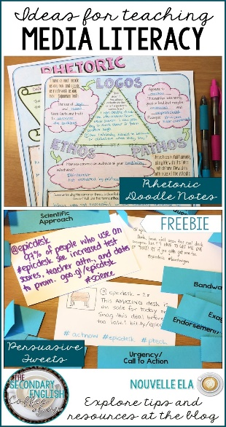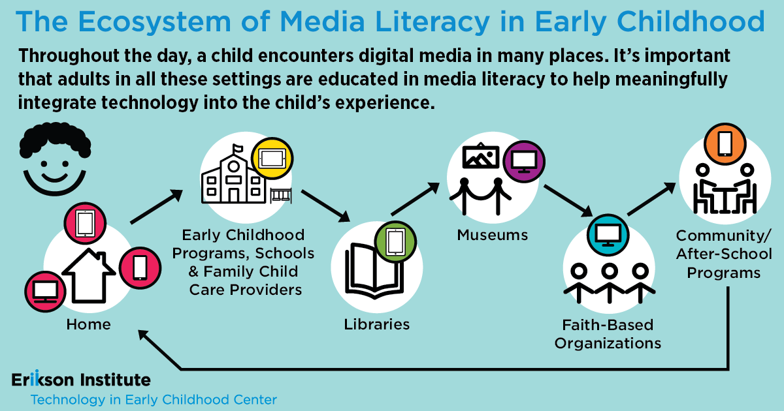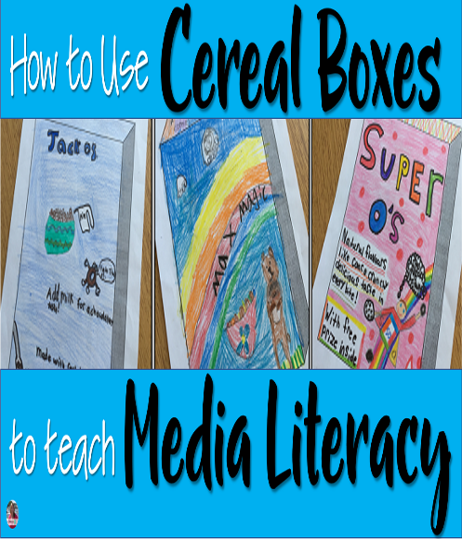

Task 2. On the basis of your search, make your own plan for a lesson in media literacy.

ADDITIONAL MATERIAL - WORK CARD 2
WORK CARD 2 – MEDIA PEDAGOGY
Task 2. Find information about virtual simulation learning as part of the constructivist approach or the integrative approach in education and suggest a way of using it in a classroom of your choice. What can you teach them?
Example. “Take” students to a virtual tour of a museum, https://www.familydaystriedandtested.com/free-virtual-tours-of-world-museums-educational-sites-galleries-for-children/
