CLASS 8
TOPIC | Becoming media literate
LEARNING CONTENT - DETAILED CHARACTERISTICS | This class focuses on the way media literacy can be used as a methodology and as instruments to make our own choice in understanding the world around us. It underlines the fact that media literacy encourages sound skepticism through helping us formulate correct and appropriate questions and thus find the proper answers. It shows how media literacy boosts the development of a new type of pedagogy, media pedagogy, that helps us deconstruct and construct communicated messages. The attention of the students is drawn to the framework of 5 KEY problems related to each media message that forms the basis of what we call media literacy. These problems are associated with:  - AUTHORSHIP  - FORMAT  - AUDIENCE  - CONTENT  - GOAL
KEY WORDS | media messages; deconstructing media messages, media pedagogy
SUGGESTED TOOLS | Power-point presentation  Videos and readings that can serve as examples for discussion  Discussion
TIPS / METHODOLOGICAL REMARKS  (if applicable) | The “flipped classroom” method is used. Students are assigned readings and videos to watch and then a class discussion is carried out. All steps are detailed in the description
IMPLEMENTATION OF THE CLASSES | STEP 1 | The students are assigned to read the power-point presentation and think of possible questions to discuss.
 | STEP 2 | The students are assigned to find examples illustrating at least one of the problems media messages presents.  See Work Card 1 and Work Card 2
 | STEP 3 | Discussion: the students come to class and discuss media messages and how being media literate can make us better cope with the problems media messages make us face. They ask questions based on their getting acquainted with the presentation of the lecturer.
 | STEP 4 | The lecturer clarifies the different points of view and makes students critically assess the connection between media messages and media literacy.
 | STEP 5 | Learners discuss the different examples they have found illustrating the way media messages can become problematic and the role of media literacy in helping us solve these problems.

ADDITIONAL MATERIAL - WORK CARD 1
WORK CARD 1 – MEDIA MESSAGES AND MEDIA LITERACY

Task 1: Thinking about the five problematic areas associated with the media message, write at least five questions for deconstructing one of them.

SUGGESRED ANSWERS:
Deconstructing AUTHORSHIP means not only to understand who did it, but also why did it in the way it is done.
Possible questions to ask:
1. Who created the message?
2. What creative techniques that attract attention have been used?
3. How do different people understand this message? Is it different from the way we understand it? Why?
4. What values does the message impart? What perspectives are missing? Why?
5. What is the reason to SEND this message?

Understanding the FORMAT means to be aware of all the components of the message: sound, text, picture, colors, sizes of different objects, words, highness of volume, tone, body language , if such is available, mimics, things which look obvious (why) and things that look strange (why).
Possible questions to ask:
- What does impress about you about colors, tones, sizes, moves etc.
- Are they real? What makes us think so?
- Is there something missing? Is it important? Why is it missing?
- What type of emotions does the message bring about? Why so?
- What makes the message look real? What are the convincing arguments supporting its true nature?
When thinking about the AUDIENCE we have to think about: What is the target audience of the message? Why has it been chosen? What is it’s profile? What is their experience: same, similar, different? Are there major differences in understanding the message?
Possible questions to ask:
- Have you ever experienced something similar?
- What did you learn from the message?
- What is your OWN understanding of the message?
- Are there other ways to understand the message? Where can we learn about those understandings from?
- Are those different understandings valid? Why do we think so?

The key issue about CONTENT is to properly understand the values and interests that stand behind. As well as the degree to which those values and interests meet the generally accepted social norms and ethics.
Possible questions to ask:
- What type/s of behavior (and consequences) does the message present?
- What type of character does the message provoke you to identify with?
- What social values does the message try to “sell” (promote, negate)?
- What are the missing perspectives? Where can we understand about them? Are they important?
- Would those missing perspectives, if available, have changed the way we understand the message?

When talking about GOALS we think about the following: Why is the message created? Is it related to boosting someone’s power, money, ego, influence etc.
Possible questions to ask:
- Who controls the message creation and dissemination?
- Why is it created and sent? How do we know that?
- Who has a profit due to that message? Person/s, organization/s, institution/s, state/s? Person/s, organization/s, institution/s, state/s?
- Who pays for it? Person/s, organization/s, institution/s, state/s?
- What economic interests have implicated the creation and dissemination of that message? Private, corporative, political?

Task 2. After preparing your list, find an example to illustrate at least one of the questions you have formulated.

ADDITIONAL MATERIAL - WORK CARD 2
WORK CARD 2 – MEDIA MESSAGES AND MEDIA LITERACY

Task 1. Read John Spacey’s “28 Examples of Media Messages” at https://simplicable.com/en/media-messages and think of examples of at least three of these media messages you have encountered recently. Comment on the way it has worked on you.
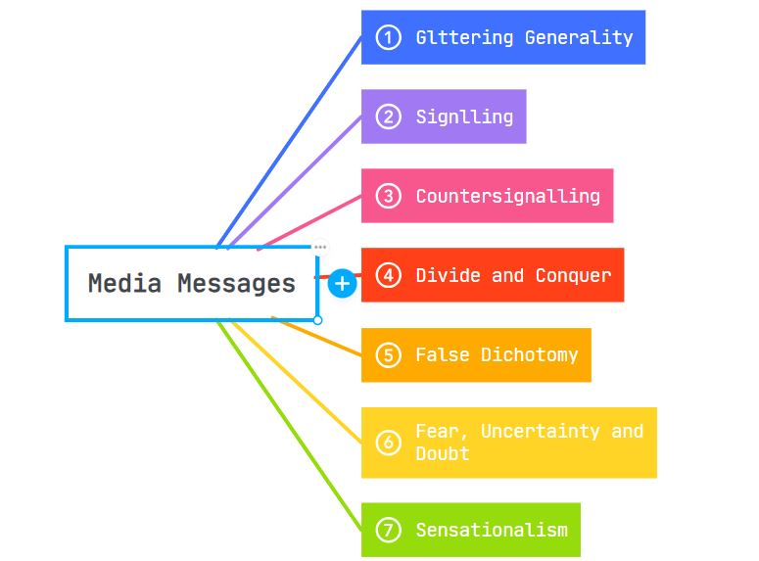
Task 2. How being media literate can help you understand better the media messages you have chosen to discuss here?

