CLASS 7
TOPIC | Media effects and media literacy
LEARNING CONTENT - DETAILED CHARACTERISTICS | This class discusses the media effect/s media create in consumers. They are discussed as all the processes resulting from consumers’ interaction with the media that affect them directly or indirectly.  The class focuses on the types of media effects such as:  - cognitive effect;  - verification effect;  - evaluation effect;  - emotional effect;  - psychological effect;  - behavioral effect.  Understanding the different types of media effect is discussed as part of becoming media literate.
KEY WORDS | Media effects; media literacy
SUGGESTED TOOLS | Power-point presentation  Videos and readings that can serve as examples for discussion  Discussion
TIPS / METHODOLOGICAL REMARKS  (if applicable) | The “flipped classroom” method is used. Students are assigned readings and videos to watch and then a class discussion is carried out. All steps are detailed in the description
IMPLEMENTATION OF THE CLASSES | STEP 1 | The students are assigned to read the power-point presentation and think of possible questions to discuss.
 | STEP 2 | The students are assigned to find examples illustrating the different types of effect the media create.  See Work Card 1 and Work Card 2.
 | STEP 3 | Discussion: the students come to class and discuss the different types of media effects. They ask questions based on their getting acquainted with the presentation of the lecturer.
 | STEP 4 | The lecturer clarifies the different points of view and makes students critically assess the different types media effects and their connection to media literacy.
 | STEP 5 | Learners discuss the different examples they have found illustrating he effects the media generate in consumers.

ADDITIONAL MATERIAL - WORK CARD 1
WORK CARD 1 – MEDIA EFFECTS AND MEDIA LITERACY
Task 1: Choose one of the media effects listed below and think of examples of its possible consequences as they are listed. Try to find examples of all the four possible consequences.
MEDIA EFFECTS MEDIA EFFECTS’ CONSEQUENCES
Cognitive Acceptance
Verification Triggering
Evaluation Changing
Emotional Intensifying
Psychological
Behavioral
Task 2. Compare your answers to James Potter’s understanding of media effects as represented in the following table from the book Media Effects (SAGE Publications Inc., 2012).
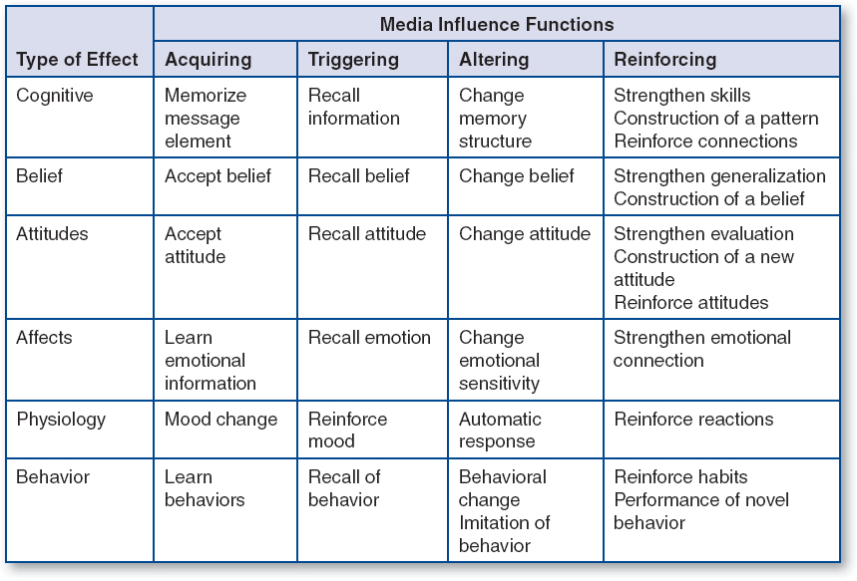
ADDITIONAL MATERIAL - WORK CARD 2
WORK CARD 2 – MEDIA EFFECTS AND MEDIA LITERACY
Task 1. Look at the levels of learning within the cognitive domain as defined by Bloom and think about the possible connection between this domain and the media effects and consequences. How do they relate to the way media literacy has been defined?

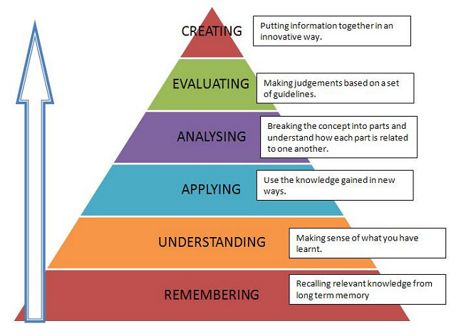

Task 2. Find suitable examples to illustrate your understanding of these issues.

