CLASS 3
TOPIC | Development of the concept of “media literacy”
LEARNING CONTENT - DETAILED CHARACTERISTICS | This class focuses on the definitions of the term “media literacy” from the theories of Marshal McLuhan to the contemporary poststructuralist and post-humanist philosophers. Media literacy is discussed as part of the theories that try to define the new “mode of information” (Poster 1990), the postmodern “critique of information” (Lash 2002) and the “network society” (Castells 2004) as well as the way media literacy has changed educational practices (Danov 2023).
KEY WORDS | Media literacy, mode of information, network society, media pedagogy
SUGGESTED TOOLS | Power-point presentation  Videos and readings about the concept of media literacy  Discussion
TIPS / METHODOLOGICAL REMARKS  (if applicable) | The “flipped classroom” method is used. Students are assigned readings and videos to watch and then a class discussion is carried out. All steps are detailed in the description
IMPLEMENTATION OF THE CLASSES | STEP 1 | The students are assigned parts of the ground-laying texts to read before the class gathers.  See Work Card 1 and Work Card 2.
 | STEP 2 | The students are assigned to read the power-point presentation and think of possible questions to discuss.
 | STEP 3 | Discussion: the students come to class and discuss the different theories within which the term “media literacy” has developed. They ask questions based on their getting acquainted with the presentation of the lecturer.
 | STEP 4 | The lecturer clarifies the different points of view and makes students critically assess what they know about this concept.
 | STEP 5 | Learners discuss the different approaches to the concept of media literacy and the way it has been taught at schools and other educational institutions.

ADDITIONAL MATERIAL - WORK CARD 1
WORK CARD 1 – THE CONCEPT OF MEDIA LITERACY

Task 1. Watch the video “Introduction to Media Literacy: Crash Course Media Literacy #1”,( https://www.youtube.com/watch?v=AD7N-1Mj-DU) and then read Chapter 1 “The Medium is the Message” from Marshall McLuhan’s Undertstanding Media: The Extensions of Man and think of three ways in which media have changed in the last fifty-five years.

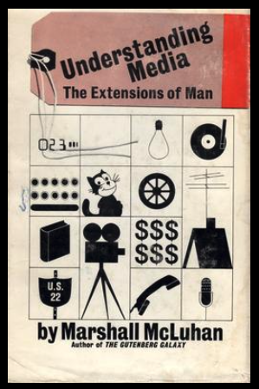
Task 2. Read the chapter “The Network Society: from Knowledge to Policy” by Manuel Castell from the book ’s The Network Society: From Knowledge to Policy and make a list of the ways in which literacy in the “network society” has become more problematic than in the “Guttenberg Universe”.

ADDITIONAL MATERIAL - WORK CARD 2
WORK CARD 2 – THE CONCEPT OF MEDIA LITERACY

Task 1. Read Danail Danov’s article “Media Literacy: Shaping the education of 21st century” and then look at EAVI’s webpage on media literacy.

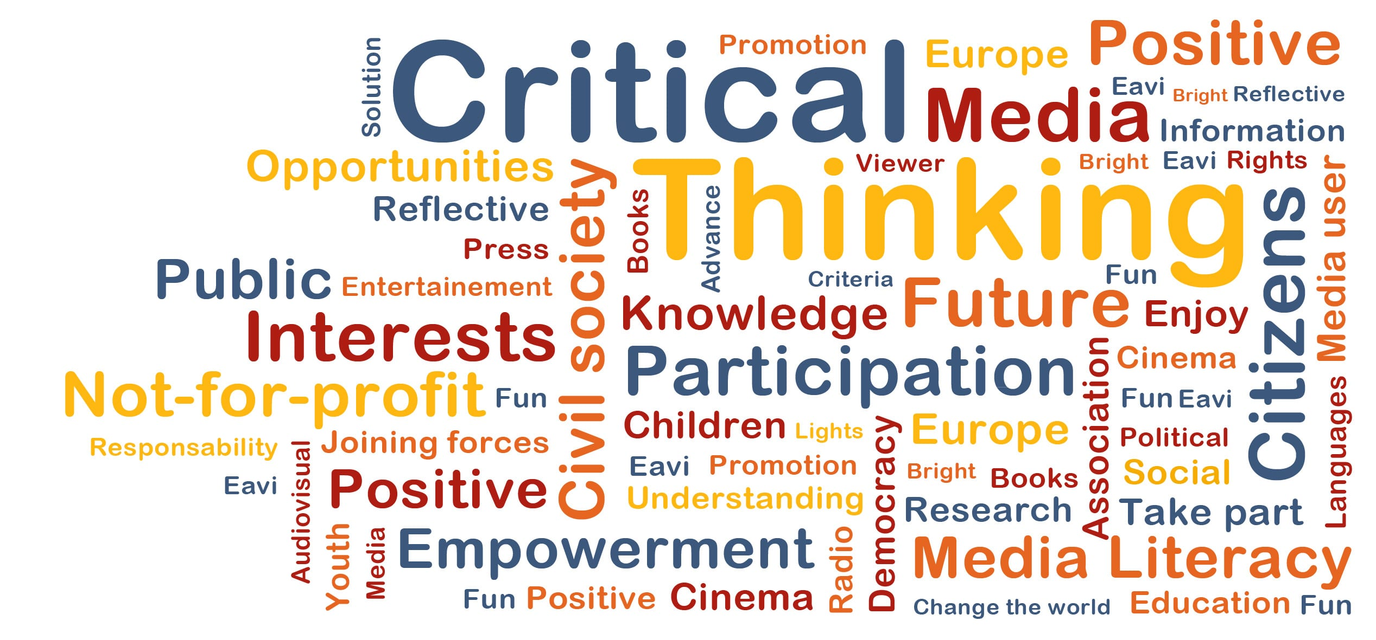

Task 2. On the basis of what you have read, think about your own experience at school in regard to media literacy and write a short essay of 350 words.

