CLASS 10
TOPIC | Media Literacy as part of the twenty-first century skills
LEARNING CONTENT - DETAILED CHARACTERISTICS | This class discusses media literacy as one of the key twenty-first-century skills for being successful nowadays as formulated in the documents of the EU. They are defined as a collection of competencies regarded as important for success in life. They are:  - Critical thinking  - Collaboration  - Communication  - Media/digital literacy  - Creativity  - Problem solving  - Environmental awareness  - Self-expression  We discuss the interrelation between all these skills and the importance of media/digital literacy. As an additional question a distinction between what has been called ‘computer-assisted learning’, ‘computer-based learning’ and ‘computer-enhanced learning’ (Chapelle 2001: 1–26) is made and its implications to education are discussed. The COVID 19 crisis is also assessed from the perspective of the extensive use and development of digital technologies and the attempt to substitute traditional education with online or computer-enhanced education.
KEY WORDS | Twenty-first skills; media literacy; online education; computer-enhanced education
SUGGESTED TOOLS | Power-point presentation  Videos and readings that can serve as examples for discussion  Discussion
TIPS / METHODOLOGICAL REMARKS  (if applicable) | The “flipped classroom” method is used. Students are assigned readings and videos to watch and then a class discussion is carried out. All steps are detailed in the description.
IMPLEMENTATION OF THE CLASSES | STEP 1 | The students are assigned to read the power-point presentation and think of possible questions to discuss.
 | STEP 2 | The students are assigned to find examples of how media literacy interacts with the other twenty-first-century skills.  See Work Card 1 and Work Card 2.
 | STEP 3 | Discussion: the students come to class and discuss media literacy and its interconnection with the other key skills of the twenty-first century. The different terms for online and digital education are discussed. They ask questions based on their getting acquainted with the presentation of the lecturer.
 | STEP 4 | The lecturer clarifies the different points of view and makes students critically assess the different skills we need today and the ones we will need tomorrow.
 | STEP 5 | Learners discuss the different examples they have found illustrating the interconnectedness among the key skills.

ADDITIONAL MATERIAL - WORK CARD 1
WORK CARD 1 – MEDIA LITERACY AND THE TWENTY-FIRST-CENTURY SKILLS

Task 1: Read Sharon Hennam-Dale’s entry on Cambridge Education Blog, https://www.cambridge.org/gb/education/blog/2021/05/20/how-has-remote-learning-affected-21st-century-skills, about the influence of COVID-19 pandemic on the way we define 21st century skills and find examples illustrating the change brought about by the pandemic.

Think before all about the first two new skills, analytical thinking and active learning.

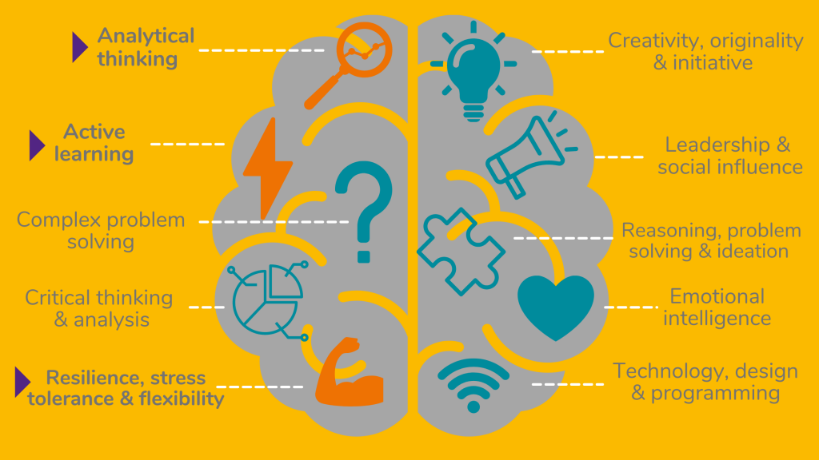

Task 2. Find answers to some of the questions posed in this blog entry.

ADDITIONAL MATERIAL - WORK CARD 2
WORK CARD 2 – MEDIA LITERACY AND THE TWENTY-FIRST-CENTURY SKILLS

Task 1. Read Jenna Buckle’s “A Comprehensive Guide to 21st Century Skills” at https://www.panoramaed.com/blog/comprehensive-guide-21st-century-skills, and on the basis of the examples she provides, try to make a framework that can be used by a school of your choice to define the college, career, and life readiness of its students adapting the existing 21st-century skill framework to fit its needs.

Example: Portrait of a Graduate example.
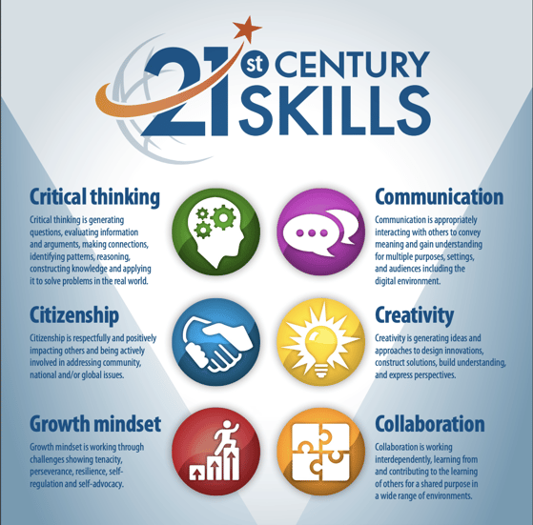
via Everett Public Schools

