CLASS 1
TOPIC | The Social Transformation at the Turn of the Century: The Postindustrial Society and Media Literacy
LEARNING CONTENT - DETAILED CHARACTERISTICS | This class focuses on the way society has changed in the last fifty years under the influence of the mass media and the new horizons that have been opened in front of humankind in view of these transformations. The questions of the social construction of identities in a world dominated by the mass media and the transformations in the way information flows function in society are discussed against the background of such theories as Daniel Bell’s theory of the postindustrial society, Pierre Bourdieu’s “cultural fields” and “symbolic capital”, Jean Baudrillard‘s “hyperreality” to the “Metaverse Ecosystem” of today and in relevance to media literacy.
KEY WORDS | Postindustrial society, cultural fields, symbolic capital, hyperreality, Metaverse, media literacy
SUGGESTED TOOLS | Power-point presentation  Videos and readings about the concepts discussed  Discussion
TIPS / METHODOLOGICAL REMARKS  (if applicable) | The “flipped classroom” method is used. Students are assigned readings and videos to watch and then a class discussion is carried out. All steps are detailed in the description
IMPLEMENTATION OF THE CLASSES | STEP 1 | The students are assigned parts of the ground-laying texts to read before the class gathers.  See Work Card 1 and Work Card 2.
 | STEP 2 | The students are assigned to read the power-point presentation and think of possible questions to discuss.
 | STEP 3 | Discussion: the students come to class and discuss the different theories related to the influence of mass media on contemporary society and the change in social identity construction. They ask questions based on their getting acquainted with the presentation of the lecturer.
 | STEP 4 | The lecturer clarifies the different points of view and makes students critically assess what they know about the issues discussed.
 | STEP 5 | Learners discuss the different theories and their relevance to media literacy.

ADDITIONAL MATERIAL - WORK CARD 1
WORK CARD – SOCIAL TRANSFORMATIONS AND MEDIA LITERACY

Task 1. Watch the video “Why Your Reality Is Not What You Think? Jean Baudrillard's Philosophy of Hyperreality ”,( https://www.youtube.com/watch?v=IE1SjL2zYiY ) and try to connect it to your own experience of being part of the world of the media. Do one of the following:

- Write an essay of 1500 words about your own “life” on social media.

- Create a diary for a week to follow how you fashion your own image on the social media.

- Do an experiment and ask a friend to reach a place without a GPS support. Describe what happened.

- Create a group for social activism on one of the social media and report about the result of achieving its cause.

Task 2. Read Lewis Carroll’s Alice in Wonderland and find parallels with Baudrillard's concept of hyperreality and the Metaverse.

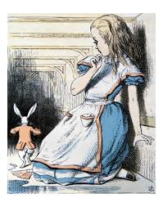
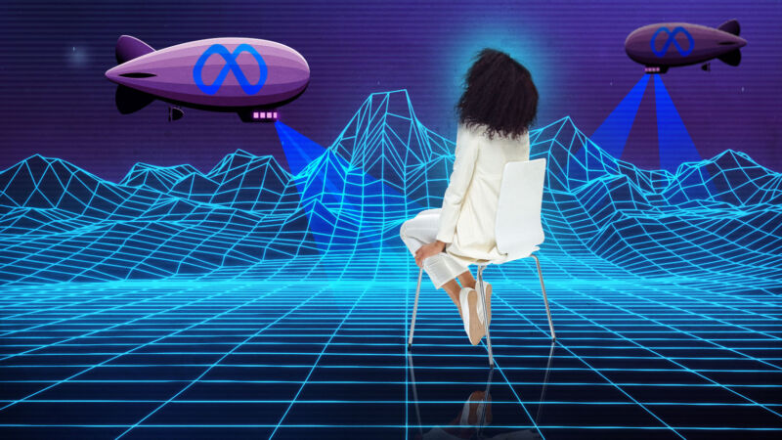

ADDITIONAL MATERIAL - WORK CARD 2
WORK CARD 2– SOCIAL TRANSFORMATIONS AND MEDIA LITERACY

Task 1. Read the article “The Impact of the Metaverse on Education” (https://skywell.software/blog/impact-of-metaverse-on-education/) and discuss your own experience of becoming media literate.

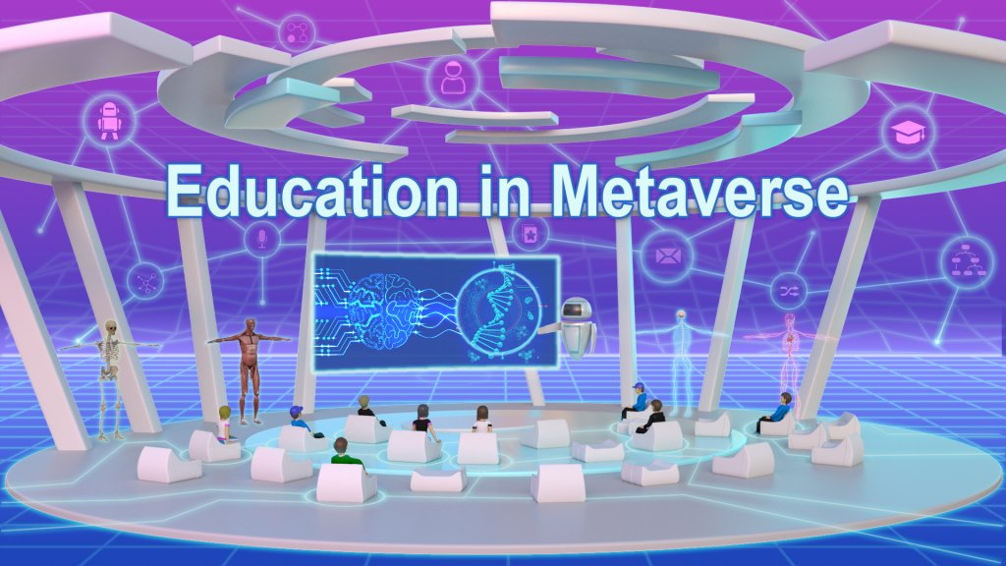

Task 2. On the basis of what you have read, choose one of the advantages of the immersive approach discussed in the article and support it with examples from your own experience:

-Visibility

- Concentration

- Safety

- Efficiency

